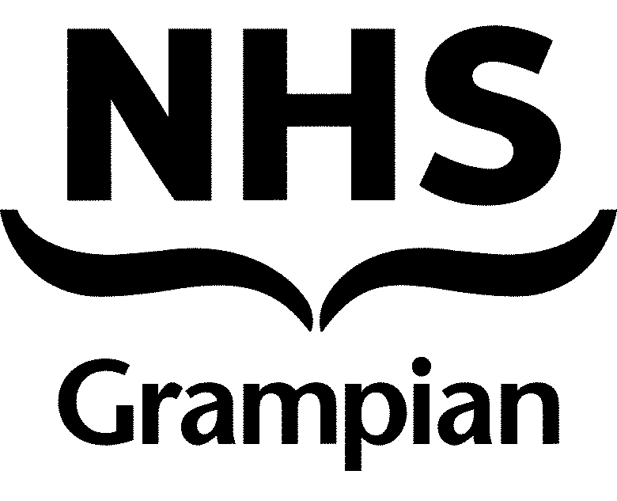
DRUG ALERT

SENSITIVE FINAL

Subject: Rapid-onset overdoses | A number of rapid-onset overdoses have been identified across Scotland and in Aberdeen City over recent weeks, leading to an increased level of harm. This has been associated with several near-fatal and fatal drug overdoses with opioid features.
Substance: Likely nitazene-contaminated heroin | While no individual substance has been identified, the cause is believed to be heroin contaminated with nitazenes.  Rapid police testing has identified a nitazene-type opioid in heroin samples linked to clusters, and further testing is underway to determine the specific substance. There is no safe way to use nitazenes.
Health Risks | There is evidence of an increased number of individuals experiencing near or fatal overdoses associated with sudden onset following consumption. The following features have been identified:  - Rapid-onset cardio-respiratory collapse following drug ingestion.  - Multiple administrations of naloxone required for a response in affected individuals.  - Heroin is the most commonly reported substance consumed, although often in the context of polysubstance use.  - Incidents have been associated with smoking or injecting as routes of consumption.  - Affected individuals have been from a broad range of age groups, and both males and females have been affected.  - Some affected individuals have background vulnerabilities including homelessness or complex physical and mental health co-morbidities.
Specific actions for staff and services | Proactively engage with individuals at potential risk and inform them of the heightened risk as soon as possible.  - Check all clients/patients have an in-date supply of naloxone and are aware of how to use naloxone.  - Avoid referring to the issue as ‘strong/potent’ heroin or substances. Highlight the issue as ‘harmful,’ ‘contaminated,’ or ‘toxic’ heroin in a trauma informed way.  - Encourage individuals to carry their naloxone on them so it is available whenever drugs are being used.  - Advise individuals that multiple naloxone kits and administrations may be required and provide an adequate supply.  - Individuals have experienced rapid overdose even with smoking as a route of consumption – advise slow consumption or to avoid using if possible.  - Encourage people to always call 999 for an ambulance if concerned.  - Encourage discussion about CPR.  - Encourage people to download and use the Aberdeen Protects Naloxone App. This will provide alerts and has instructional videos on naloxone and where to get it as well as CPR. Details and a QR code can be found in the appendix.  - If individuals cannot download the Aberdeen Protects Naloxone App, please show people the videos and resources.  - Use outreach services proactively.  - Consider multi-agency review within services for individuals who may be at risk.
Specific harm reduction advice for people at risk | All people using drugs, but particularly heroin, should be advised to take extra precautions:  - Do not use drugs alone – Have someone with you who can help in an emergency.  - Avoid mixing substances – combining drugs (including alcohol and prescription medication) increases the risk of overdose.  - Know the signs of overdose – symptoms include:  - Sudden collapse  - No response to stimulation  - Blue or pale skin  - Snoring, gurgling, or raspy breathing  - Seizures or fits  - Carry naloxone – if you or someone you know uses drugs, having naloxone could save a life.  - Call 999 immediately if someone overdoses – stay with them and provide first aid until help arrives  - If you do mix, use much less than you would normally.  - Check what you are taking. WEDINOS is a postal service which will check what substances your drugs actually contain -www.wedinos.org  - Share this information with others.
What to do if the substance has been taken | - If you are concerned that someone is experiencing overdose, or at significant risk of harm from a substance they have taken, call 999 and ask for an ambulance.  - Know the signs of overdose. If the person is not responding take action - administer naloxone and use basic life support if you know how.  - Stay with the person until a professional arrives and takes over.
Accessing naloxone restock for services | - Within hours: Restock of naloxone can be obtained by emailing specialist pharmacy at gram.smspharmacists@nhs.scot  - Out-of-hours: If restock of naloxone is required out-of-hours, contact the Senior Manager On-Call for the relevant HSCP. In the case of Aberdeen City, this can be done by phoning NHS Grampian Switchboard on 0345 456 6000 and asking for the Senior Manager on Call for Aberdeen Health and Social Care Partnership.
Resources for individuals at risk | - Alcohol and Drugs Action has a freephone helpline. They can put you in touch with your nearest support service:  Call 0333 344 8355 or text/WhatsApp us on 07927 192 706  7 Days a Week  Monday to Friday 10.30am to 1pm; 2 to 5pm  Saturday and Sunday 2 to 5pm  - Your GP can also put you in contact with local support  - Community pharmacies can supply naloxone kits – some are open 7 days  - NHS Grampian has a webpage for naloxone: www.nhsgrampian.org/your-health/healthy-living/drugs/overdose/naloxone/  - A supply of naloxone can be ordered from Scottish Families Affected by Alcohol and Drugs here
Alert Dissemination | Target services:  - Young people services  - All public services  - Integrated Drug and Alcohol Services  - 3rd sector drug services  - Community Pharmacies  - GP teams  - ED, toxicology and AMIA teams  - Please circulate widely with colleagues working with people who use drugs
National Resources | - SDF Overdose Alert Information  - SDF Overdose Alert PDF  - PHS overdose media statement  - RADAR nitazene alert
Family support | - https://www.sfad.org.uk/
If your service has any information or intelligence which may help, please email: gram.substancemisusealert@nhs.scot providing a brief overview of what has occurred or been reported.
We encourage people to continue to report any drug concerns and trends to RADAR, though our reporting form or email

Sender name/designation: Phil Mackie, Consultant in Public Health
Contact e-mail address: gram.businesssupport@nhs.scot
Date e-mail sent: 14/03/2025

ENDS

APPENDIX 1
The Aberdeen Protects app was developed in partnership by Aberdeen City Council and the ADP, Alcohol and Drugs Action (ADA), lived experience from Aberdeen In Recovery, NHS Grampian and Aberdeen City Health and Social Care Partnership. It aims to promote the uptake and use of naloxone.

Naloxone (Nah-lox-own) is a free and safe medicine available as a kit to anyone to carry. It can reverse the effects of an opioid overdose whilst an ambulance is called. Even if the overdose is not from an opioid it is still safe to use. These days there are highly potent substances being mixed together - so no one can be totally sure what they are taking.

The app allows people to:
- find nearest stockists of naloxone
- videos on how to use naloxone and respond to an overdose
- understand signs and symptoms of overdose
- harm reduction advice
- order postal naloxone kit online
- links to support services
- links to national drug alerts
- local push notifications of drug alerts, harms and local support
The app is for anyone - whether parents, staff or people using substances. Whether its young people at a party, people out at the weekend or people who have used substances for a long time, we can all reduce harm by understanding the risks and how to respond.

The app works on Apple and Android phones and tablets. It can be used for naloxone training and discussion points with service users.

Map Functions: to allow the app to work on finding and mapping nearest naloxone stockists the app needs access to your location.

Notifications: we can send notifications through the app of drug alerts, updates about help and support. Click 'allow notifications' when installing or via settings
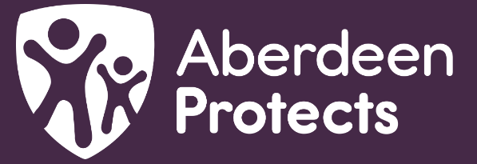
Naloxone App
SAVE A LIFE

Get Naloxone
Carry Naloxone
Use Naloxone

Sign up for drug alerts and harm reduction info



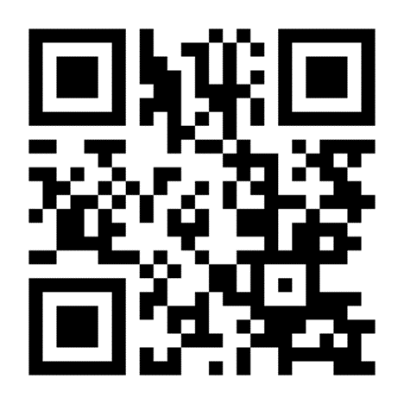
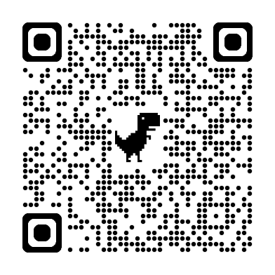

Sign up to receive updates, alerts and harm reduction information
Naloxone App
SAVE A LIFE

Naloxone App
SAVE A LIFE

Get Naloxone
Carry Naloxone
Use Naloxone

Sign up for drug alerts and harm reduction info

Apple: Aberdeen Protects - Apps on Apple
Android: Aberdeen Protects - Apps on Google Play

