Process for Managing Student Formal Reports of Staff Misconduct

Information | Detail(s)
For use in: | All Colleges/Schools/Departments/Divisions of the University
For use by: | All students and all staff
Joint Owners | The University of Leicester
Launch date: | September 2022
Contact – Comments: | Associate Director of Equality, Diversity and Inclusion - Angie Pears, angie.pears@leicester.ac.uk
Policy approved by Director of Human Resources and Academic Registrar
Version Control | Version 1
Review Date: | September 2024

Contents
1. Introduction 3
2. Process for Responding to Allegations 3
3. Investigating Student Formal Reports of Staff Misconduct 3
4. Right of Appeal for Students 8
5. Key Contacts 8

Appendix 1 - Process for Managing Student Formal Reports of Staff Misconduct Flowchart
Appendix 2 - Initial Assessment Form
Appendix 3 - Interpersonal Non-Academic Staff Misconduct Formal Reporting Form

Introduction
  - This document sets out guidelines for responding to formal reports made by students about staff misconduct. It takes into account the legal and contractual positions relating to staffing matters and the relevant Senate Regulations related to student complaints.

  - The University’s Staff Discipline Ordinance sets out the policy and procedure governing how matters of staff misconduct should be dealt with. This takes into account relevant employment legislation and good practice, as set out in the ACAS Code of Practice. For the purpose of the Discipline Ordinance, misconduct is defined as conduct or behaviour of a member of staff that falls below acceptable standards and further detail relating to definitions of staff misconduct are included in the Staff Discipline Ordinance Procedure.

  - These guidelines apply to any student allegation, complaint or report that includes elements relating to staff misconduct.

  - Senate Regulation 11 governs student conduct and behaviour. Senate Regulation 11 should be referred to, where the alleged misconduct is against a registered student or applicant at the University.

  - Senate Regulation 12 governs the process for student complaints relating to both academic and non-academic matters (12.13 and 12.14) and the circumstances under which complaints should be referred to HR procedures (paragraph 12.21).

Process for Responding to Allegations
  - The process for responding to a student report relating to staff misconduct is summarised in the flowchart attached at Appendix 1.

Investigating Student Formal Reports of Staff Misconduct
  - A student disclosure about staff misconduct should be made through the Report and Support website, which is managed by Student Support Services.

  - Once a disclosure about staff misconduct has been made by a student, Student Support Services will carry out a risk assessment normally within 2 working days, but will depend on the individual case, and an appropriate action plan, including support for the student, will be put in place. This risk assessment, where appropriate, should include Human Resources.

  - If severe risks or statutory Safeguarding issues are identified, this will be escalated to the Cause for Concern Group who will liaise with the HR Team and determine the appropriate processes to follow. The Cause for Concern Group will urgently assess the risk and an action plan will be put in place. Action may be taken without the student’s consent where there is an identified risk to self or others.

  - If, following the disclosure, the student wishes to make a formal report and provides consent for this to be shared for the purposes of addressing the complaint, a pro-forma will be completed by the student and shared with Standing Together Team and a case conference will be arranged.

  - This case conference will normally include the Senior Officer (usually the Head of College or Professional Services area), the relevant Human Resources Business Partner or Assistant Director of Human Resources, the Head of Student Complaints, Conduct and Resolution, the Head of Student Support Services and Associate Director of EDI.

  - The case conference should also consider the risk and needs assessment and identify any actions that need to be immediately taken, and confirm that, where potential safeguarding issues have been identified, appropriate action plans, including any support for the student, are in place.

  - A summary of any actions from the case conference will be taken and circulated to attendees, following the meeting. In some circumstances, it may be necessary for further information to be gathered and a further case conference convened, for example if an alternative PhD supervisor needs to be put in place to ensure impact on the student is mitigated as far as is reasonably possible.

  - The Human Resources Business Partner or Assistant Director of Human Resources and the Head of College (or equivalent in Professional Services) will decide (depending on the grade of the member of staff concerned) if it is appropriate to delegate the Senior Officer role to a suitably trained officer who could chair any potential disciplinary hearing if the formal procedure is invoked.

  - The Human Resources Business Partner and Senior Officer will identify an Investigating Officer, in line with both the Student Complaints Procedure and the Staff Discipline Ordinance, taking into account the nature of the complaint and the grade of the staff member.

  - Student Support Services will ensure that appropriate support is available to the student throughout the process, and a member of the relevant HR Team will ensure that the student is informed at all stages of the process (although, as detailed below, some information cannot be shared because of the confidentiality of staff processes).

  - The Senior Officer will notify the student of how the case will proceed and provide details of the process to be followed. The process will be dependent on whether the complaint involves both allegations of staff misconduct and other issues covered by Senate Regulation 12 or if it is solely related to alleged staff misconduct.

  - The Investigating Officer will interview the student to collate further details on the complaint and will share this information with the Senior Officer and Human Resources Business Partner. The operational processes to be followed for this interview, should be similar to those under Senate Regulation 11 and include the caseworker, risk assessments and consideration of any reasonable adjustments. Where appropriate, the interview process may involve a representative from Students’ Union Advice Service.

  - If it has been determined that there are not sufficient grounds to invoke HR processes, then a clear rationale will be communicated by the Senior Officer to the student.

  - All decisions about whether to invoke any formal HR processes, will be informed on a case by case basis and will be dependent on whether any University Ordinance, policy, process or guidelines, such as the Dignity and Respect at Leicester Policy, has potentially been breached.

  - If the outcome from the case conference is that there are not sufficient grounds to invoke formal HR Processes but there are other issues (which are not related to staff misconduct) that need to be investigated, the matter may be progressed in line with the Student Complaints process and there will be no further HR involvement in the process. This will also be communicated by the Senior Officer to the student.

  - If the outcome from the case conference is that there are sufficient grounds to invoke the formal staff disciplinary process or another formal process, then the student will be notified of this and informed of next steps and the likely timescales for concluding the investigation into the staff conduct issues. Due to the confidential nature of any subsequent disciplinary process, the student will not be provided with details regarding the final outcome of any such process, other than the complaint has been upheld, partially upheld or not upheld. It may be appropriate to review the original risk assessment based on the outcome to ensure support is in place for the student to continue their studies.

  - If the complaint involves both alleged staff misconduct and service delivery issues, then the student will be notified that both issues will be investigated concurrently by the same Investigating Officer and that the matters relating to the alleged staff misconduct will be dealt with in accordance with the appropriate HR Ordinance policy and procedure.

  - All investigation meetings relating to the alleged staff misconduct will be supported by the Human Resources Business Partner (or nominated Senior HR Adviser).

  - The Investigating Officer will determine who needs to be interviewed and arrange for the relevant individuals to be invited to interview, provided with a right to be accompanied in accordance with the University’s Discipline Ordinance.

  - The Human Resources Business Partner (or nominated Senior HR Adviser) will ensure that the member of staff who is the subject of the complaint receives appropriate notifications of the investigation, provided with access to support, in accordance with the Discipline Ordinance.

  - Once all interviews are complete, the Investigating Officer will produce a report on the complaint of staff misconduct for consideration by the Senior Officer in their capacity as Chair of any disciplinary panel that may be required.

  - If the outcome of the investigation is that there is no case to answer, and this is supported by the Senior Officer, the member of staff will be notified that no further action will be taken.

  - If the outcome of the investigation is that formal action is not merited but informal action is recommended and this is supported by the Senior Officer, the member of staff will be notified of this and the relevant line manager informed of the informal action that needs to be taken.

  - Where the outcome of the investigation is that the matter should proceed to a formal hearing, a panel will be arranged in accordance with the Discipline Ordinance, the hearing held and an outcome notified to the member of staff.

  - The member of staff will have the right to appeal the decision in accordance with the Discipline Ordinance.

  - In all of the above outcomes, the Senior Officer will notify the student that the investigation is complete and whether the allegations were upheld, not upheld or partially upheld and that appropriate action has been taken. For reasons of confidentiality, no further details can be provided to the student on this and the student will be informed of this.

  - Where allegations have been upheld or partially upheld, the student will be informed that the member of staff has a right of appeal against the decision. The student will also be informed of the outcome of any appeal made.

  - A copy of this notification will be sent to the Head of Student Complaints, Conduct and Resolution and Head of Student Support Services if appropriate who will ensure that appropriate support is provided to the student.

  - Where a complaint of staff misconduct is identified through an allied procedure, for example the Student Complaints Process, the nature of the report and all of the matters raised, will be discussed in line with Senate Regulation 12 and within the remit of this policy. In some circumstances, details may be shared across both teams to ensure that full consideration of all elements of the report are considered through the most appropriate policy.

Right of Appeal for Students
  - There is no right of appeal for the reporting student under the HR procedures.

  - If the student is dissatisfied with the findings relating to the non-staff misconduct, the student may consider submitting a complaint in accordance with Senate Regulation 12.

  - Upon receipt of a formal complaint, paperwork relating to any non-staff misconduct matters may be shared with the Complaints Team where it is relevant to do so.

  - The Academic Registrar or their nominee will decide at which stage the complaint will be considered.

Key Contacts
Angie Pears, Associate Director of Equality, Diversity and Inclusion, angie.pears@leicester.ac.uk
Emma Setchfield, Head of Student Complaints, Conduct and Resolution, els47@leicester.ac.uk
Liz Jennings, Wellbeing Case Manager and Standing Together Lead, liz.jennings@le.ac.uk

Appendix 1: Process for Managing Student Formal Reports of Staff Misconduct Flowchart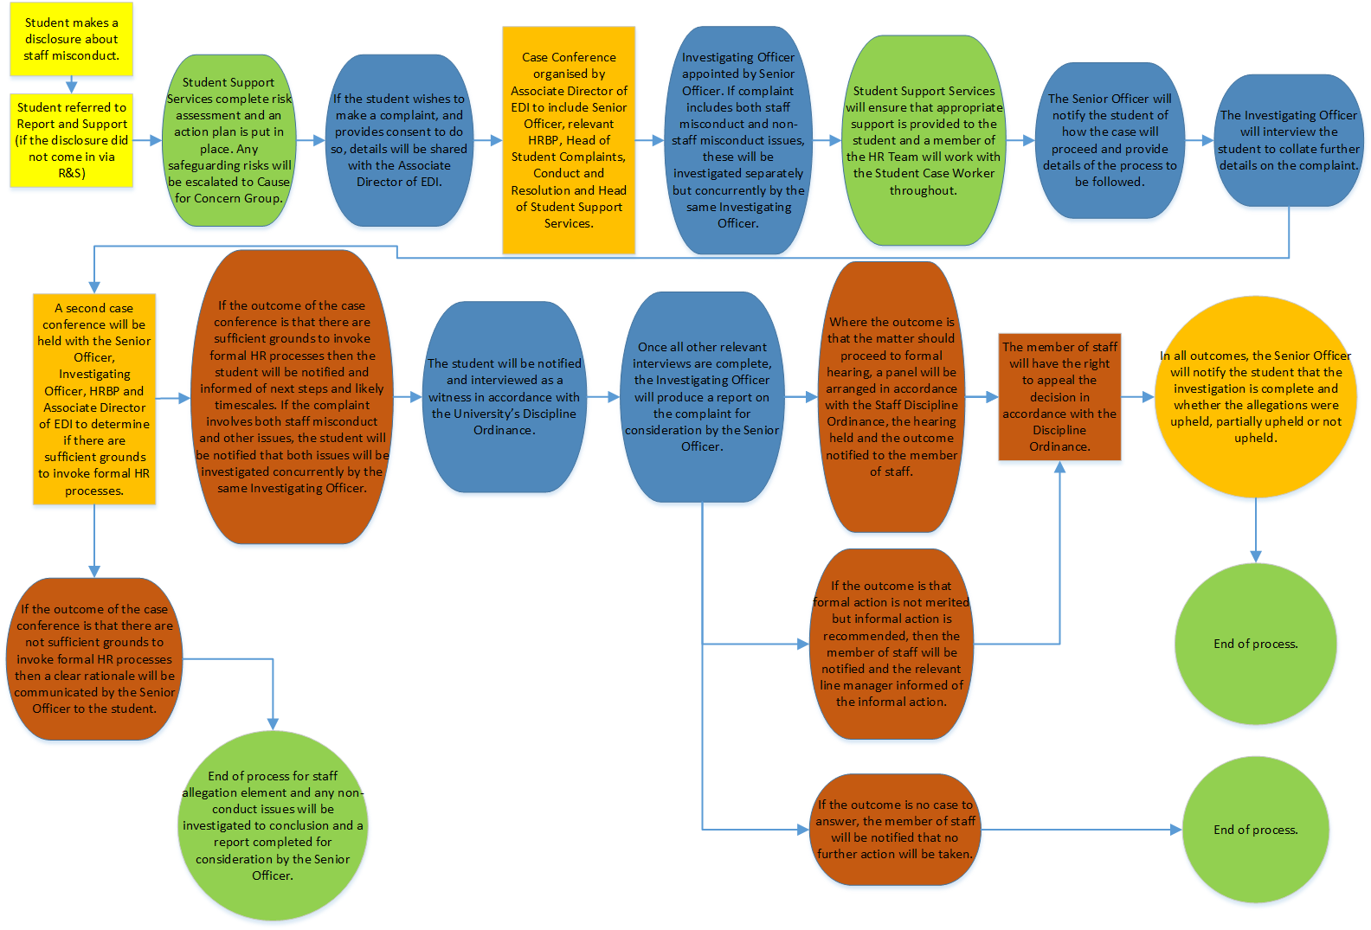

Appendix 2: INITIAL ASSESSMENT FORM

0 – No risk or needs identified | 1 - Mild risk or needs identified that can be managed by the student | 2 – Moderate risk or needs identified that can be managed by SSS | 3 – Significant risk or needs identified that require support from other services/depts

SECTION 1
Questions | Details | Risk Rating
Name
Assessment is for reporting student or reported student or N/A? | Choose an item.
Student Number
DOB
Are they U18 | ☐Yes ☐No | Choose an item.
Course |  | Choose an item.
Year of Study |  | Choose an item.
Home/EU/Intl | Choose an item. | Choose an item.
Visa and Immigration |  | Choose an item.
Disclosed disability or any additional needs |  | Choose an item.
Are any reasonable adjustments required?
Known to Student Support Services | ☐Wellbeing  ☐AccessAbility  ☐Welfare  ☐Cause for Concern  ☐ Not known to any
Accommodation | Choose an item.
Student Life activities (Volunteering, SU, Sport) |  | Choose an item.
Is the student employed? If so where? |  | Choose an item.
Previous related concerns/incidents |  | Choose an item.
Emergency Contact consent provided | Choose an item. | Choose an item.
Religious/Cultural Needs |  | Choose an item.
Route concern was raised | Choose an item.
Type of concern

SECTION 2
Questions | Details | Risk Rating
When incident occurred |  | Choose an item.
Where incident occurred |  | Choose an item.
Nature of the incident |  | Choose an item.
Reported to police (Include crime number) |  | Choose an item.
Other students involved |  | Choose an item.
Name of student involved in incident |  | Choose an item.
Student number
Accommodation of student involved | Choose an item. | Choose an item.
Course |  | Choose an item.
Known to Student Support Services | ☐Wellbeing  ☐AccessAbility  ☐Welfare  ☐Cause for Concern  ☐ Not known to any
Previous related concerns/incidents |  | Choose an item.

SECTION 3
Questions | Details | Risk Rating
History of mental health difficulties? |  | Choose an item.
Current mental health conditions |  | Choose an item.
Are they engaged with their GP?  (include whether it is VHPC) |  | Choose an item.
Support networks |  | Choose an item.
Identified coping mechanisms |  | Choose an item.
Drug and Alcohol usage |  | Choose an item.
Any other health concerns – eating/sleeping difficulties? |  | Choose an item.
Engaged with external services (counselling, non-profit organisations for support.) |  | Choose an item.
Academic concerns |  | Choose an item.
Name of Personal Tutor
Does the student want contact to be made with the school?
Adequate and safe accommodation |  | Choose an item.
Financial concerns |  | Choose an item.

SECTION 4
Risk to | Identified Risks | Level of risk | Support to mitigate risk | Managed by
Choose an item. |  | Choose an item.
Choose an item. |  | Choose an item.
Choose an item. |  | Choose an item.
Choose an item. |  | Choose an item.
Choose an item. |  | Choose an item.
Choose an item. |  | Choose an item.
Choose an item. |  | Choose an item.
Choose an item. |  | Choose an item.
Choose an item. |  | Choose an item.
Choose an item. |  | Choose an item.
Risk and Support Management

SECTION 5
Precautionary Measures
(To be populated by Conduct Office or CFC)
Precautionary Measure | Date | Student Notified
 | Date Issued | Choose an item.
 | Date Issued | Choose an item.
 | Date Issued | Choose an item.
 | Date Issued | Choose an item.

SECTION 6
FIRST COMPLETION
ASSESSMENT COMPLETED BY | DATE | DATE RAISED AT CFC | DATE SUBMITED

ONGONING REVIEWS
COMPLETED BY | DATE REVIEW

Appendix 3: Interpersonal Non-Academic Staff Misconduct Formal Reporting Form

You are submitting a report concerning alleged interpersonal non-academic misconduct by a member of staff that you believe may render the staff member liable to University disciplinary action.
By submitting this report, you are agreeing that this is an accurate and true representation of the facts to the best of your knowledge and belief at the time of submission. If information provided is confirmed to be intentionally falsified, or key information is withheld, you may be liable to disciplinary action under the University Discipline Regulations (Senate Regulation 11).
This report will be considered by the University, who will determine whether an investigation will take place. The process of determination will consider all available and appropriate documentation and evidence at the time of submitting the report. By submitting this report, you are consenting to the information provided being used by the University to consider disciplinary action. In cases where there is a perceived significant risk of harm to yourself or others, relevant information may be shared with external agencies if it is required for safeguarding purposes or by law through a Data Subject Access request from the police.
All information presented and gathered in the course of the investigation of these allegations will be treated with due confidentiality. Only University staff directly involved in the investigation will be able to see this and other relevant investigation files. The elements of this and subsequent information that amount to the allegation will be shared with the reported student.
If you don’t or can’t participate in the subsequent steps of the process, the case may be progressed in your absence however, your cooperation is valued.
You should not discuss the matters covered by the investigation with others, unless it is to seek advice or support through University support channels or from other relevant professional bodies.
Details of Member of Staff (or Members of Staff) Involved
*Mandatory information required

Reporting Party’s / Parties’ Details
Student ID Number* | First Name(s)* | Surname(s)* | Gender Identity | Address

Email Address* | Telephone | Academic Department / Course | Type / Year of Study

Reported Member of Staff’s Details
First Name(s)* | Surname(s)*

Email Address* | Telephone | Department

Student ID Number | First Name(s)* | Surname(s)* | Gender Identity | Address

Email Address* | Telephone | Academic Department / Course | Type / Year of Study

Details of the incident(s)
It is important to focus on the known facts about the situation and/or what has been observed by yourself directly. If you believe others can contribute to the potential investigation, please provide their details (at least their full name and (University) email address) above. This may be confirmed with yourself before contact is made.
- How many incidents would you like to report against the alleged member of staff?
e.g. one, multiple
  - Please specify / elaborate:

- What best describes the incident you would like to tell us about?
e.g. sexual misconduct, physical misconduct, interpersonal non-academic misconduct
  - Please specify / elaborate:

- When did the incident(s) occur?
e.g. in the last few days, in the last few weeks, in the last few months, in the last year
  - Please specify / elaborate:

- Where did the incident(s) occur?
e.g. on campus, in private accommodation, in a local in the city
  - Please specify / elaborate:

- What are your expectations for this formal reporting process? What do you hope the outcome(s) might be?

