

Prevent
Information Sheet


What is Prevent?

Prevent s a UK government strategy designed to stop people from becoming terrorists or supporting terrorism by intervening early to support individuals susceptible to radicalisation. As one of the four pillars of the CONTEST counter-terrorism strategy, it focuses on safeguarding vulnerable people through multi-agency support.

Spot the Signs:

- accessing extremist content online or downloading propaganda material
- justifying the use of violence to solve societal issues
- altering their style of dress or appearance to accord with an extremist group
- being unwilling to engage with people who they see as different
- using certain symbols associated with terrorist organisations
- drastic changes in behaviour, withdrawal from family and friends

Key Aspects of Prevent:

- Purpose: To tackle the ideological causes of terrorism and support people at risk of being drawn into extremism.

- Operation: It is a non-criminal, voluntary, and supportive process that acts in anticipation of radicalisation.

- Types of Terrorism: Addresses all forms, including extreme right-wing and Islamist terrorism
.
- Partnership Approach: Delivered by local authorities, police, health, and education professionals to provide tailored support.

- Channel Programme: A key part of Prevent, which offers tailored support plans for individuals identified as having a high risk of being drawn into terrorism.

Prevent aims to protect individuals before any criminal activity occurs. It is not a tool for surveillance, and referrals do not show up on criminal record checks.

THE RISKS IN THIS COUNTRY / REGION

- It is almost certain that Islamist terrorism will remain the most significant terrorism threat to the UK in the long term.
- It is highly likely that any Islamist inspired attack in the UK would be conducted by a Self-Initiated Terrorist (S-IT), or a small cell (2-3 people) at this time.
- However, in the North East the biggest threat is the Extreme Far Right.
- The country is currently at SUBSTANTIAL threat level

Your Safeguarding Team


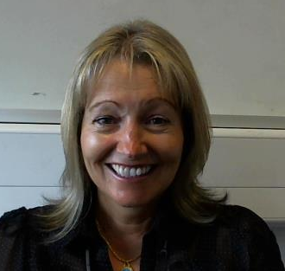

JULIE DAVISON
Head of Student Services and Safeguarding
01325 503036
07760767324

CAROLE TODD
Deputy Principal
01325 503178


JENNIFER ELLIS
Assistant Student Services and Safeguarding Manager
01325 503033 / 07484500690

The Safeguarding Team and the Safeguarding and Welfare Advisers are here to offer support and advice.

