# 

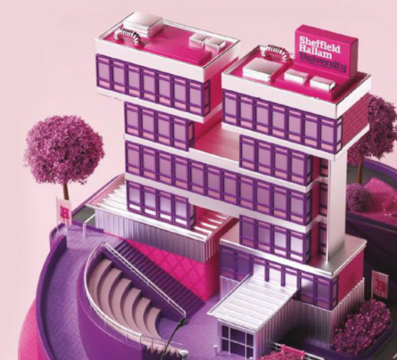

Report + Support at Hallam

Report 2018-2022

This is intended as an accessible format version of the *Report + Support at Hallam Report 2018-22* Prezi report, available via Sheffield Hallam University’s [Equality, Diversity and Inclusion](https://www.shu.ac.uk/about-us/our-values/equality-and-diversity) page. If you have any queries or need any further support with accessing this document and the dataset reported on, please contact us at [reportandsupport@shu.ac.uk](mailto:reportandsupport@shu.ac.uk).

# 

# 

# Welcome

Sheffield Hallam University strives to be a safe, tolerant and inclusive community. We stand against all forms of harassment, discrimination and violence, and where this behaviour occurs it should never go unchallenged.

We actively encourage students and staff who experience or witness any form of harassment, discrimination, abuse or violence to report it. Incidents are reported through our dedicated Report and Support service and can be made anonymously or with contact details so support services from our specialist trained advisors can be accessed.

As part of our commitment to this policy, we recognise there is a need to publicly report our statistics received through our Report and Support service.

This is the first report to identify the scale of harassment, violence, hate and discrimination at Sheffield Hallam University and highlight the work that the University is engaged in to address this. From 2022-23 an annual report will be published each Autumn. This report summarises the University’s work over the last 4 years.

# 

# 

# Our Policy

Sheffield Hallam University strives to be a safe, tolerant and inclusive community. We stand against all forms of harassment, discrimination and violence, and where this behaviour occurs it should never go unchallenged.

All members of our student and staff community have the right to live, work and learn safely and to always be treated with dignity and respect. We value being a diverse community, and aim to create an inclusive environment where all individuals are respected for who they are and for the contribution they make.

We want to create an environment that is free from harassment, violence, hate and discrimination of any kind, with effective policies and processes in place, a clear system for incidents to be reported, and a range of specialist support available. We know that we haven’t always got things right in the past and we are determined to do better, by investing in educational prevention programmes, and in training for support services.

We understand that sexual harassment, abuse or violence can be experienced by any individual, and that women, members of the LGBTQ+ community and disabled people are disproportionately affected in society.

We actively encourage students and staff who experience or witness any form of harassment, discrimination, abuse or violence to report it. Incidents should be reported through our dedicated [Report and Support](https://reportandsupport.shu.ac.uk/) service, where reports can be made anonymously, or with contact details so that support services from our specialist trained advisors can be accessed.

Complainants will always be treated with dignity and respect, and we are fully committed to investigating any complaints or disclosures that are made. We will work together with other appropriate agencies where necessary: these could include the Police, Sheffield City Council, the University of Sheffield, or other groups and support services.

[Student Wellbeing](https://www.shu.ac.uk/wellbeing)

 [Our Student Charter](https://www.shu.ac.uk/about-us/governance-and-strategy/governance/our-student-charter)

[Report + Support](https://reportandsupport.shu.ac.uk/)

[Conduct and Discipline](https://students.shu.ac.uk/regulations/conduct_discipline/index.html)

# 

# 

# Report and Support

Sheffield Hallam is a safe and tolerant community. We don’t stand for harassment or abuse. If you have experienced sexual violence, harassment, abuse or hate crime report it either anonymously or get support from an adviser.

## What is Report and Support?

Report and Support is Sheffield Hallam University's online disclosure platform for both students and staff who have been affected by Sexual Misconduct, Bullying, Harassment, Discrimination, Racism, Hate Incidents and/or Hate Crime. The platform recognises the often intersectional nature of harassment, providing options for both anonymous and named disclosures.

# How to use our report

Our statistics are split into academic years ranging from 2018-19 through to 2021-22. An academic year runs from 1st August through to 31st July.

To ensure the data in this report is accessible, where we have included visual presentations of data we have also included the data as simple tables in the appendix. If you would prefer to read the online version of this report with dynamic charts, it is available on Sheffield Hallam University’s [Equality, Diversity and Inclusion](https://www.shu.ac.uk/about-us/our-values/equality-and-diversity) page.

We have used our data to progress and make improvements to our service to help change culture in order to reach our goal to create an environment that is free from harassment, violence, hate and discrimination of any kind.

# 

# 

# Contents

* A summary of our journey so far...
* Awareness Training
  + for students
  + for staff
* Service Feedback on Report and Support
* Our Data Insights
* Overview
* Student Disclosures
* Who is Disclosing?

(including Gender, Ethnicity, Disability, Age, Sexual Identity and Faith/Religion)

* Suspected Factors
* Where were incidents taking place?
* Student Disciplines Outcomes
* Staff Disclosures
* Improving Our Service
* Appendix – data tables

# 

# 

# A summary of our journey so far...

## September 2018

Report & Support was launched for Sexual Violence, Hate and Harassment. Student Support, Security and Hallam Help staff were all trained on handling disclosures, making referrals and third-party reporting.

Engagement and awareness-raising campaigns were launched: ‘Is this OK’, ‘Love not Hate’, ‘What was she wearing’ exhibition.

Report + Support posters were placed on every toilet door across the two University campuses, sports facilities, research centres and sent to every accommodation provider. Marketing campaigns across the University channels for plasma screens and banner stands.

## January - April 2020

Student Wellbeing staff and investigators received training from Lime Culture and Intersol Global.

## April 2021

The Office for Students (OfS) published a statement of expectations to provide a clear framework for colleges and universities in preventing and responding to incidents of harassment and sexual misconduct that affect students.

The Students’ Union’s Deputy President and Social Sciences & Arts College Officer developed a policy aimed at reducing sexual violence and relationship abuse amongst students across the UK. The Sexual Violence, NDAs (Non-Disclosure Agreements) and Relationship Abuse policy was passed with no amendment at NUS Conference 2021.

## May 2021

We established a Harassment, Sexual Misconduct and Hate Crime Steering Group to have oversight of the University’s commitment.

# 

# ...continued

## September 2021

We added ‘racism’ as a stand-alone ‘type of incident’ as opposed to being a motivating factor in other types of incidents. We increased staffing in Report and Support dedicated to student facing support.

An Epigeum ‘Being an Active Bystander’ course was introduced to students.

## October 2021

We upgraded to Culture Shift's 'Gold Package', allowing us to access more proactive measures to drive culture change. We set our Equality Objectives for 2021-24 to embody the University’s ambition to create a transformational and aspirational culture of inclusion for all students and staff.

We launched 'Protect and Respect' a new learning and development programme for all staff - its purpose is to focus on how we continue to build a safe and inclusive culture across the University.

## February 2022

Workshops were held to review the work of the Harassment, Sexual Misconduct & Hate Crime Steering group. We implemented a new set of distinct workstreams to feed into the work of the Steering Group.

## March 2022

We signed a government-backed pledge to end the use of Non-Disclosure Agreements (NDAs) when dealing with student and staff complaints of sexual harassment, bullying and misconduct.

## May 2022

We produced a Harassment, Sexual Misconduct & Hate Crime Policy Statement.

# 

# 

# Awareness Training for our Students

## Epigeum Active Bystander Module

In order to promote an inclusive campus community all students are expected to complete the *Epigeum Active Bystander Module*.

A link to this course is included as an essential element on all course induction schedules.

The Active Bystander course teaches our students:

* How to recognise harassment and hate incidents
* Appropriate strategies for intervening, and,
* How to make a positive impact on your university community from the start

Since September 2021, 430 students have passed the course. Our main challenge is student engagement. There are ongoing discussions on how to encourage key members of the student community to engage and promote the module including; Student Reps, members of Sports and Academic Societies and Student Ambassadors. We will also be looking at how the module can be promoted at key relevant points of the academic year alongside other University and Students’ Union activity.

Other Student Activities:

* Promotion of Report and Support in the Your Hallam Welcome Module and during welcome week
* Inclusion of awareness raising information in the Supporting You at Hallam Session – a mandatory support session that all students are expected to attend during welcome week
* Encouraging and supporting students who disclose to Student Support Advisers to engage with Report and Support
* Delivering a Supporting You at Hallam Session to all staff, including a session on the Report and Support Service and Supporting Students in Difficult Circumstances

# 

## Other awareness training is also available to our students which includes:

* Mandatory Sheffield Hallam University Epigeum Course
* Consent Matters: Boundaries, Respect, and Positive Intervention training
* Healthy relationships training
* Targeted training to student groups such as sports teams
* Bystander interventions training

# 

# 

# Awareness Training for our staff

## Protect and Respect

The University launched phase one of the Protect and Respect staff learning and development programme in October 2021.

The programme presents the University’s vision for a safe and inclusive culture and inspires staff to take an active role in promoting and maintaining this. It provides a space for engaging in conversation, exploring different perspectives and challenging biases. It encourages all staff to be active bystanders and enables them to recognise inappropriate behaviour and understand how best to challenge it.

Module 1

Staff attend an online workshop 'Actively Building a Safe and Inclusive Culture', a 90-minute workshop that is held live.

Modules 2 and 3

Staff are asked to complete two E-learning modules provided by Epigeum:

* Being an Active Bystander
* Responding to Disclosures

## Protect and Respect completion rates so far...

* Actively Building a Safe and Inclusive Culture’ - 1031 staff (26%)
* Being an Active Bystander - 642 staff (16%)
* Responding to Disclosures - 540 staff (14%)

The main challenge is getting wider engagement with the programme, something we hope to tackle as we continue to roll out phase one and start delivering phase two of the programme.

# 

# Service Feedback on Report and Support

"*When I made my report I was so broken and hopeless. However, reporting was incredibly easy and I was greeted with a fast, empathetic and non-judgmental response. From that moment I knew I had an ally.*" A reporting student

"*The service is outstanding. They are really easy to talk to.*" A reporting student

"*To get in contact with this support, they are very kind and helpful. They provided so much support to me, even talking to the lovely staff supported and helped me through my experience."* A reporting student

"*Make use of this service it's vital and does make a difference. Takes some pressure off you by having a confidential conversation, so you’re not alone.*" A reporting student

We ask all the students we support to complete our feedback form, if they wish. Providing feedback is never made mandatory, but is always appreciated by the Student Wellbeing Team.

# 

# Our Data Insights

Academic Year runs from 1st August – 31st July

# 

# Overview

### What is disclosure in Report and Support?

A disclosure is when someone lets us know what's happened to them or someone else. This is not a stage 2 formal complaint.

## Total Number of Disclosures

## What was disclosed?

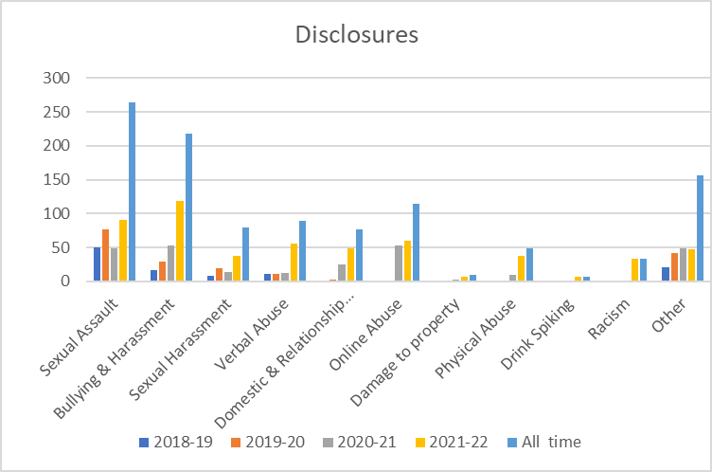

New incident types are reviewed and added by Culture Shift each year and more than one type can be selected in a report. The charts above are also provided in a table format, see Appendix.

# 

# Student Disclosures

We actively encourage students and staff who experience or witness sexual violence, harassment, racism or any hate incident to report it.

## Students who disclosed being affected by harassment from 2018-19 to 2021-22, both anonymously and with personal details

The chart above is also provided in a table format, see Appendix

## Most common reasons some students disclose anonymously

1. I'm worried about possible repercussions

2. I'm worried the perpetrator would retaliate

3. Nothing would be done if I made a complaint

Reporting with personal details is important because the University can only address these issues if we have a picture of what is happening, the prevalence and circumstances. By telling us we can help people explore help and support options.

# 

# Who is disclosing?

When a report is filled in with Personal details, these fields are optional.

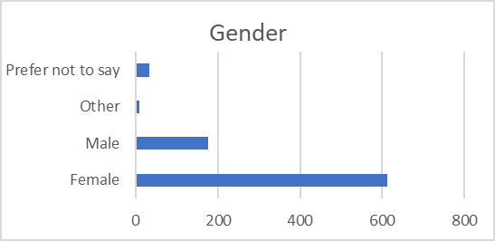

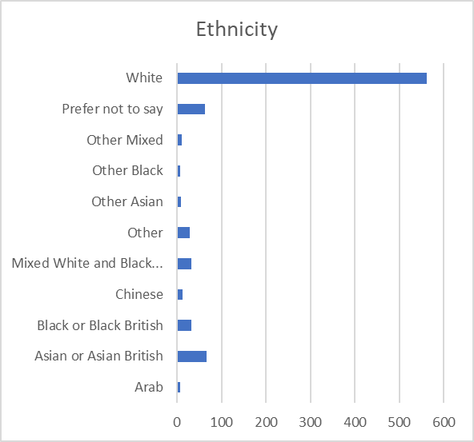

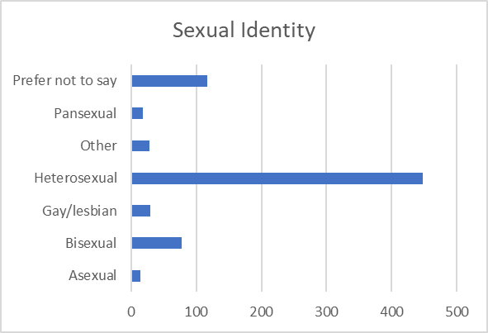

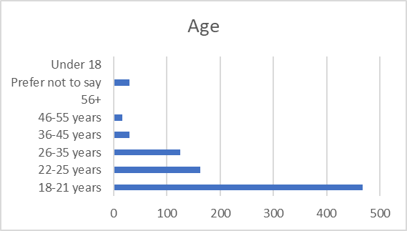

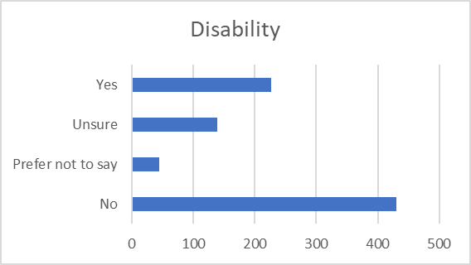

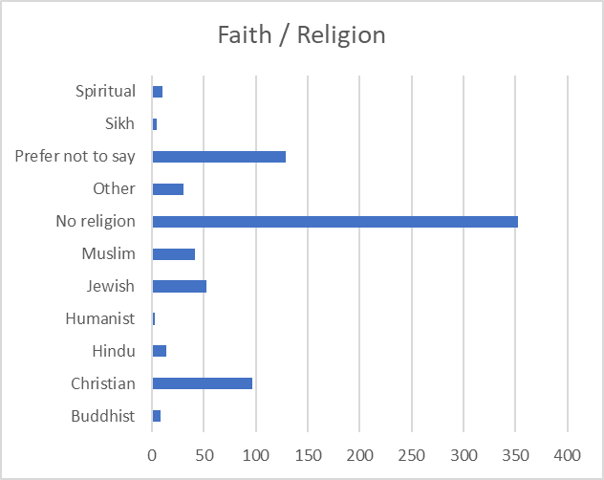

# 

# Motivating factor(s) by incident type

The motivating factors in this section are determined by the reporting party and are why incidents occurred.

NB - Multiple options could be selected in a single report.

The table above shows reported motivating factors (where known) for all incident types across the full period of this report, covering academic years 2018-19 to 2021-22. The legend shows the incident types, and these can also be seen by hovering over the sections of each bar. The appendix includes the data in a table format also reflecting those recorded as Other or None for the motivating factor.

The dynamic version of this report referenced earlier allows further interaction with this data, for example to filter the data by year. If you need any further support with accessing this data, do please let us know.

# 

# Incident type by motivating factor(s)

The motivating factors in this section are determined by the reporting party and are why incidents occurred (by incident type).

NB - Multiple options could be selected in a single report

The table above shows incident types for all incidents across the full period of this report, covering academic years 2018-19 to 2021-22. The legend shows the motivating factors, and these can also be seen by hovering over the sections of each bar. The appendix includes the data in a table format.

The Prezi version of this report referenced earlier allows further interaction with this data, for example to filter the data by year. If you need any further support with accessing this data, do please let us know.

# 

# Where were incidents taking place between 2018 and 2022?

## Did you know?

The [Student Advice Centre](https://www.hallamstudentsunion.com/advice_help/) within Sheffield Hallam Students' Union is a designated Hate Crime Reporting Centre and we work closely with South Yorkshire Police to tackle hate crime across the city.

### Locations

* On campus – 11%
* Off campus – 41%
* Online – 20%
* Other / Undisclosed – 28%

### Specific locations of ‘off campus’ reports

The chart above is also available in a table format, see Appendix

# 

# Student Discipline Outcomes

These cases are investigated by our Student Policy, Casework & Compliance Team between 2018-19 to 2021-22. Not all cases referred to the team came via Report & Support.

‘On hold’ cases are ongoing cases due to police investigation.

## Sexual Misconduct

## Discrimination and Harassment

The charts above are also provided in a table format, see Appendix

# 

# Staff Disclosures

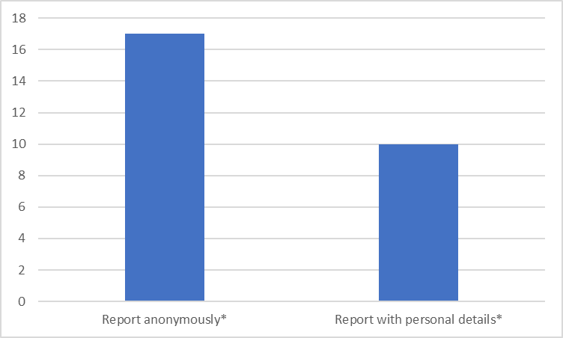

# * These reports are made by staff on behalf of themselves and doesn't include third party reports*.*

## Most common reasons some staff disclose anonymously

* I am worried about repercussions of making this referral
* I don't think it is serious enough to warrant a complaint
* I don't want to be contacted about this

## What are our staff reporting?

## The areas where staff work and numbers of staff who made reports between 2018 and 2022

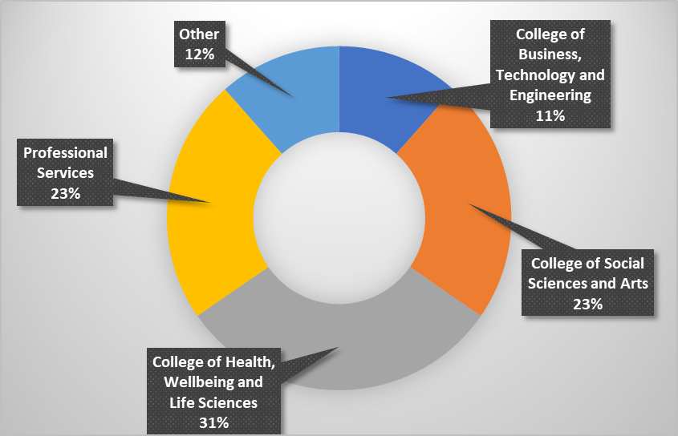

The charts above are also provided in a table format, see Appendix

# 

# There's always room for us to improve our service...

1 We will review and consolidate the foundational policy and associated governance that underpins and supports the embedding of Sheffield Hallam’s approach to tackle harassment, sexual misconduct and hate crime in a structured and systematic way and defines and implements reporting mechanisms to provide demonstrable evidence on our impact.

2 We will create an effective, proactive and meaningful communication and engagement strategy to engage with students, staff and visitors to the University.

3 We will design, develop and deliver consistent, equitable and accessible processes for students, staff and visitors to report harassment and sexual misconduct and hate crime and create the onward case management protocols to ensure a high level of support is provided, individuals are treated sensitively, and cases managed in confidence, underpinned by a visible and effective disciplinary process.

4 We will work in partnership with the Students’ Union and continue to be actively engaged in a number of preventative and harm reduction campaigns including a city-wide campaign on spiking.

5 We will create a single training strategy document consolidating the University's vision, supporting policies and commitments to addressing harassment, sexual misconduct and hate crime. This strategy will cover all stakeholders including students, staff and governors.

6 We will deliver phase two of our staff training and offer a range of modules that look at various subjects that support anti-discrimination and what this means at Hallam.

7 We commit to consider alternative options to improve student awareness and training.

8 We commit to continue to be represented at the Sheffield Hate Crime Priority Group and engage with training provided through the group.

9 We will create an evaluation plan which aims to evidence impact against the long-term goal of preventing harassment, sexual misconduct and hate crime at Sheffield Hallam University.

10 We will continue to publish our data and ensure that it drives continual process improvements and ongoing learning and development for our staff and students.

# 

# Appendix

### Page 13 – Number of disclosures

|  |  |  |  |  |  |
| --- | --- | --- | --- | --- | --- |
|  | 2018-19 | 2019-20 | 2020-21 | 2021-22 | All time |
| Number of reports | 115 | 195 | 260 | 344 | 1110 |
| Report anonymously | 31 | 66 | 63 | 86 | 292 |
| Report with personal details | 84 | 129 | 197 | 258 | 818 |

### Page 13 – What was disclosed?

|  |  |  |  |  |  |
| --- | --- | --- | --- | --- | --- |
|  | 2018-19 | 2019-20 | 2020-21 | 2021-22 | All time |
| Sexual Assault | 50 | 76 | 48 | 90 | 264 |
| Bullying & Harassment | 17 | 29 | 53 | 119 | 218 |
| Sexual Harassment | 8 | 19 | 13 | 38 | 79 |
| Verbal Abuse | 11 | 11 | 12 | 55 | 89 |
| Domestic & Relationship Abuse | 0 | 2 | 25 | 49 | 76 |
| Online Abuse | 0 | 1 | 53 | 60 | 114 |
| Damage to property | 0 | 0 | 2 | 7 | 9 |
| Physical Abuse | 0 | 0 | 10 | 38 | 48 |
| Drink Spiking* | 0 | 0 | 0 | 6 | 6 |
| Racism* | 0 | 0 | 0 | 33 | 33 |
| Other | 20 | 42 | 48 | 47 | 157 |

### Page 14 – Students affected by harassment

|  |  |  |  |  |  |
| --- | --- | --- | --- | --- | --- |
|  | 2018-19 | 2019-20 | 2020-21 | 2021-22 | All time |
| Report anonymously | 13 | 22 | 36 | 40 | 152 |
| Report with personal details | 65 | 86 | 118 | 162 | 601 |

### Page 16 – Who is disclosing?

|  |  |  |  |  |  |  |
| --- | --- | --- | --- | --- | --- | --- |
|  |  | 2018-19 | 2019-20 | 2020-21 | 2021-22 | All time |
| Gender | Female | 77 | 150 | 156 | 229 | 612 |
|  | Male | 18 | 18 | 75 | 65 | 176 |
|  | Other | 1 | 1 | 4 | 4 | 10 |
|  | Prefer not to say | 2 | 4 | 13 | 15 | 34 |
|  |  |  |  |  |  |  |
|  |  | 2018-19 | 2019-20 | 2020-21 | 2021-22 | All time |
| Ethnicity | Arab | 2 | 2 | 0 | 3 | 7 |
|  | Asian or Asian British | 6 | 15 | 17 | 28 | 66 |
|  | Black or Black British | 1 | 5 | 10 | 17 | 33 |
|  | Chinese | 6 | 4 | 2 | 1 | 13 |
|  | Mixed White and Black... | 2 | 13 | 5 | 12 | 32 |
|  | Other | 3 | 9 | 11 | 6 | 29 |
|  | Other Asian | 0 | 3 | 2 | 3 | 8 |
|  | Other Black | 0 | 2 | 1 | 3 | 6 |
|  | Other Mixed | 1 | 2 | 3 | 4 | 10 |
|  | Prefer not to say | 6 | 10 | 22 | 24 | 62 |
|  | White | 71 | 106 | 173 | 212 | 562 |
|  |  |  |  |  |  |  |
|  |  | 2018-19 | 2019-20 | 2020-21 | 2021-22 | All time |
| Sexual Identity | Asexual | 1 | 3 | 4 | 6 | 14 |
|  | Bisexual | 5 | 23 | 20 | 30 | 78 |
|  | Gay/lesbian | 5 | 2 | 3 | 19 | 29 |
|  | Heterosexual | 63 | 87 | 149 | 149 | 448 |
|  | Other | 1 | 10 | 10 | 7 | 28 |
|  | Pansexual | 2 | 5 | 2 | 9 | 18 |
|  | Prefer not to say | 10 | 29 | 32 | 46 | 117 |
|  |  |  |  |  |  |  |
|  |  | 2018-19 | 2019-20 | 2020-21 | 2021-22 | All time |
| Age | 18-21 years | 58 | 110 | 130 | 169 | 467 |
|  | 22-25 years | 24 | 40 | 37 | 61 | 162 |
|  | 26-35 years | 8 | 13 | 47 | 57 | 125 |
|  | 36-45 years | 5 | 7 | 4 | 13 | 29 |
|  | 46-55 years | 0 | 4 | 7 | 5 | 16 |
|  | 56+ years | 0 | 0 | 0 | 2 | 2 |
|  | Prefer not to say | 1 | 6 | 15 | 9 | 30 |
|  | Under 18 yrs | 0 | 1 | 0 | 1 | 2 |
|  |  |  |  |  |  |  |
|  |  | 2018-19 | 2019-20 | 2020-21 | 2021-22 | All time |
| Disability | No | 59 | 96 | 122 | 153 | 430 |
|  | Prefer not to say | 4 | 15 | 13 | 12 | 44 |
|  | Unsure | 14 | 32 | 34 | 59 | 139 |
|  | Yes | 21 | 32 | 80 | 94 | 227 |
|  |  |  |  |  |  |  |
|  |  | 2018-19 | 2019-20 | 2020-21 | 2021-22 | All time |
| Faith / Religion | Buddhist | 2 | 3 | 0 | 3 | 8 |
|  | Christian | 17 | 23 | 28 | 29 | 97 |
|  | Hindu | 2 | 3 | 3 | 6 | 14 |
|  | Humanist | 0 | 1 | 1 | 1 | 3 |
|  | Jewish | 2 | 1 | 37 | 13 | 53 |
|  | Muslim | 5 | 9 | 6 | 21 | 41 |
|  | No religion | 53 | 74 | 100 | 125 | 352 |
|  | Other | 4 | 7 | 10 | 9 | 30 |
|  | Prefer not to say | 9 | 30 | 38 | 52 | 129 |
|  | Sikh | 0 | 1 | 4 | 0 | 5 |
|  | Spiritual | 0 | 2 | 2 | 6 | 10 |

### Page 17 – Motivating factor(s) by incident type

### Multiple suspected factors can be selected in a single report and reports of 3 or less (0-3) are grouped to protect the identity of the reporting party.

|  |  |  |  |  |  |  |  |  |  |  |  |  |  |
| --- | --- | --- | --- | --- | --- | --- | --- | --- | --- | --- | --- | --- | --- |
|  | Bullying / Harassment | Bullying/Harassment including stalking) | Damage To Property | Domestic / Relationship Abuse | Drink Spiking | Online Abuse | Other | Physical Abuse | Racism | Sexual Assault | Sexual Harassment | Verbal Abuse | Total |
| Age | 0-3 | 10 | 0 | 0-3 | 0-3 | 0-3 | 0-3 | 0 | 0-3 | 4 | 7 | 5 | 38 |
| Disability | 13 | 7 | 0 | 0-3 | 0 | 8 | 4 | 0 | 0 | 0 | 0-3 | 6 | 41 |
| Gender | 8 | 14 | 0-3 | 6 | 0 | 4 | 11 | 5 | 0-3 | 15 | 23 | 12 | 102 |
| Marriage / Civil Partnership | 4 | 0 | 0 | 5 | 0 | 0 | 0 | 0 | 0 | 0 | 0 | 0 | 9 |
| None | 45 | 56 | 4 | 49 | 4 | 29 | 72 | 43 | 0 | 200 | 38 | 36 | 576 |
| Other | 9 | 11 | 4 | 0-3 | 0 | 15 | 25 | 6 | 0-3 | 8 | 0-3 | 12 | 97 |
| Pregnancy / Maternity | 0 | 0 | 0 | 0 | 0 | 0 | 0 | 0 | 0 | 0 | 0 | 0-3 | 0-3 |
| Race / Ethnicity | 15 | 12 | 0 | 0 | 0 | 50 | 23 | 6 | 30 | 0-3 | 0-3 | 12 | 152 |
| Religion / Belief | 0-3 | 0-3 | 0 | 0 | 0 | 51 | 6 | 0-3 | 15 | 0 | 0 | 6 | 86 |
| Sexual Orientation | 5 | 9 | 0 | 4 | 0 | 4 | 6 | 4 | 0 | 4 | 8 | 10 | 54 |
| Transgender / Non-Binary | 0-3 | 0-3 | 0 | 0 | 0 | 0-3 | 0-3 | 0 | 0 | 0 | 0-3 | 0-3 | 13 |

### Page 18 – Incident type by motivating factor(s) Multiple suspected factors can be selected in a single report and reports of 3 or less (0-3) are grouped to protect the identity of the reporting party.

|  |  |  |  |  |  |  |  |  |  |  |  |  |
| --- | --- | --- | --- | --- | --- | --- | --- | --- | --- | --- | --- | --- |
|  | Age | Disability | Gender | Marriage / CP | None | Other | Pregnancy / Maternity | Race / Ethnicity | Religion / Belief | Sexual Orientation | Transgender / Non-Binary | Total |
| Bullying / Harassment | 0-3 | 13 | 8 | 4 | 45 | 9 | 0 | 15 | 0-3 | 5 | 0-3 | 106 |
| Bullying / Harassment incl. stalking | 10 | 7 | 14 | 0 | 56 | 11 | 0 | 12 | 0-3 | 9 | 0-3 | 124 |
| Damage to Property | 0 | 0 | 0-3 | 0 | 4 | 4 | 0 | 0 | 0 | 0 | 0 | 9 |
| Domestic / Relationship Abuse | 0-3 | 0-3 | 6 | 5 | 49 | 0-3 | 0 | 0 | 0 | 4 | 0-3 | 72 |
| Drink Spiking | 0-3 | 0 | 0-3 | 0 | 4 | 0 | 0 | 0 | 0 | 0 | 0 | 6 |
| Online Abuse | 0-3 | 8 | 4 | 0 | 29 | 15 | 0 | 50 | 51 | 4 | 0-3 | 164 |
| Other | 0-3 | 4 | 11 | 0 | 72 | 25 | 0 | 23 | 6 | 6 | 0-3 | 153 |
| Physical Abuse | 0-3 | 0 | 5 | 0-3 | 43 | 6 | 0 | 6 | 0-3 | 4 | 0 | 68 |
| Racism | 0-3 | 0 | 0-3 | 0 | 0-3 | 0-3 | 0 | 30 | 15 | 0-3 | 0 | 54 |
| Sexual Assault | 4 | 0 | 15 | 0 | 200 | 8 | 0 | 0-3 | 0 | 4 | 0-3 | 234 |
| Sexual Harassment | 7 | 0-3 | 23 | 0 | 38 | 0-3 | 0 | 0-3 | 0 | 8 | 0-3 | 83 |
| Verbal Abuse | 5 | 6 | 12 | 0-3 | 36 | 12 | 0-3 | 12 | 6 | 12 | 0-3 | 107 |

### Page 19 – Locations of ‘off campus’ reports

|  |  |
| --- | --- |
| Student housing / Halls of residence | 65% |
| Private house | 12% |
| In a bar or club | 17% |
| At work | 5% |
| Hotel | 1% |

### Page 20 – Student discipline outcomes – sexual misconduct

|  |  |
| --- | --- |
| Total number of cases | 38 |
| On Hold | 4 |
| No case to answer/no action | 10 |
| Allegation withdrawn/not progressed by reporter | 8 |
| Internal resolution – no contact arrangement | 10 |
| Written warning, no contact arrangement and behavioural contract for duration of course | 1 |
| Written warning and behavioural contract to prevent contact with reporting student, apology letter, and complete an online resource | 1 |
| Referred into Fitness to Practise Process | 1 |
| Expulsion | 2 |

### Page 20 – Student discipline outcomes – discrimination and harassment

|  |  |
| --- | --- |
| Total number of cases | 80 |
| On Hold | 1 |
| Couldn’t be identified as SHU student | 1 |
| No case to answer/no action | 9 |
| Allegation withdrawn/not progressed by reporter | 25 |
| Internal resolution – advice issued | 6 |
| Internal resolution – no contact arrangement | 32 |
| Restorative justice – letter of apology | 2 |
| Written warning, no contact arrangement and behavioural agreement | 1 |
| Written warning and behavioural contract, not permitted to be awarded Hallam Award, excluded from enrolling on another SHU course for 5 years | 1 |
| Behavioural agreement | 1 |

### Page 22 – Staff disclosures, anonymous or with personal details

|  |  |
| --- | --- |
|  | All time |
| Report anonymously* | 17 |
| Report with personal details* | 10 |

### Page 22 – What are our staff reporting

|  |  |
| --- | --- |
|  | All time |
| Sexual Assault | 1 |
| Bullying & Harassment | 12 |
| Sexual Harassment | 3 |
| Verbal Abuse | 2 |
| Domestic & Relationship Abuse | 1 |
| Online Abuse | 3 |
| Physical Abuse | 1 |
| Racism* | 8 |
| Other | 2 |

### Page 23 – Work areas of reporting staff

|  |  |
| --- | --- |
| College of Business, Technology and Engineering | 11.54% |
| College of Social Sciences and Arts | 23.08% |
| College of Health, Wellbeing and Life Sciences | 30.77% |
| Professional Services | 23.08% |
| Other | 11.54% |