Triggers, Flashbacks and Nightmares

What Are Triggers?
A trigger is a person, place, feeling or thing that immediately induces a stress-based physical or emotional response based on a past traumatic experience. The mind perceives triggers as a threat and causes a reaction like fear, panic or agitation. Think of the reaction to triggers as a defence mechanism: the memory of the traumatic event places you right back into the experience, which causes your walls to go up against the perceived threat in an attempt to protect yourself.
Triggers can be internally generated by feelings of stress, anger or sadness, or have causes rooted in the external environment.

Internal Triggers
- Anger
- Memories
- Loneliness
- Feeling vulnerable or abandoned
- Sadness
- Anxiety
- Frustration
- Tension
- Feeling out of control
- Pain

External Triggers
- Break-up or end of a relationship
- News
- Anniversaries
- Smells
- Specific places
- Witnessing another accident or similar event
- Holidays
- Arguments
- Seeing people that remind you of the event
- Films or books that remind you of the event
Safety Planning
Think Ahead - Before you go out, think about whether you might encounter some triggers. Identify what those triggers may be and how you can avoid them. If you can't avoid your triggers, come up with several methods of coping with them. Learning how to identify and cope with triggers is an important first step in putting together your safety plan. Some common external triggers include seeing people or places that remind you of your trauma, anniversaries, holidays or smells.
Write Down a List of Emergency Numbers - Social support can be an excellent way of coping with symptoms.
Identify Ways of Coping - "Coping cards" are notecards you can carry with you that take you through a particular coping strategy. Write down, step-by-step, what you would need to do to cope with distress using a particular coping strategy, such as deep breathing or grounding. Take these cards with you wherever you go. Then, when you are experiencing distress, take out the card and go through each step.
Identify Early Warning Signs - Take time to learn about and write down the early warning signs that a trigger may be coming on. Often symptoms don't suddenly occur, but are, in fact, preceded by warning signs which may include changes in how you think, changes in your mood or changes in your behaviour.
Enlist the Help of Others - If you are going somewhere you know there may be triggers, consider having someone you trust contact you several times throughout the day to see how you are doing and whether you need any support. Check-ins like these will make sure that help is not far away should you need it.
See Figures 1-3 below for examples of safety planning.

Figure 1: Triggers Safety Plan Example 1
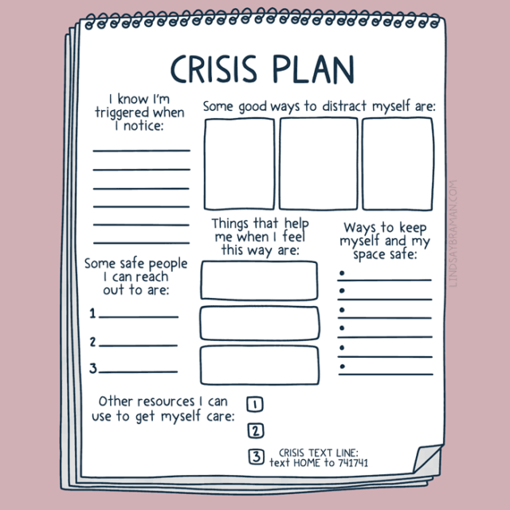

Figure 2: Identifying Early Warning Signs of Triggers
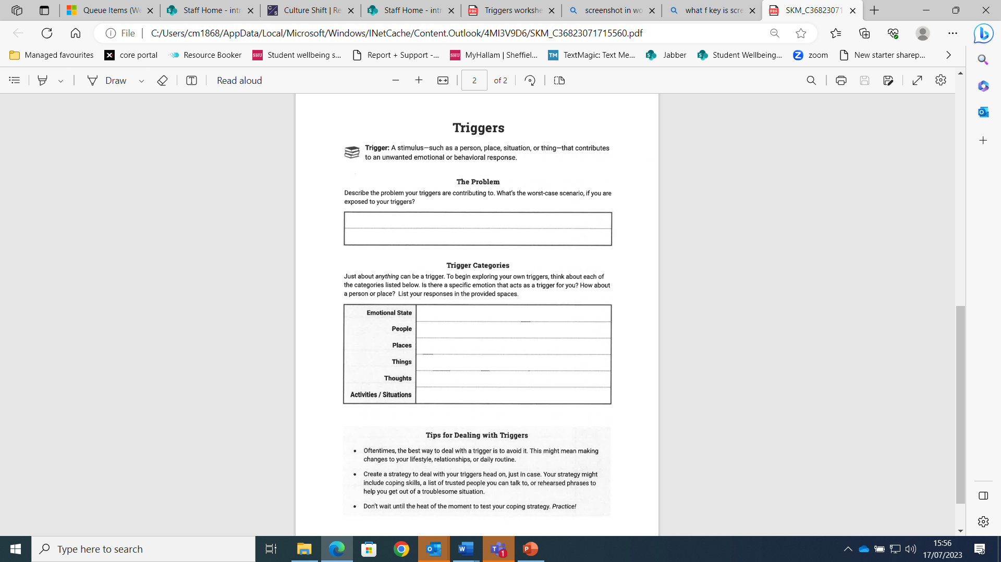

Figure 3: Triggers Safety Plan Example 2
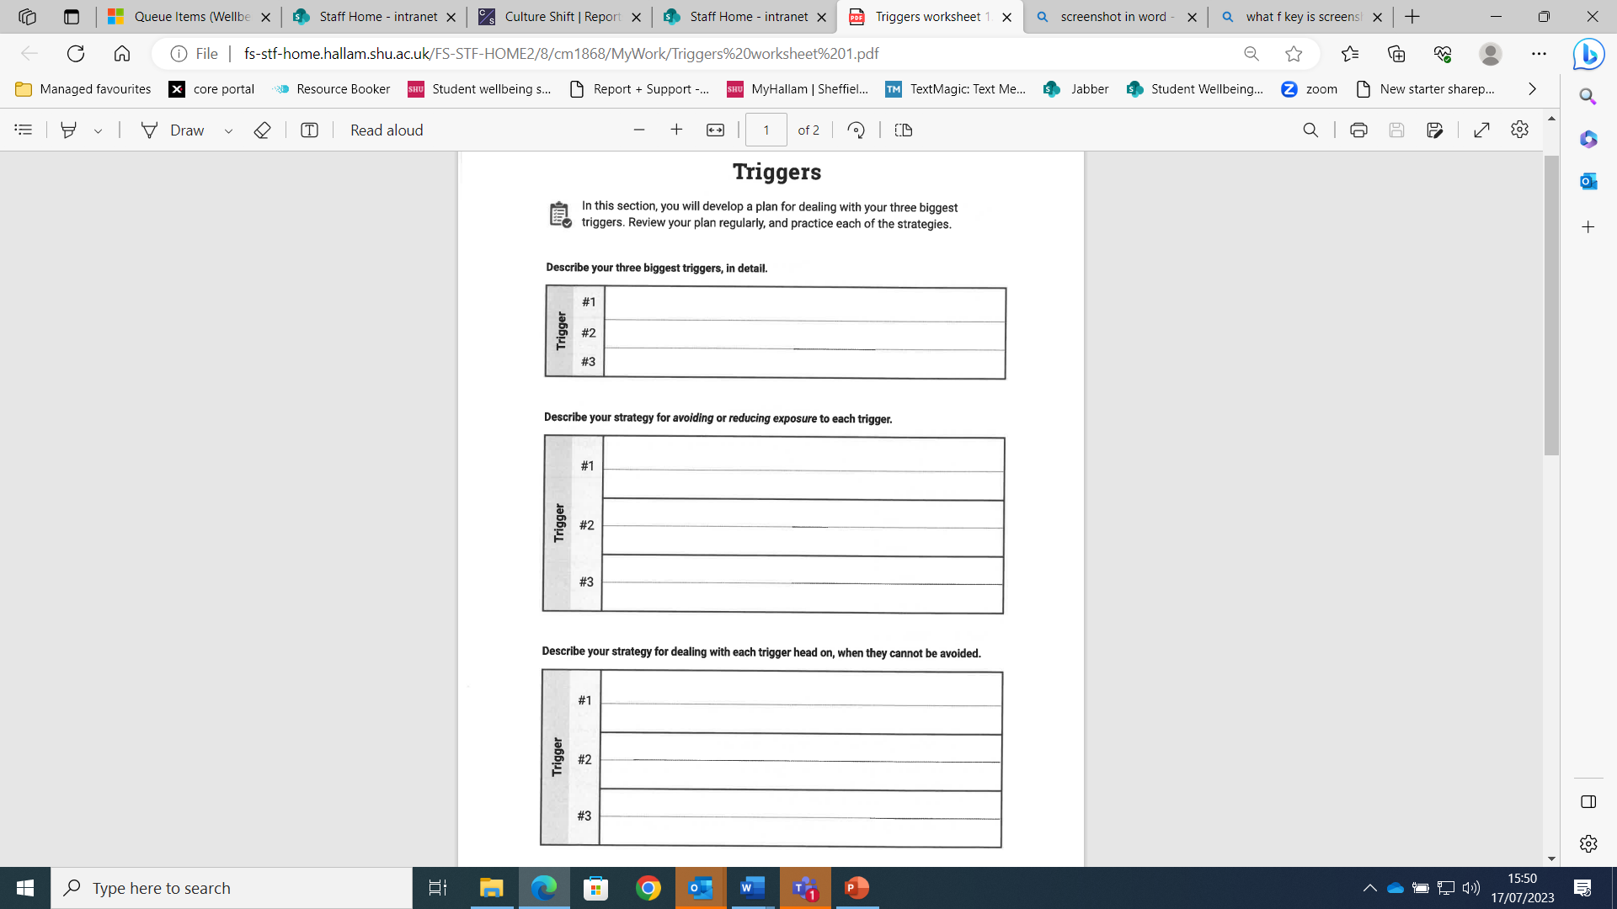

Flashbacks

What Are Flashbacks?
Flashbacks usually happen suddenly, without warning. They are vivid memories of a traumatic event that feel like they are happening now. You may re-experience what you saw, heard, smelt, felt and your body's reactions, such as a fast heartbeat. They can last from seconds to hours.

What Do Flashbacks Feel Like?
Flashbacks feel different for different people. They can happen at any time, even when we're feeling happy. They can be very scary and distressing as you re-experience your trauma and it can feel like it's really happening. You may see what happened as single images or like a film, hear sounds or words, or feel as though you're being touched. You might be able to smell or taste something linked to your trauma and your body might react the same way by your heart beating fast or sweating.
Flashbacks can make you feel vulnerable, anxious and scared. They can leave you feeling isolated and not wanting to talk to anyone. You might experience intense feelings of anger, shame or numbness.

Why Do We Have Flashbacks?
Current theories are that flashbacks happen because our brains tend to store information about traumatic events in a different place to normal information. It is as if they have filed away trauma in a cabinet marked ‘here be monsters’. Our brains can refuse to take us to the trauma cabinet when we want to go there, when we are trying to deal with them. Then our brains will open the cabinet and let out information as flashbacks when we do not want them.
Normally, information about what has happened to us in the past is stored so that when we remember it, we are aware that it happened in the past, not now. Because trauma information is stored differently, we do not have that sense of the past when we recall it.
You have a flashback when your brain has recognised similarities between your current situation and your experience of trauma. Your fight or flight response is triggered, and your body reacts instinctively and causes the same reactions that kept you alive during the last time your life was in danger. This theory suggests flashbacks are an attempt to get you to repeat your previous life-saving behaviour.

Managing Flashbacks
- Tell yourself you are having a flashback. You are not losing control. Flashbacks are a temporary and natural reaction to surviving trauma.
- ‘Ground’ yourself in NOW. Look around and note what is happening. What can you see and hear? Tell yourself your name and the date and time. You could keep an elastic band on your wrist and ‘ping it’ to bring yourself back to the here and now. Or you could carry a pebble, a hankie or keyring in your pocket which you can hold or rub when you have a flashback.
- During the flashback, let part of yourself stay in the present, whilst allowing yourself to remember the past. Take long deep breaths and focus on your breathing as the memory emerges. Breathe in deeply, in for a count of 5 and out for a count of 5. Put your hand on your tummy and watch it rise and fall as you breathe.
- If you can, try not to fight the flashback. This may be very difficult but if you try to distract yourself or ignore the memories, they may become stronger as they try to emerge.
- If you can speak with your partner (if you have one) about your experience of sexual violence, you may be able to explain to them about flashbacks and agree in advance what you wish to happen if a flashback happens during intimacy. If you experience a flashback during sex, your partner may be able to help ground you, saying your name and letting you know you are safe. It is OK to take time out from the sexual side of your relationship to work through these memories. Your partner should respect your choice and support you. If you are unable to disclose your experience of sexual violence to your partner, perhaps it would still be possible to talk about what you are or are not comfortable with sexually.
- If you have a flashback when you are out and about, try to get yourself to somewhere that you feel safe. If you cannot go to a safe place, try to focus on your breathing: taking long slow breaths will help. Remind yourself that you are not being hurt now; that it is in the past. You can also try to visualise a safe place, it can be an actual place or something that you imagine and that brings you comfort.
- Process your flashback. If you feel up to it, you can write about your flashback or talk to a friend. This can help get it out of your mind. Keep a list of people you can contact.
It may help in the short-term to avoid things which you know can trigger your flashbacks (although you cannot control when they occur). But be careful about this, as it can lead to you limiting yourself. This can get in the way of living the life you want and deserve. With support, many survivors find that they can predict their flashbacks and their effect. Often, talking about the flashbacks, and more generally about your experience of trauma, can help.
Flashbacks can be very tiring. It may take hours or even days before you feel OK again. After a flashback, take time for yourself. Try to do something that makes you feel good such as having a relaxing bath or listening to your favourite music.

Nightmares

What Are Nightmares?
The trauma of sexual violence may lead to nightmares. These are more than simply ‘bad dreams’. You may feel that the attack or an aspect of the abuse is really happening to you in your sleep. If you experience nightmares regularly, it is likely that you will be apprehensive about sleeping. Try to remind yourself that nightmares are an effect of the abuse you experienced. It is possible to develop ways of reducing the nightmares and of coping with the after-effects. It can be helpful to try to understand the nightmares as part of your recovery. Your brain is recalling images or sensations which it needs to process before moving on.
Nightmares may be an intense expression of the body working through traumatic experiences, so intense that the nightmare causes the sleeper to wake up. Nightmares may also represent a breakdown in the body’s ability to process trauma.
Long-term, repetitive nightmares are linked to difficulties in reducing the brain’s fear response combined with chronic hyperarousal. The fight-flight-freeze response can remain activated long after a traumatic experience has ended.
Many neuroscientists and psychologists believe that dreams help to integrate our experiences into long-term memory, a process called memory consolidation. When our experiences are traumatic, dreams may reflect the body’s attempt to cope and learn from these situations.

Managing Nightmares
Remind yourself that nightmares are not real. They are very distressing but they are a memory of what happened; they are not happening now.
Keep a diary of when you have nightmares to see if there are any patterns. Do your nightmares have the same images or content? Talking to someone about these can help take the image or event out of your head. This may help you feel more in control. If you can see patterns to your nightmares, you may be able to develop ways of changing or coping with these.
When you wake from a nightmare try to ‘ground’ yourself in the present. There are many ways to do this.
- Remind yourself that the nightmare is not real, but that it is natural to feel fear and stress. Notice your environment and try to establish a routine that you find soothing and can rely on if you have a nightmare, either through the night or in the morning. Some people find it helpful to practise relaxation techniques, to have a warm drink, listen to music, to write down their feelings, read, have a bath, call a helpline or speak to someone they trust.
- Practise relaxation techniques, deep breathing, yoga or anything that helps you reduce stress and anxiety.
- Develop a safe place image – a place in your mind which makes you feel safe or comfortable. Imagine the feelings, the sounds, the temperature and the sights. It could be real or from your imagination. Practise visiting this safe space when you are feeling good, so when you need it, you can go there.
You can try The Dream Completion Technique by Justin Havens to overcome nightmares. This technique has been used with many survivors of PTSD and has proved a successful way of overcoming nightmares. If it doesn’t work first time, keep trying: Learn how to stop PTSD nightmares with Dr Justin Havens (extended self-help version) – YouTube

Improving Sleep Habits
Try not to go to bed until you feel tired. It can help to avoid taking naps during the day and to take regular exercise (not within 4 hours of going to bed).
Check your sleeping arrangements. Think about comfort, temperature, light and noise levels. If you have something special which you find comforting – a pillow, a teddy or a photograph – take this to bed with you or have it close by in case you need it.
Learn to de-stress before bed, for example, by having a warm bath and a milky drink. Try to eat early - well before you go to bed - and avoid rich, spicy or sugar-rich foods, red meat and cheese.
If you self-medicate with alcohol or drugs - prescribed or illegal - it may feel as if they help in the short-term but over time they can become problematic. It may be helpful to seek medical advice or to find other ways of coping. Even moderate drinking and smoking can affect your quality of sleep.
Other things that can help to build into your routine are:
- Trying to get rid of difficult thoughts by writing them down or drawing images which play on your mind
- Trying to interrupt unwanted thoughts with activities or positive thoughts about a person or place
- Practice a relaxation technique before you go to bed. Breathe in deeply, in for a count of 5 and out for a count of 5. Put your hand on your tummy and watch this rise and fall as you breathe. Consciously tense and relax your muscles in turn: start with your toes and work up.
- Mindfulness is a technique that helps you to focus on the present moment - your breathing, your thoughts and feelings. Mindfulness helps you to observe your thoughts and feelings without judging yourself and to become more aware of any changes in how you see or feel about yourself. Mindfulness can help to relax you before sleeping or if you wake up from a nightmare.
- Try complementary remedies. Yoga, meditation, homeopathy or herbal remedies, such as lavender, may help.
- Don’t try to force sleep - it will only make you feel more anxious. Try keeping your eyes open instead and, as they start to close, tell yourself to resist. The more you try to stay awake, the sleepier you’ll become.
- Do not stay in bed. If you cannot sleep, get up after 20 minutes and go through your relaxation routine again.

Grounding Techniques
Grounding techniques help control the symptoms of triggers by turning attention away from thoughts, memories or worries, and refocusing on the present moment. They work by ridding your body of excessive energy, calming and slowing down emotions you are feeling and calming your mind, to allow you to connect back with yourself in the present. Grounding techniques are very personal, so you may find some work better than others. They become easier with practice.
They can be broken down into the following 3 areas. You may find you are drawn to a certain type of technique.
- Mental - To help you refocus your thoughts.
- Physical - To help you feel physically grounded and connected to your body.
- Soothing - To help you feel calm, safe and relaxed.

Mental Techniques
5-4-3-2-1 - This technique helps you to focus your attention on the present:
- Name 5 things you can see
- Name 4 things you can feel (“my feet on the floor”)
- Name 3 things you can hear (“traffic outside”, “birds singing”)
- Name 2 things you can smell
- Name 1 thing you can taste
Alphabet game - Pick a category (e.g. food) and think of an item for every letter in the alphabet (e.g. apple, banana, crisps… etc).
Concentrate on a mental task - Complete a tricky mental task or calculation. For example:
- Go through your times tables (3 x 2 is…, 3 x 3 is…)
- Say the alphabet backwards
- Do some challenging sums (19 x 21 = …)
Imagery - Visualise something that stops you from focusing on your unwanted thoughts or feelings. For example, you could imagine:
- A big STOP sign
- Changing the ‘TV channel’
- ‘Turning down the dial’ on your emotions
Use an anchoring phrase - Describe who you are, how old you are, the date today, the time, where you are now. For example:
- “My name is Emma, I am 20 years old. Today is Monday 23rd March, it’s 10am, I’m sitting at my kitchen table.”
- You can keep adding details until you feel better. “My tea is warm. I can hear the breeze outside. It’s my day off today.”
Imagine yourself leaving the painful feelings behind - Visualise:
- Gathering the emotions, balling them up and putting them into a box
- Walking, swimming, biking or jogging away from painful feelings
- Your thoughts as a song or TV show you dislike, changing the channel or turning down the volume - they’re still there, but you don’t have to listen to them

Physical Techniques
Breathe - Pay attention to your breath. Inhale through your nose and out through your mouth. Place your hands on your tummy. Watch as your hands move up and down as you breathe. Box Breathing Technique - YouTube
Touch a grounding object - Try carrying a small object in your pocket wherever you go, for example, a small stone. Touch or grip this when you feel overwhelmed or triggered.
Dig your heels in - Concentrate on putting your weight into your heels. Remind yourself that you are physically connected to the ground. Stamp your feet if that helps. You could try it barefoot on a soft carpet or rug.
Tense and release - Try clenching and releasing your fists. You can also tense up your entire body and focus on slowly releasing it, from the forehead, jaw, shoulders right down to your toes.
Touch or grip objects - Touch or grip different objects around you. Think about how they feel. Or try gripping onto your chair as hard as you can.
Wiggle and stretch - Stretch your arms and legs. Try wiggling your fingers or toes.
Savor a food or drink - Take small bites or sips of a food or beverage you enjoy, letting yourself fully taste each bite or sip. Think about how it tastes and smells, and the flavours that linger on your tongue.
Take a short walk - Concentrate on your steps - you can even count them. Notice the rhythm of your footsteps and how it feels to put your foot on the ground and then lift it again.
Put your hands in water - Focus on the water’s temperature and how it feels on your fingertips, palms and the backs of your hands. Does it feel the same in each part of your hand? Use warm water first, then cold. Next, try cold water first, then warm. Does it feel different to switch from cold to warm water versus warm to cold?

Soothing Techniques
Happy place - Think about a place where you can relax, feel safe and be happy. It can be real or imagined. This could be a tropical beach, a cosy room with a log fire, high up on a mountain overlooking the world.
List positive things - Write or mentally list four or five things in your life that bring you joy, visualising each of them briefly.
List favourites - List three favourite things in several different categories, such as: foods, trees, songs, films, books, places.
Plan a treat - Think about a soothing, relaxing treat for later, for example, a bubble bath, a nap under your favourite blanket or nice meal.
Coping statements - Repeat coping statements to yourself or write them down. For example, “I am strong”, “I have done this before”, “This too shall pass”.
Safety statements - Repeat safety statements to yourself or write them down. For example, “I am safe now”.
Self-kindness - Repeat kind, compassionate and encouraging statements to yourself or write them down. For example, “I matter”, “I am having a tough time but I will get through this”, “I am trying hard and doing really well”.
Picture the voice or face of someone you love - Visualise someone positive in your life. Imagine their face or think of what their voice sounds like. Imagine them telling you that the moment is tough but that you’ll get through it.

