Harassment, Sexual Misconduct

and Hate Crime Programme

Annual Report 2024-25

Contents
1. Report Headlines 2
2. Introduction 2
3. Reporting to Report and Support 4
4. Institutional Data and Insights 6
5. What Happened After Reports Were Made 18
6. Student Feedback 22
7. Work Towards Meeting the OfS E6 Regulations 23
8. OfS Sexual Misconduct Survey Results 28
9. Let Us Know What You Think 30

1. Report Headlines
- A total of 415 reports were submitted to Report and Support, a slight decrease from 418 in the previous year.
- 75% of reporters provided personal details rather than reporting anonymously.
- Most reports were submitted by students reporting on their own behalf and by staff reporting on behalf of students.
- The majority of reported parties were Sheffield Hallam University students.
- Bullying and harassment accounted for 44% of all reports, making it the most common incident type.
- 20% of incidents involved a suspected hate-based motivating factor.
- Most incidents occurred off-campus, followed by on-campus locations, with a smaller proportion occurring online.
- 22% of all reports progressed to a formal complaint.
- 47% of student harassment, bullying or discrimination cases resulted in no further action following investigation.
- 25% of staff harassment, bullying or discrimination cases had sanctions applied.
- 100% of student feedback survey respondents said that reporting was easy, responses were timely and support was helpful.
- Mandatory student training was scheduled to commence during enrolment for the 2025-26 academic year, following previously optional training with limited uptake.
- 63% of staff completed the mandatory harassment and sexual-misconduct training.

2. Introduction

2.1 Strategic Context
Sheffield Hallam University aims to create an environment that is free from harassment, violence, hate and discrimination of any kind, with effective policies and processes, a clear system for incidents to be reported and a range of specialist support available.
In 2018 the University's Report and Support service was launched as part of the Student Wellbeing Service, providing an online platform for students, staff and visitors to find out information about sexual misconduct, bullying, harassment, discrimination or hate, and to make a disclosure. Since 2021 our Harassment, Sexual Misconduct and Hate Crime (HSMHC) Programme has been the strategic lead on tackling issues in this area.

2.2 Focus for 2024-25
The focus for 2024-25 was enhancing our existing provision to ensure compliance with regulatory expectations in the Office for Students' Condition E6: Harassment and Sexual Misconduct, which came into force on 1 August 2025. An E6 Project Group was established as a strategic initiative with key aims to deliver:
- Comprehensive student and staff training
- Updated policies and procedures
- Enhanced support services
- A single source of information (SSI) platform
- A 12-month evaluation strategy

2.3 Purpose of the Report
This is our fourth annual report, which aims to:
- Provide assurance to service users and stakeholders that we actively consider and respond to the issues reported to us
- Strengthen confidence in our reporting processes
- Offer insight and evaluation to support the development of good practice
- Supply governance groups and colleagues with information that enables ongoing process and service improvements
- Demonstrate compliance with the Office for Students' Condition E6: Harassment and Sexual Misconduct

2.4 Approach to the Data
In this report we have chosen to focus on high-level institutional trends to provide a comprehensive overview. University staff are able to request more detailed data by emailing reportandsupport@shu.ac.uk. The data presented covers the reporting period 1 August 2024 to 31 July 2025 and is mostly drawn from Report and Support, our main reporting platform, which includes both anonymous reports and those for which personal details were provided.
Terminology in the data insights corresponds to that used on the Report and Support reporting form. Data is also presented from other reporting pathways, such as the Student Policy, Casework and Compliance team, Human Resources and Organisational Development directorate, and our training and survey platforms.
Duplicate and spam reports have been removed. To avoid possible identification of individuals where the number is 0-5, data has been presented as '5 or fewer' or categories have been grouped. Percentages quoted in the text are generally rounded up or down to aid reading. For charts where more than one option could be selected on the report form, percentages are not displayed. Equality monitoring data is compared with the University's HESA Standard Registration population.
Throughout the report, we refer to individuals as the ‘reporting party’ or ‘reporter’ and the ‘reported party’.
A downloadable version of this report is also available.

3. Reporting to Report and Support

3.1 Pathways to Reporting
The University’s Report and Support website provides a single, publicly accessible source of information on harassment, sexual misconduct and hate crime. The majority of reports relating to harassment, sexual misconduct, domestic abuse or hate incidents are submitted through this system. A smaller number of complaints involving students are made directly to the Student Policy, Casework and Compliance team.

3.2 How Report and Support Works
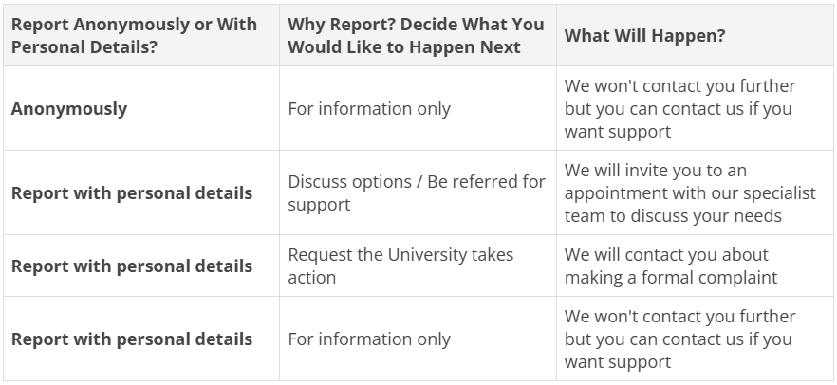
Table 1: Summary of the Report and Support Reporting Process.

3.3 How Reports Are Managed
We are committed to ensuring that anyone making a disclosure or complaint is treated with dignity and respect. All reports received are reviewed and, where appropriate, investigated. When necessary, we work in partnership with relevant external organisations, which may include the Police, Sheffield City Council, the University of Sheffield or specialist support services.
Further information on how reports are handled can be found in the Reporting section of our Report and Support website. Guidance is also available for individuals who have been accused of an incident.
Staff who report an incident about themselves through the service will be offered an initial support call. Following this, they may be directed to further sources of help, which could include their line manager, Human Resources and Organisational Development or the Employee Assistance Programme (an external support service available to University staff).

4. Institutional Data and Insights

4.1 Who Reported What

Total Number of Reports
During 2024-25 the University had around 33,650 students enrolled and 4,300 staff. Chart 1 shows that the Report and Support service received a total of 415 reports during the year, a slight decrease from the 418 reports submitted in 2023-24.
Although reporting increased consistently from 2018-19 to 2023-24, the rate of growth had slowed in recent years and 2024-25 marks the first annual decrease. Reporting levels were highest in October, November and May.

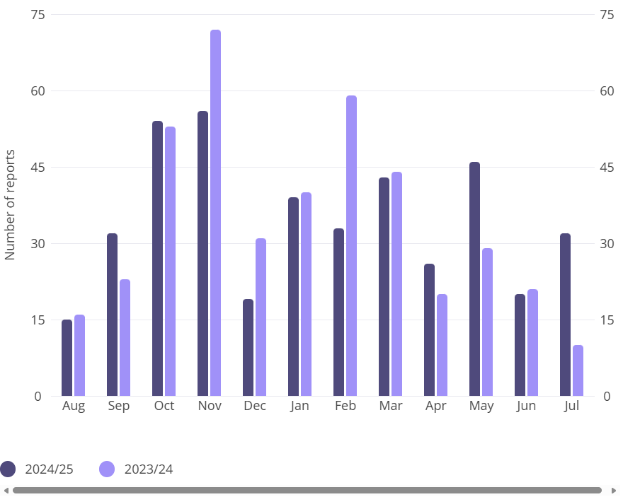
Chart 1: The number of reports received by month for 2024-25 compared with 2023-24.

Anonymous Versus Named Reports
Chart 2 shows that most individuals chose to provide their personal details when submitting a report. This continues a four-year trend in which around 75% of reports have included personal details.
Providing personal details enables us to respond directly to the reporting party and offer appropriate support. The sustained proportion of named reports also indicates a continuing level of trust in the Report and Support service, while recognising that reporting anonymously remains an important option for some individuals.
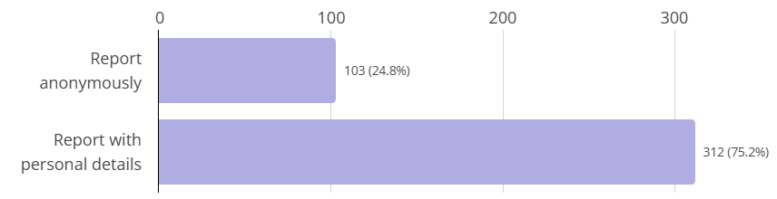
Chart 2: The number of anonymous reports compared with reports made with personal details.
Table 2 highlights that, across all groups (students, staff and other), around three quarters of individuals chose to provide personal details when reporting on behalf of themselves. Students account for the highest number of reports in total.
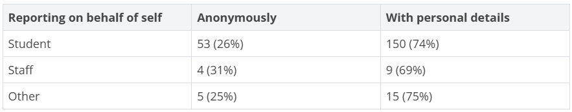
Table 2: The number of reports submitted on behalf of oneself for students and for staff.

Reasons for Reporting Anonymously
Table 3 outlines the reasons selected by those who submitted anonymous reports. (More than one reason could be chosen.) The most frequently selected reasons were concerns about possible repercussions and fears of retaliation from the reported party.
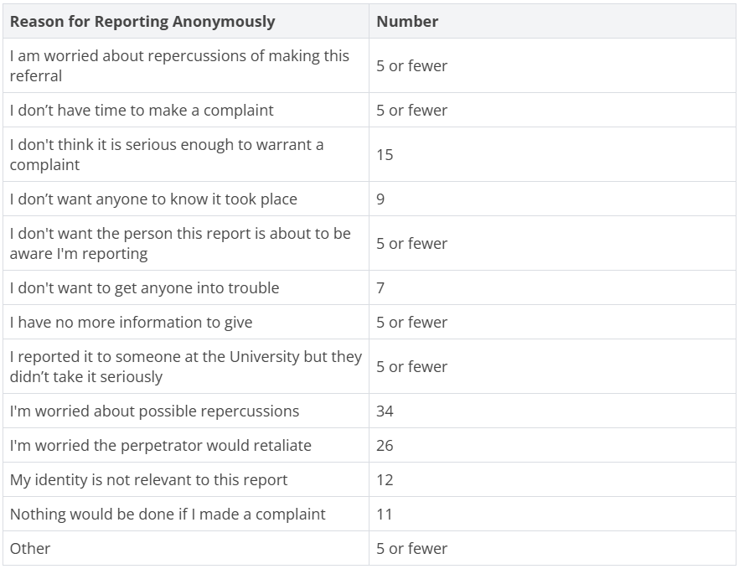
Table 3: The reasons for reporting anonymously. Please note that people can select more than one reason.

Relationship to the University
Table 4 shows whether reports were submitted by students, staff or others, and whether individuals were reporting for themselves, for someone else or as ’Other’. The ’Other’ category captures circumstances where individuals may have witnessed behaviour that did not directly affect them, such as racist graffiti, or where incidents involved multiple parties.
Students reporting on their own behalf accounted for the largest proportion of submissions (49% of all reports). By comparison, only 3% of all reports were staff reporting on their own behalf. Most staff submissions were made on behalf of students (82% of staff reports), and only 10% related to staff members reporting personal experiences. Accordingly, equality monitoring data focuses on students and compares patterns to overall student demographics.

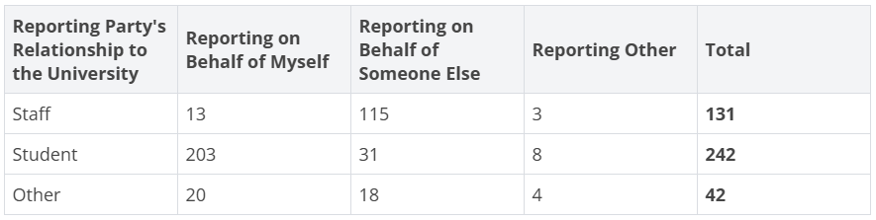
Table 4: The reporting party's relationship to the University and whether they are reporting on behalf of themselves, on behalf of someone else or something different.

4.2 Characteristics of Reporting Parties
Equality monitoring data helps the University identify areas where further awareness-raising or support may be needed. Submission of this information is optional; around 90% of reporting parties chose to provide at least some equality data. The following tables relate to the individual who experienced the incident, regardless of whether they reported directly or someone else reported on their behalf.
As Table 4 shows, the majority of reports were submitted by students or on behalf of students. Equality data therefore focuses on student reporters and is compared with University demographic data, using the HESA Standard Registration population.

Gender
Reporters have the option to describe their gender. Table 5 shows that 61% of reports related to female students, compared with 20% relating to male students. The proportion of reports from females is consistent with their making up 56% of the total student population, whereas males made up 43%, so are underrepresented.
The reporting form also asks whether the person’s gender matches the sex they were assigned at birth. 15 students indicated that their gender did not match their assigned sex at birth, representing 4.6% of student-related reports. This is more than three times the 1.3% recorded in the University student population.
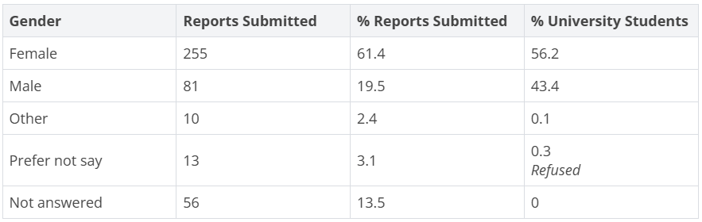
Table 5: The number of reports by gender compared to University demographics.

Age
Table 6 compares the age of reporting parties with data from the University population and shows that 43% of reports were submitted by or on behalf of students aged 18–21.
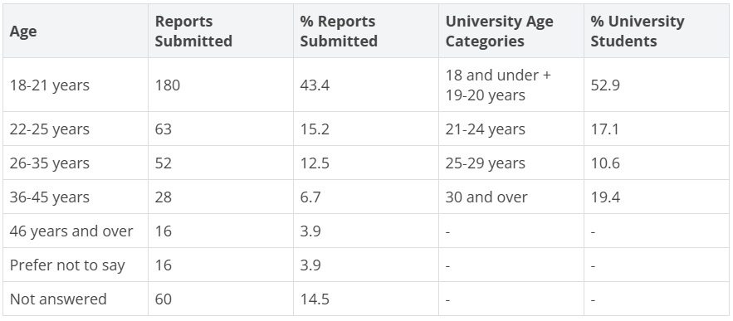
Table 6: The number of reports by age compared to University demographics.

Sexual Orientation
Table 7 compares the sexual orientation of reporting parties with data from the University population. Heterosexual students submitted the most reports but at a lower rate than expected given their majority in the population. Bisexual students were over-represented, reporting at nearly twice their population share, while gay and lesbian students reported broadly in line with their overall representation.
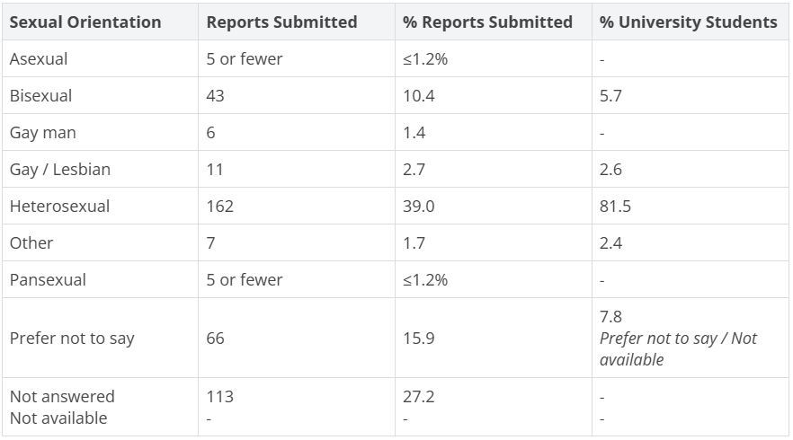
Table 7: The number of reports by sexual identity compared to HESA demographics.

Ethnicity
Table 8 compares the ethnicity of reporting parties with the University demographics. Reports from Asian students are proportionally higher, accounting for 16% of submissions compared with their 9% representation in the wider University population.
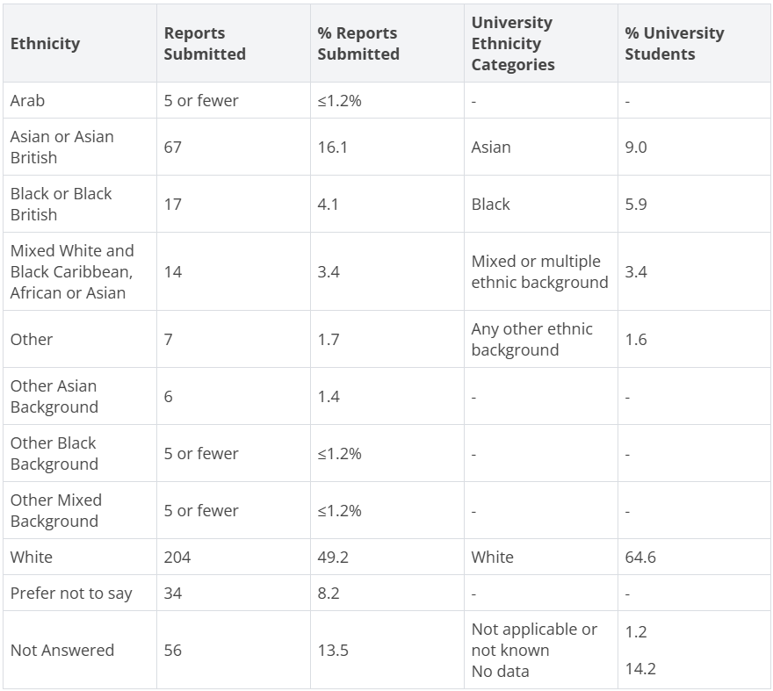
Table 8: The number of reports by ethnicity compared to University demographics.

Disability
Table 9 shows that the distribution of reports by disability status generally reflects the University’s demographic pattern, with no major over- or under-representation among students who report having a disability.
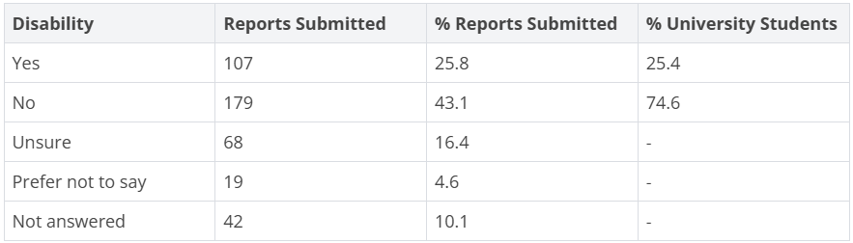
Table 9: The number of reports by declaration of disability compared to University demographics.

Religion or Belief
Table 10 compares the religion or belief of reporting parties with the University population. Students with no religion and Christian students submitted the most reports but are proportionally under-represented, while 'Prefer not to say' and Muslim students report at levels similar to their population share. Minority-faith groups appear in very small numbers, and over 23% of reports had no response to the religion question, limiting interpretation.
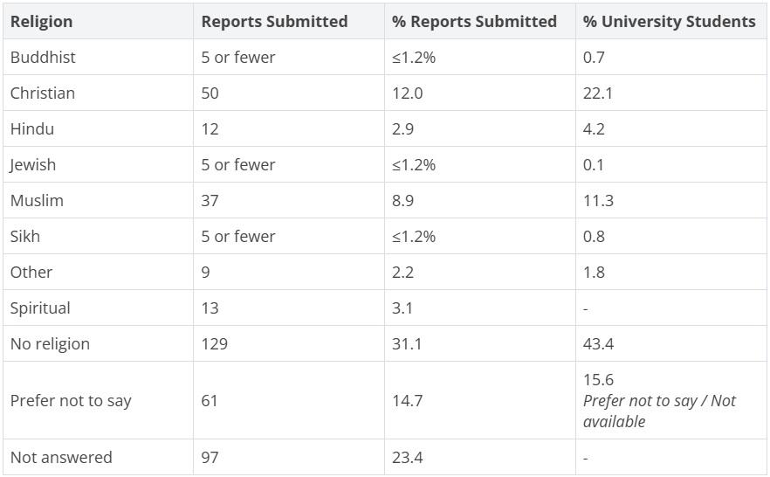
Table 10: The number of reports by religion or belief compared to HESA demographics.

4.3 Who Was Reported
The ’reported party’ is the individual alleged to have committed the behaviour described in a report. Allegations are not proven at the point of reporting, regardless of whether they concern another student, a member of staff or someone external to the University.
The University does not make assumptions about the validity of a complaint. No individual is considered to have acted improperly unless an investigation establishes this. However, preventative measures may be put in place if there are indications of ongoing risk. All parties involved are treated fairly and offered support. Where a crime is reported, the University will cooperate with police investigations.
Chart 3 summarises the reported party’s relationship to the University. The largest proportion (47%) was Sheffield Hallam students. As most reports were submitted by or on behalf of students, this reflects students reporting other students. The ’Other’ category includes cases where the relationship to the University was unclear.

Relationship to the University
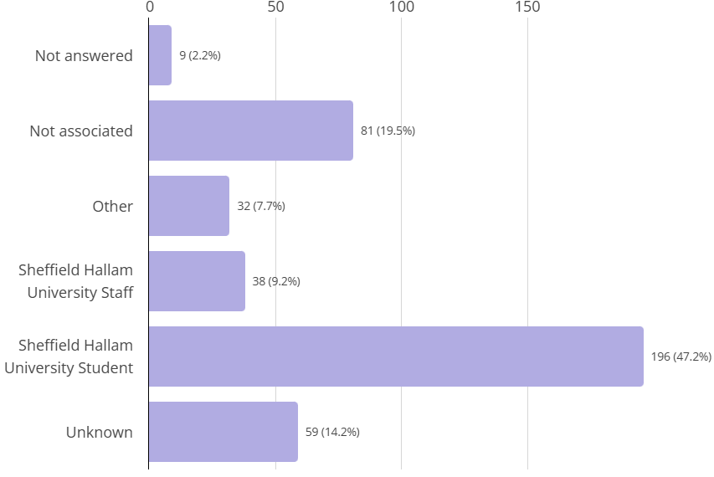
Chart 3: The reported person's relationship to the University.

4.4 What Was Reported

Incident Type
Chart 4 shows that 'Bullying / Harassment' was the most frequently reported category, included in 44% of submissions. This has remained the largest category for the past five years. Of these incidents, 61% indicated that the reported party was a Sheffield Hallam University student, 10% were University staff, 9% were others and 11% were not associated with the University.
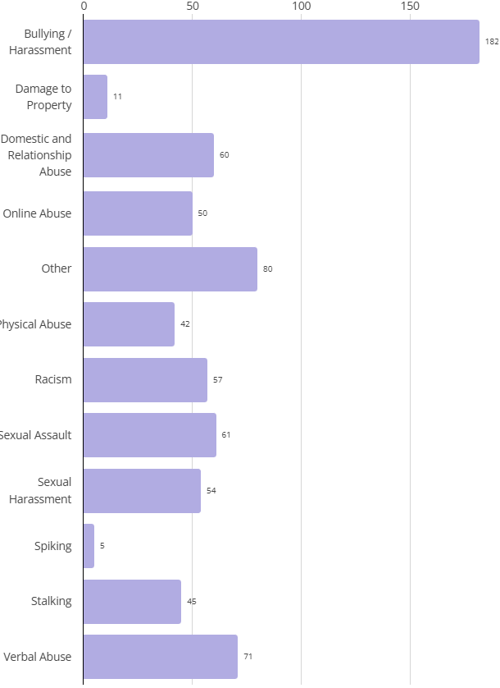
Chart 4: The number of reports by incident type. Please note that people can select more than one incident type.

Motivating Factor (Hate)
Reporters can indicate whether they believe an incident was motivated by prejudice related to a protected characteristic and Table 11 outlines the characteristics selected. Reporters could choose more than one option. In 20% of cases, the incident was perceived as motivated by hate.
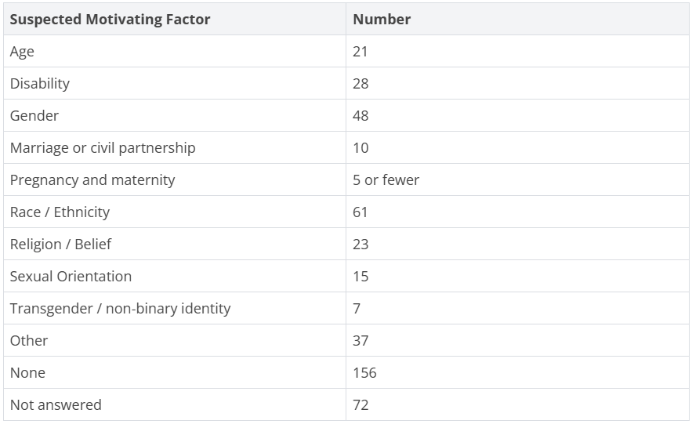
Table 11: The suspected motivating factor. Please note that people can select more than one factor.

Location
Chart 5 summarises incident locations. The largest number occurred off campus (133 reports). The second largest category was on-campus locations (93 reports), followed by online and halls of residence.
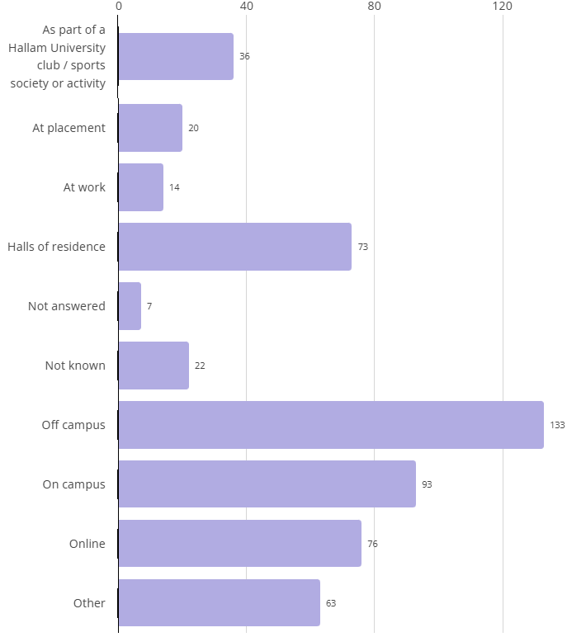
Chart 5: The location of incidents. Please note that people can select more than one location.

Departmental Insights
Chart 6 shows the reporting party’s University department. Most reports came from the Colleges, reflecting the high number of student reports and staff reports submitted on behalf of students. Some staff reporting on their own behalf were also based in a College.
When compared with student enrolments for 2024–25 (BTE 32.6%, HWLS 30.5% and SSA 36.9%), no College received a disproportionately high number of reports. However, HWLS, the smallest College, received the same number of reports as SSA, the largest. This indicates that reporting patterns do not simply reflect population size, although additional qualitative insight would be required to explain the variation.
The lower number of reports from Professional Services aligns with fewer staff reporting on their own behalf. The ’Other’ category is included because reports may also come from people outside the institution.
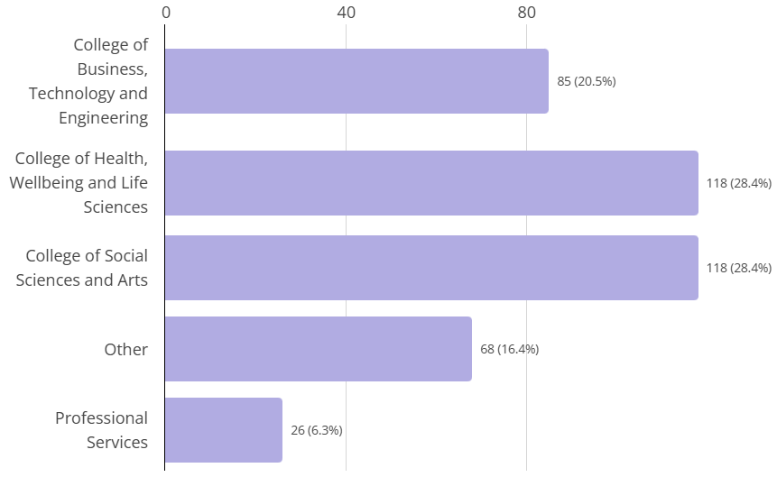
Chart 6: The reporting party's University department.

5. What Happened After Reports Were Made

5.1 Desired Outcomes from Reporters
The Report and Support form invites reporters who provide their personal details (as opposed to reporting anonymously) to indicate their desired outcome in making the report. More than one option can be selected, and it is common for individuals to request both to 'Discuss options / be referred to support services' and 'Request the University takes action'.
Table 12 summarises the outcomes selected by students, staff and others. Because reports may be submitted on behalf of another individual, the data include all reports relating to the person who experienced the incident, regardless of who made the report. Most student-related reports sought to discuss options or access support services (177 cases), while 106 requested that the University take action.
A student or staff member selecting 'Discuss options / be referred to support services' is offered an appointment with a member of the Report and Support team.
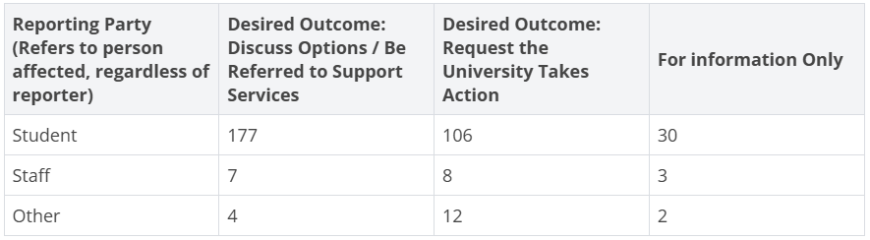
Table 12: The reporting party's relationship to the University split by their desired outcome. Please note that people can select more than one desired outcome.

5.2 Progression to Formal Complaints
Students and staff have a range of routes through which they can raise concerns about sexual misconduct, harassment, bullying or discrimination.
For students, most concerns are reported via Report and Support, although some are submitted directly to the Student Policy, Casework and Compliance team, which manages allegations of misconduct under the Student Code of Conduct.
A request for University action does not automatically result in a formal complaint. This may be due to non-engagement following initial contact, a decision not to proceed after discussing available options or a determination that the reported behaviour does not meet the threshold for a breach of the Student Code of Conduct. This is often the case in reports involving interpersonal conflict, such as difficulties between housemates.
Staff can report concerns via Report and Support or submit them in writing to their line manager or a more senior manager. Concerns are addressed in line with the Staff Code of Behaviour and the Problem Resolution Framework.
Table 13 shows the number of Report and Support cases that progressed to formal complaints in 2024-25. The 318 reports of harassment, bullying and discrimination included:
- 182 reports of 'Bullying / Harassment'
- 57 reports of 'Racism'
- 79 reports where another incident type (excluding 'Sexual Harassment' and 'Sexual Assault') was selected with a discriminatory motivating factor
Reporters may select multiple incident types in a single submission. This means that there may be some duplication in the columns for Sexual Misconduct and for Harassment, Bullying and Discrimination in the table below in terms of numbers of reports.
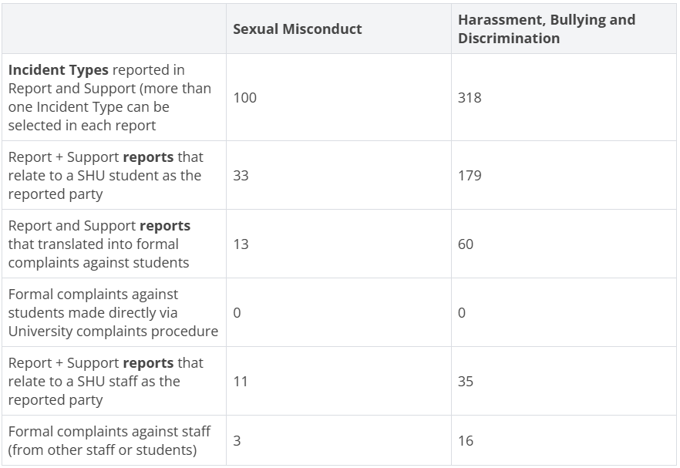
Table 13: The number of reports that progressed to a formal complaint.

5.3 Student Disciplinary Outcomes
Complaints about student behaviour which may be in breach of the Student Code of Conduct are investigated by the Student Policy, Casework and Compliance (SPCC) team in accordance with the Student Disciplinary Regulations and Procedures.
Table 14 summarises the outcomes of complaints referred to SPCC relating to sexual misconduct (sexual harassment or sexual assault) or harassment, bullying and discrimination.
47% of complaints about harassment, bullying and discrimination resulted in no further action after investigation. Generally, this was where the investigation found no evidence to support the allegation against the reported student or where the investigation found no indication of any breach of the Student Code of Conduct.
A further 13 complaints were submitted but then either withdrawn or the reporting student did not respond to contact from SPCC for further information and/or their consent to disclose their details to the reported person. In such situations, it is not possible to take the case forward, but the reporting person is informed that the case could be re-opened in the future if they wanted to pursue it later.
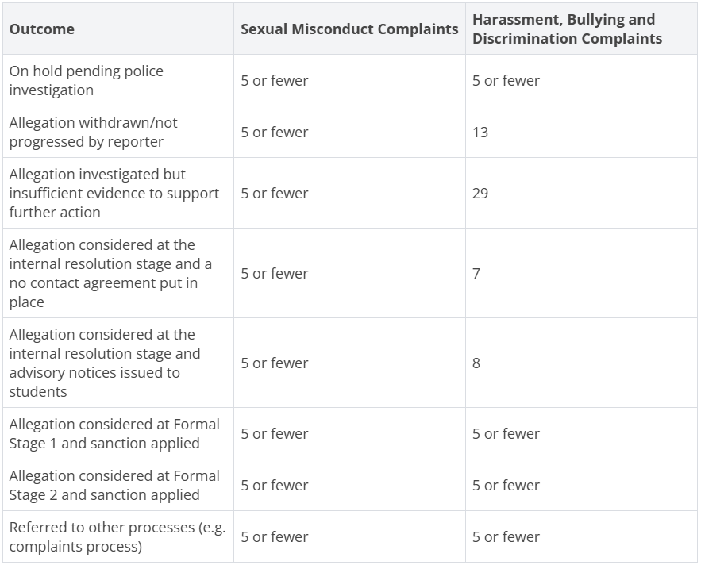
Table 14: Summary of student disciplinary outcomes.

5.4 Staff Disciplinary Outcomes
Table 15 summarises disciplinary outcomes for complaints of staff sexual misconduct (sexual harassment or sexual assault) or of harassment, bullying or discrimination by staff.

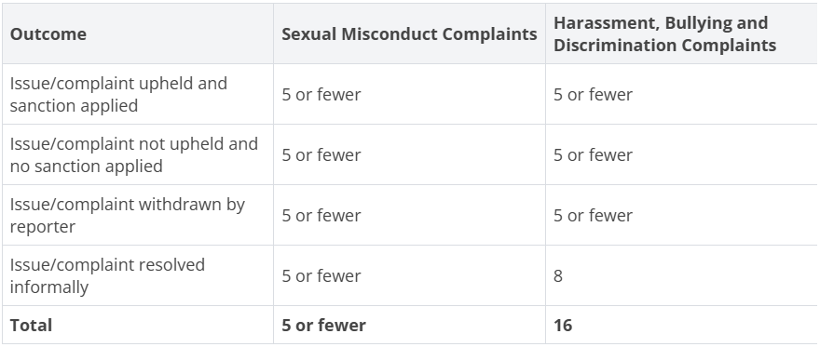
Table 15: Summary of staff disciplinary outcomes.

6. Student Feedback
Providing feedback is optional but highly valued, as it helps us develop and improve the support we offer. The Student Wellbeing service, including the Report and Support team, invites students to complete a short voluntary survey at the end of each semester.
In 2024-25, 14 students responded to the Report and Support section of the survey. Their feedback demonstrated strong confidence in the service:
- 100% found it easy to make a report
- 100% agreed they received a quick response
- 92% (12 out of 13) said their appointment met their needs
- 100% agreed the overall support was helpful

6.1 What Students Valued Most
Students particularly appreciated:
- Clear guidance and time to talk through their experiences
- Referrals to appropriate specialist teams
- Staff liaising with other services on their behalf
- A safe and confidential space to speak
- Being listened to with empathy and without judgement
- Practical coping strategies, including anxiety management
- Friendly, supportive staff throughout the process

6.2 What Students Wanted Others to Know
When asked what advice they would give to someone in a similar situation, students shared a consistent message: 'Reach out early and don’t try to manage things alone'. In their own words:
- "Don't wait to reach out, it's worth the support."
- "Get in contact to see what arrangements and help can be made instead of feeling anxious and alone."
- "Get support as soon as you can - you may not feel that you 100% need it but it can be more useful than you first realise."
- "Ask for help if you need - there is nothing wrong in seeking help."
- "Please ask for help and take as much help as you can get. They are really supportive"
- "Please speak to someone. You do not have to deal with it on your own."
- "Report and support gave me a safe and confidential space to talk ... Support was given regarding assignment deadlines and referring me to appropriate teams to provide further support."
- "Report it, even if it doesn't feel a big deal, you can get support."
- "Report it, even if nothing happens after the situation."

6.3 Suggestions for Improvement
Students also offered ideas to help us continue developing the service. Themes included:
- Increasing awareness and visibility of the service
- Offering more in-person appointments
- Providing additional follow-up appointments where needed

7. Work Towards Meeting the OfS E6 Regulations
On 1 August 2025, the Office for Students (OfS) introduced new regulatory requirements for higher education providers to prevent and address harassment and sexual misconduct. These include maintaining a single, comprehensive source of information on policies, procedures and support.
Sheffield Hallam has taken the following steps to meet these requirements:

7.1 Governance
The Harassment, Sexual Misconduct and Hate Crime (HSMHC) Steering Group oversees our institutional approach. It reports to the Safeguarding Delivery Group and the University Safeguarding Board, with oversight from the University Executive Board and the Board of Governors.
From 2025-26, the Safeguarding Delivery Group will retain strategic oversight of the HSMHC Programme.

7.2 Policies
The University’s Student Conduct Regulations and Procedures set out how concerns about student behaviour are reported and addressed. The Student Anti-Harassment Policy and Procedure forms part of this framework.
Previous versions of policies and summaries of changes are clearly accessible on a dedicated page.
Staff policies include:
- Prevention of Bullying, Discrimination, Harassment and Victimisation
- Prevention of Sexual Harassment and Sexual Misconduct
- Staff and Students Personal Relationships Policy
The University does not use non-disclosure agreements (NDAs) in cases involving harassment or sexual misconduct, recognising their potential to silence individuals and hinder institutional learning.

7.3 Freedom of Speech
All anti-harassment policies are managed in line with legal duties to uphold freedom of speech and academic freedom within the law.

7.4 Visible and Accessible Website
The University’s Report and Support website provides a single, easily accessible source of information on harassment, sexual misconduct and hate crime. It is:
- Publicly available without login
- Linked from all external University webpages
- Linked from the MyHallam (student website) homepage
Content is clear, comprehensive and includes:
- Definitions and examples of unacceptable behaviours
- Reporting mechanisms
- Support services
- Policy and procedure links
- Training resources
Signposting to Report and Support is included in the student enrolment declaration, ensuring early awareness.

7.5 Definitions
Clear definitions of harassment and sexual misconduct are published on the Report and Support website, referencing relevant legislation including the Equality Act 2010, Sexual Offences Act 2003 and Protection from Harassment Act 1997. This includes online harassment and sexual misconduct, which is covered in our policies.

7.6 Communication and Awareness
Report and Support is highlighted in our online prospectus, Student Handbook and as part of student enrolment each year. It is promoted throughout the year at key times, such as during welcome week training and induction.
In 2024-25, staff engaged students through campus activities linked to national awareness campaigns, including:
- National Hate Crime Awareness Week
- 16 days of Activism Against Gender-based Violence
- Sexual Abuse and Sexual Violence Awareness Week
We continued to offer trauma-informed support sessions to staff and included trauma-informed practice in the new staff mandatory training module.

7.7 Student and Staff Training

Student Training
During 2024-25 our existing student training modules on Being an Active Bystander and Consent were still available but not mandatory. A new mandatory module, Understanding Harassment and Sexual Misconduct, was co-designed with students and reviewed by a broad stakeholder group. It includes:
- Definitions and scenarios
- University policies and expectations
- How to report incidents and access support
- Interactive learning
The module will be launched on Blackboard for all new students in August 2025. It will be rolled out through our welcome and course induction programmes, ensuring all new students are signposted on multiple occasions to complete the module. An opt-out option will be offered.

Staff Training
Mandatory online training for staff, Preventing and Addressing Harassment and Sexual Misconduct, was developed in-house and covers:
- Definitions and examples
- Legal and regulatory responsibilities under OfS E6
- Responding to disclosures
- Reporting and escalation routes
- Bystander intervention and prevention strategies
By July 2025, 63% of staff (2,761 individuals) had completed the training.
Additional specialist in-person training is being rolled out in three phases. An opt-out option is offered for both the online and in-person training.
Staff are also asked to complete the 'Sexual Harassment in the Workplace - Worker Protection Act' online training, which is not mandatory.

7.8 Reporting and Handling of Information
Students and staff can report incidents online, with or without personal details. Information is held confidentially and shared only on a strictly need-to-know basis, unless there is a risk to someone’s safety.

7.9 Support
The dedicated Report and Support team provides specialist support to any student making a report with their details. This support extends to anyone who discloses an experience, whether or not it meets the criteria for a formal report, and is offered throughout their time at Hallam. Support is also available to individuals who have been accused.
Staff reporting an incident about themselves are offered an initial support call and signposted to further help.

7.10 Fair Investigations
Specialist staff are assigned to investigate and adjudicate in cases of harassment or sexual misconduct by students. Processes adhere to the principles of natural justice, ensuring issues are resolved in an atmosphere of trust, openness and fairness, with proportionate and reasonable outcomes. This includes:
- Informing reported students of the allegation and identity of the reporter
- Impartial investigators with no prior involvement
- Strict confidentiality
- Clear rights of appeal for reported students

7.11 Sharing Outcomes
We recognise the importance of keeping reporting parties informed while at the same time complying with data protection and regulatory requirements.
Judgements made during investigations do not constitute legal determinations on whether or not criminal activity has taken place.

7.12 Data and Evaluation Strategy
A comprehensive 12-month evaluation strategy underpins the implementation of OfS E6. The strategy uses a blend of methodologies to assess how interventions across policy, training, support and communications contribute to improved student safety, awareness and confidence in our processes. Methods include:
- Pre- and post-training surveys
- Student listening rooms
- Engagement and completion monitoring

Early Findings from Staff Training
Early evaluation of the staff online staff training module Understanding Harassment and Sexual Misconduct shows:
- Increased staff confidence
- 85% rating the training ‘Good’ or ‘Very good’
- 98% agreeing the content is essential for all staff
Feedback from the in-person workshops also highlighted strong engagement and practical value.

Ongoing Learning and Improvement
Insights from training will inform future improvements, and student feedback on the new training module will be reviewed in 2025-26.
In addition, the Harassment, Sexual Misconduct and Hate Crime annual report supports transparency, accountability and continuous improvement.

8. OfS Sexual Misconduct Survey Results

8.1 Survey Overview
This section presents selected findings from the Office for Students (OfS) Sexual Misconduct Survey 2025 and compares the responses of Sheffield Hallam University students with the national picture.
The survey was conducted in January 2025 and issued nationally to final year undergraduate students as a follow-on to the National Student Survey (NSS). Around 50,000 students across England responded, including approximately 450 students from Sheffield Hallam University. This represents a sector-wide response rate of around 12%, compared with under 10% at Hallam.
The University has been provided with a limited dataset summarising responses from our students. This data is disaggregated by gender only and does not include other student characteristics that are available in the national dataset. As a result, comparisons with the wider sector should be interpreted with appropriate caution.
Overall, the results suggest that the experiences reported by Hallam students broadly mirror those seen across the higher education sector, particularly when differences in sample size are taken into account.
The full OfS analysis of the sector-wide results is available on the OfS website. The OfS plans to run a further sexual misconduct survey linked to the NSS in 2027.

8.2 Summary of Responses

Sexual Harassment
Finding 1 – 29% of students at Sheffield Hallam had experienced at least one form of unwanted behaviours of a sexual nature since being a student. Across the sector as a whole, this stood at 25%.
The most common behaviours were sexually suggestive looks or staring at body, persisting with suggestions of a sexual or romantic relationship, and hinting or making unwelcome requests for sex. The prevalence of different behaviours experienced by Hallam students was a close match to the sector as a whole.
Finding 2 – 37% of those reporting incidents at Hallam were reporting incidents in a University setting (compared to 59% in the sector) and 46% involved somebody connected to the University (58% in the sector).
The sample size for these two questions fell to 80 and 60 respectively, so difference to the sector should be treated with caution.
Finding 3 – Other students were the most commonly involved in incidents (49% at Hallam, 61% sector). 4% of incidents (from a sample of 80 responses) involved University staff (4.7% sector).
Finding 4 – Female students were more likely to report harassment than male students (40% compared to 15%). The difference in prevalence across the sector was similar (33% for female students, 12% for males).

Sexual Assault / Violence
Finding 1 – 17% of students at Sheffield Hallam had experienced at least one form of unwanted sexual contact since being a student. Across the sector as a whole this stood at 14%.
The most common form of unwanted sexual contact reported by students at Hallam and across the sector involved being touched in a sexual manner (not involving attempted sexual penetration). The prevalence of different types of incident experienced at Hallam was a close match to the sector as a whole. The survey also asks questions about the involvement of other students, staff and other categories in the incidents. Sample sizes are very small (30-40) but a small percentage do involve University staff (both at Hallam and in the wider sector).

Reporting
Finding 1 - Respondent numbers to the question at Hallam were very low, but suggest that the vast majority of incidents are not reported. The sector data similarly shows over 80% of incidents or harassment or assault going unreported.
Finding 2 – Around 62% of respondents from Hallam said they felt confident about where to seek support within the University. The sector figure stood at 68%.

8.3 Use of the Findings
The data has been shared with relevant teams for more detailed consideration and to inform any further actions where appropriate. The timing of the survey also means it provides a useful benchmark for Sheffield Hallam, capturing the position prior to much of the University’s work relating to the OfS E6 regulations.

9. Let Us Know What You Think
Sheffield Hallam University is committed to creating an environment free from harassment, violence, hate and discrimination.
If you have feedback on this annual report or the Report and Support service, please contact: reportandsupport@shu.ac.uk

