2020 – 2021 annual report on bullying, harassment, and sexual misconduct

Provost’s Foreword
This is the second annual data and insight report into bullying, harassment and sexual misconduct at UCL. It marks the second anniversary of the launch of our online reporting platform Report + Support. Where possible the report includes additional evidence and data to demonstrate the known issues at UCL. It is important to state at the outset that the data presented here are based on reports made to UCL, and that they are not prevalence data. The issues known to UCL are just the tip of the iceberg. In 2019, UCL was one of the respondents to the Equality and Human Rights Commission (EHRC) University survey that informed their report on tackling racial harassment in H.E. institutions. The report highlighted that “racial harassment is a common experience for a wide range of students and staff” (p.6), with “20% of students being physically attacked, and 56% of students who had been racially harassed had experienced racist name-calling, insults and jokes (p.6)”

The past year has been an extremely challenging one, as we shifted our ways of working, studying, conducting assessment, and interacting with one another online. As a result, we have seen a corresponding increase in online mediated abuse. Across the UK there has also been a huge rise in calls to domestic violence charities, in the context of national lockdown restrictions. Refuge, the UK’s largest domestic abuse charity, reports that calls to its Helpline have risen by 25% since lockdown measures began.
Due to this move online we saw significant increased uptake in our Active Bystander training, delivered by the Students’ Union. Nearly 10,000 students took part in the online facilitated sessions, a big increase from just over 2,000 students in the previous year. In turn, this has led to an increase in reports from students, as demonstrated by the data in this report.
Accountability and transparency are values that UCL strongly upholds, which is why publishing these data and describing our approaches to tackling harmful behaviour are important. We welcome feedback on the information contained in this report and the data you would like to see in future reports.
While the data period takes us up until February 2021, I would like to highlight the establishment of a new task and finish group, at the request of Academic Board, to review UCL’s reporting procedures for harassment, discrimination, and prejudice, with a particular focus on antisemitism.
I am personally committed to ensuring that we work to improve our response to all forms of bullying, harassment, and sexual misconduct. We have clear contractual expectations of our staff and a detailed code of conduct for students, and we will continue to raise awareness of these expectations, to ensure that everyone in our community is able to flourish.

UCL President and Provost, Dr Michael Spence

Background
In 2017, UCL held an internal conference chaired by the then President and Provost, Professor Michael Arthur, called ‘Full Stop’. The conference was attended by 100 students, academics, and professional staff to explore the prevalence and impact of sexual harassment in higher education, including at UCL. Following this conference, the Provost established the Preventing Sexual Misconduct Strategy Group.
UCL launched Report + Support and the accompanying Full Stop campaign in February 2019 to provide students and staff with one place to find out about support and campaigns, to report anonymously or contact an advisor regarding issues of bullying, harassment, and sexual misconduct.
Fully anonymised data from Report + Support is shared with Faculty leadership teams to ensure a proactive and strategic approach to intervention and prevention. The Equality, Diversity, and Inclusion (EDI) team works with HR and Faculty and Departmental leads to design and deliver targeted interventions in response to the data and local knowledge of problematic cultures.
One of the key objectives of the work is to ensure UCL students and staff feel safe reporting issues of bullying, harassment, and sexual misconduct. UCL recognises that increased reporting is essential to effective prevention. Therefore, UCL views an initial increase in disclosures and reports as an indicator of greater trust and confidence in the reporting process and its importance in instigating an effective response.

Progress made in the last 12 months
- Changes have been made to the Prevention of Bullying, Harassment and Sexual Misconduct Policy to reflect the inclusion of research participants, in line with UKRI’s recommended actions for safeguarding in research.
- In June 2020 the EDI team organised and hosted an international conference: ‘Calling Time on Sexual Misconduct: best-practice prevention in higher education’. The conference was attended by 350 people from the following countries: Australia, Brazil, Canada, China, Czech Republic, Estonia, Finland, France, Germany, Hong Kong, India, Iran, Iraq, Ireland, Italy, Jersey, Malaysia, Mexico, Netherlands, New Zealand, Panama, Philippines, Saint Lucia, Singapore, South Africa, Spain, St Helens, UAE, UK, and USA.
- We launched the next phase of the Full Stop Campaign, Let’s Talk About Race.
- An intervention framework for Faculties and PS areas was developed to move beyond strategies that view training as the only perceived means of culture change.
- Our Where do you draw the line? training on preventing and responding to bullying, harassment, and sexual misconduct was updated to provide an online delivery model. Due to reduced staff capacity during the pandemic fewer sessions took place this year. However, 17 Departments and 351 people participated in these online workshops.
- Updates and improvements were made to Report + Support, including editing the reporting questions so that harassment related to a protected characteristic could be captured, the introduction of a domestic violence category, and some changes to how demographic questions are asked in line with best practice.
- A web accessibility audit of Report + Support was carried out, resulting in immediate improvements and the development of a web accessibility statement identifying further improvements to be made.
- We delivered bespoke training and presentations to a range of UCL staff and students.
- Students’ Union UCL Active Bystander Programme was successfully adapted to an online delivery model and trained 10,000 students in bystander interventions this academic year. 33,000 students have taken the programme since it was launched in 2015.
- We continued to run the B-MEntor and Inclusive Advocacy programmes, and we launched Emerging Leaders and Accelerate to Leadership. These are all advancement programmes for Black, Asian and Minority Ethnic staff, as data in UCL’s Race Equality Charter submission indicates that experiences of racial harassment and racialised microaggressions are institutional barriers to progression for these members of staff.
- An online leadership module called Let’s talk about Race, was created, aimed at managers who support staff through our Emerging Leaders programme.
- We held training sessions for staff delivered by Rape Crisis South London.
- 23 new dignity advisors were recruited and trained (bringing the total to 36) to work with students and staff on informal responses to bullying, harassment, and sexual misconduct.
- UCL Security has applied for ProtectED accreditation, which is a comprehensive audit of the student safety, security, and wellbeing practices that have been embedded at UCL. The outcome of this application will be announced in Autumn 2021.
- A new Interim Measures Panel and process were established for clearer and more consistent decision-making regarding the measures that can be put in place whilst investigations are carried out, and an associated risk assessment template is now in use.

Data insights from 25 February 2020 – 24 February 2021
The data presented here include anonymous reports and advisor requests from Report + Support during the given data period, which marks the second anniversary of the launch of the online reporting platform. In addition, we have included information from HR and the Student Casework team on formal cases and outcomes.
218 duplicate reports were removed from this reporting period. These have been marked as such when someone has submitted information that is clearly identifiable as a duplicate (this assessment is made by the EDI team lead administrator for Report + Support in partnership with the Head of HR for the area). Some duplicates have been identified where reporters have filled in both an anonymous report and then a contact advisor request with identical information. In order to reduce such occurrences a function has now been added to the site so that people can switch forms before submission should they change their mind about reporting anonymously or with contact details.
Of these 2018 reports, 204 are in relation to the Bartlett School of Architecture, all containing identical information and we believe are associated with a known reporter. At the time of writing this report UCL received 13 non-identical reports through Report + Support from current and former students and staff in the Bartlett School of Architecture regarding bullying, sexism, and racism. Some of these reports have been mentioned in national and social media. As the reporting period falls outside the remit of this report they are not addressed here, but it should be noted that UCL are in process of commissioning an environmental investigation into the culture of the Bartlett School of Architecture in response to these reports. For further information see https://www.ucl.ac.uk/news/2021/may/ucl-news-statement-allegations-relating-bartlett-school-architecture

Reporting Categories
Reporting parties can select any of the categories below, which are explained as follows:

Bullying
Bullying is intimidating, hostile, degrading, humiliating or offensive behaviour, through means which have the purpose or effect of violating a person’s dignity or creating an intimidating, hostile, degrading, or humiliating environment. Bullying usually involves a repeated course of conduct.

Harassment
Harassment is unwanted conduct related to a relevant protected characteristic that has the purpose or effect of violating a person’s dignity or creating an intimidating, hostile, degrading, humiliating or offensive environment for that person. The unwanted conduct can be physical, verbal or non-verbal. From November 2020 those reporting could indicate if their experience of harassment relates to one or more of the following protected characteristics, age, disability, gender reassignment, race, religion or belief, sex, sexual orientation, or other.

Sexual Misconduct
Sexual misconduct is a form of harassment and is unacceptable behaviour of a sexual nature. It can include sexual harassment; sexual violence; intimate partner violence; sexual assault; grooming; coercion or bullying with sexual elements; sexual invitations and demands; comments; non-verbal communication; creation of atmospheres of discomfort; and promised resources or advancement in exchange for sexual access.

Domestic Abuse
Domestic abuse can be an incident or pattern of incidents of controlling, coercive, threatening behaviour, violence, or abuse between people aged 16 and over, who are, or have been, intimate partners or family members regardless of gender or sexuality. This can include forced marriage, so-called ‘honour-based’ violence and ritual abuse. This category was added in November 2020.
While trends will emerge over time, there is a clear need to promote Report + Support and build trust and confidence, which will take a concerted effort across UCL. The insights have informed preventative action thus far, and the action plan for 2021/22 is detailed below.

Summary of Reports received in Report + Support

- Of a total of 335 reports (41 fewer than 2020), 47% reports were by staff, 25% by postgraduate students, 25% (up from 11% in 2020) by undergraduate students and 3% by third party staff.
- 234 reports related to bullying, 155 related to harassment, 56 reports related to sexual misconduct, and fewer than 5 reports were about domestic abuse.
- Bullying remains the key concern for staff, with 54% of all reports about bullying coming from staff.
- Sexual misconduct reporting is most significantly concentrated among undergraduate students, representing 55% of all sexual misconduct reports.
- All domestic abuse reports were from undergraduate students.
- 53% of reports were anonymous, and 47% of students and staff contacted an advisor (and so were not anonymous). Anonymous reports decreased 12.4% since the 2020 report.
- There have been low rates of reporting for domestic abuse (fewer than 5), however this is a new category introduced in November 2020.
- The main reasons selected by reporters for reporting anonymously include: I'm worried about retaliation (17%); I have concerns it might affect my current/ future career (16%); nothing would be done if I made a complaint (15%).
Fear of retaliation has increased from 8.1% last year. Worries about career and nothing being done have remained consistent with last year's figures.

Report + Support website traffic

970 visits were made to the website, resulting in 1057 page views and 830 unique visitors. 341 were return visitors.

Quantitative data

Table 1. Total number of reports in relation to UCL profile
UCL profile | Number of staff/students | Number of reports | %
All staff | 14,780 | 169 | 1%
All students | 48,168 | 166 | <1%

In the context of the pandemic, UCL has been conducting weekly pulse surveys with staff since July 2020. Two questions in this survey are relevant to this report:
‘I believe that UCL is an inclusive workplace and I have not personally experienced behaviour I would describe as bullying since government restrictions were imposed’ This statement scores an average of 8.2/10 across all surveys since July 2020, suggesting that more staff might be experiencing bullying than the 1% who are reporting it via Report + Support.
Similarly, the statement: ‘I believe that UCL is an inclusive workplace and I have not witnessed behaviour I would describe as bullying since government restrictions were imposed scored’ 7.9/10 across all surveys since July 2020, suggesting that there is a persistent and unacceptable level of bullying behaviour being witness across UCL.

Table 2. Total number of records and proportion of the form of reporting
Form of reporting | Number of reports | %
Contact an advisor | 157 | 47%
Report anonymously | 178 | 53%
Total | 335 | 100%

Table 3. Reasons for reporting anonymously
Why reported anonymously | Count | %
I'm worried about retaliation. | 108 | 17%
I have concerns it might affect my current/future career. | 102 | 16%
Nothing would be done if I made a complaint. | 96 | 15%
I am worried about being called a troublemaker. | 75 | 12%
I'm worried that there would be repercussions in my social circle. | 57 | 9%
I reported it to someone at the university but they didn’t take it seriously. | 52 | 8%
I'm worried that I won’t be believed. | 43 | 7%
I feel too embarrassed or ashamed. | 21 | 3%
I don't want to get anyone into trouble. | 19 | 3%
I don't know how to make a complaint. | 13 | 2%
I don't have time to make a complaint. | 12 | 2%
It's not serious enough to warrant a complaint. | 11 | 2%
I feel partly to blame for what happened. | 8 | 1%
I don’t want anyone to know it took place. | 8 | 1%
I reported it to the Students' Union but they didn’t take it seriously. | 5 | 1%
I cannot prove the behaviour took place. | 4 | 1%

Table 4. The number and proportion of reported issues
Reported issues | Count | %
Bullying | 236 | 53%
Harassment | 155 | 35%
Sexual Misconduct | 56 | 12%
Domestic Abuse | < 5 | <1%

Figure 1. The number and percentage of reported issues from staff and student groups
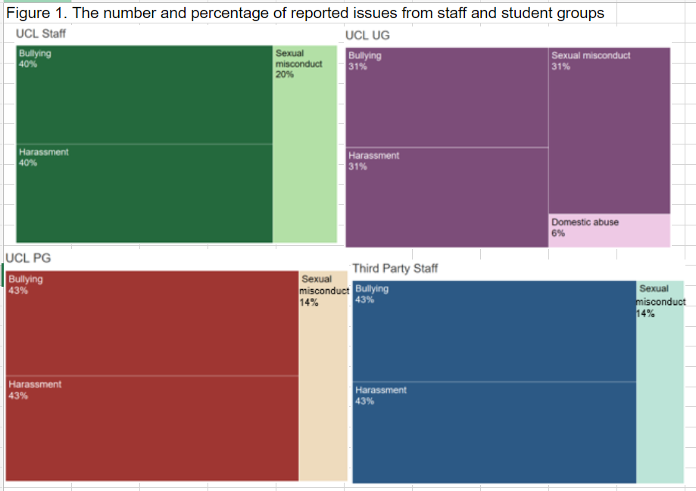
The reported issue by percentage is- 40 % bullying, 40% harassment and 20% sexual misconduct for UCL staff; 43% bullying, 43% harassment and 14% sexual misconduct for third-party staff; 31% bullying, 31% harassment, 31% sexual misconduct and 6 % domestic abuse for undergraduate students; and 43% bullying, 43% harassment and 14% sexual misconduct for postgraduate students.
Table 5. The number and proportion of reports indicate when the incident(s) started or took place
When | Count | %
Within the last 3 months | 187 | 56%
Within the last 12 months | 72 | 21%
Within 1-3 years | 53 | 16%
3 years or more | 23 | 7%

Figure 2. When incidents were reported
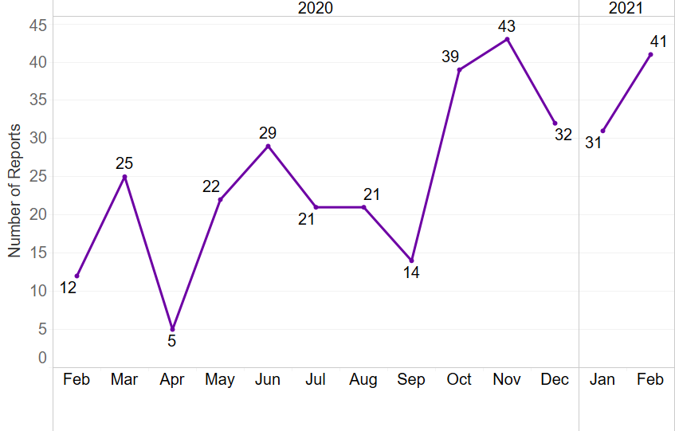

Most reports were made just after the start of academic year in the months of October (39 in number) and November (43 in number) in 2020, followed by high numbers in January 2021 (31) and February (41) 2021. The least numbers of reports received were in April 2020 (5) followed by February 2020 (12). Month-wise reporting numbers from Feb 2020-21 are as: February 2020- 12, March 2020- 25, April 2020- 05, May 2020- 22, June 2020- 29, July 2020- 21, August 2020- 21, September 2020- 14, October 2020- 39, November 2020- 43, December 2020- 32, January 2021- 31, February 2021- 41.

Qualitative Data
Qualitative analysis of the description of behaviours provided by reporters in the free text ‘incident details section’ of the reporting forms was undertaken using NVivo. The ‘incident detail section’ textual data were coded in terms of content and reported party. Note that domestic abuse has been excluded from that data due the low number of reports.

How behaviours were described when bullying was selected as reporting category:
As is evident from quantitative data tables above, bullying is the most reported category through Report + Support. The NVivo analysis finds that the range of reported behaviours (as described in the figure below) are often explicitly described as bullying within the free text ‘incident details section’. The chart below represents the coded behaviours reported under bullying. The more frequently a behaviour appears in the free text section, the larger the box.
Figure 3. Frequency of specific behaviours in reports of bullying (to scale).
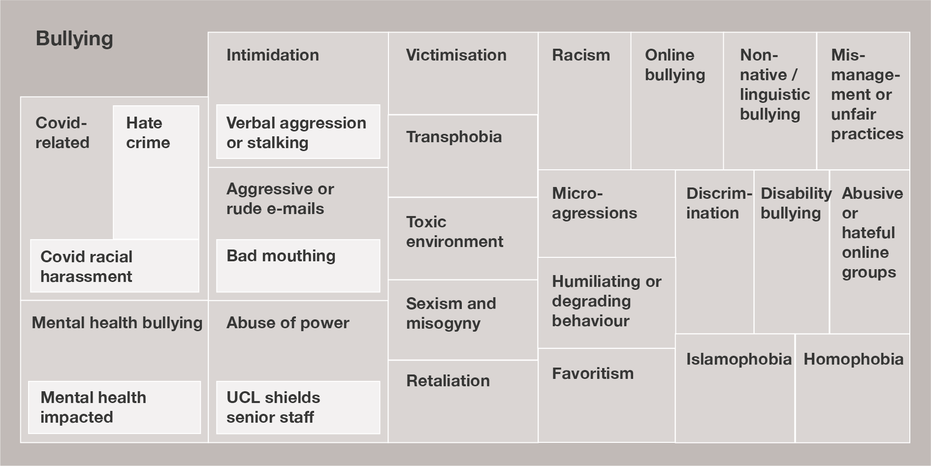

Following behaviours appear from highest to the least mentioned- toxic work/learning environment (28 entries), intimidation including verbal aggression (24 entries), abuse of power including allegations of UCL shielding their staff (18 entries), humiliating or degrading behaviour (18 entries), generic mention of bullying (14 entries), bullying due to mental health status including impacts on mental health (9 entries), mismanagement or unfair practices ( 9 entries), sexism and misogyny (9 entries), aggressive or rude email including bad mouthing (8 entries), covid-related racial harassment or hate crimes (8 entries), racism (8 entries), retaliation (8 entries), abusive or hateful online groups (4 entries), discrimination (5 entries), favouritism (4 entries), homophobia (4 entries), islamophobia (2 entries), bullying due to disability ( 1 entry), microaggressions (1 entry), online bullying (1 entry), and transphobia (1 entry).

Data Note
The coding was of behaviours mentioned across all reports, rather than by individual report; thus, one report might mention several types of behaviour. The behaviours listed are those most often coded and do not correlate with number of reports.

How behaviours were described when harassment was selected reporting category:
Online harassment was the most common type of harassment reported. Harassment was reported most frequently in relation to the protected characteristics of race and ethnicity, sex and/or gender, disability, and religion/belief. People who ticked certain protected characteristics like ethnicity, sexuality, gender identity, and age often did not submit an incident detail form or one with less detail. This may indicate mistrust or a sense of uneasiness in sharing these experiences through the online form.
Figure 4. Frequency of specific behaviours in reports of harassment (to scale)
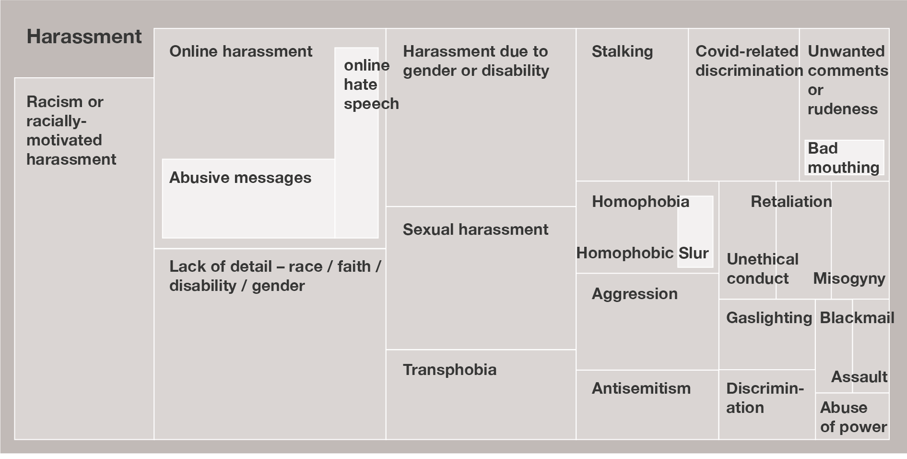
Following behaviours appear from highest to the least mentioned- online harassment (15 entries), racism or racially motivated harassment (15 entries), reports mentioning race, faith, disability or gender without any other details (13 entries), harassment due to gender or disability (10 entries), sexual harassment (8 entries), covid related harassment (5 entries), online harassment including online hate speech (5 entries), stalking (5 entries), transphobia (5 entries), aggression (4 entries), homophobia including homophobic slur (4 entries), unwanted comments or rudeness including bad mouthing (4 entries), antisemitism (3 entries), discrimination (2 entries), gaslighting (2 entries), misogyny (2 entries), retaliation (2 entries), unethical conduct (2 entries), abuse of power (1 entry), assault (1 entry), and blackmail (1 entry).

Trend overview across bullying and harassment qualitative data
‘Toxic environment’ with ‘aggressive’ or ‘demeaning’ conduct, including in online communication such as emails and MS Teams meetings, and other unreasonable demands or expectations placed by senior members or managers appeared most often throughout the free text section in staff reports of bullying. Other key mentions in staff reports were abuse of position of power in either subjecting a staff member to unprofessional treatment or allegations of favoritism.
For students, bullying and harassment by supervisors or other members of academic staff appeared throughout the free text section, with the most frequent codes being for unreasonable behaviour such as ‘public humiliation’, setting ‘unrealistic deadlines’ or undue workload, unwanted or ‘insensitive comments’ towards students due to their gender, ethnicity, disability or their being non-native speakers (international students), threats and intimidation, or allegations of favoritism, especially in relation to someone’s gender and/or sex.
Student to student reports of bullying and harassment covered themes of bullying in residences and in student social life, including at club and societies events, and including online activities and groups using digital platforms such as WhatsApp, Facebook, and Twitter. Most reports highlighted more overt behaviour, with ‘microaggressions’ named directly only a few times, which might suggest that subtle behaviours are not regarded as ‘serious enough’ to be reported.
Several reports of bullying were made by witnesses rather than by the person who experienced the behaviour. A small number of reports also mentioned student to staff bullying behaviour, with most relating to online communication.
Covid-19 specific bullying and harassment could be grouped into two categories:
- Covid-19 hate crimes or harassment: these include name calling, racial slurs or other remarks specifically or more generally towards persons of East and other Asian heritage. The reported parties were both UCL members as well as members of the public. This also includes staff feeling targeted in communications about Covid-19 where the managers directed their questions or concerns about Covid-19 to a particular individual.

- Unreasonable work-demands or Covid-19 specific mismanagement: Many reports in this category highlighted unreasonable demands by managers or senior management in relation to workload especially around parenting and caring, booking leave, and concerns around health and safety.
Two common themes ran across staff and students reports of bullying and harassment. First was mention of the impact of these behaviours on mental health, and second was fear of reporting or taking other steps to resolve their situation, with reports detailing retaliation coming from both staff and students.
The analysis finds that these were often mentioned alongside one or more social factors, most often sex or sexuality, gender, religion/belief, race and/or ethnicity, disability, mental health status, caring responsibilities, age, and grade/level of study.
Most bullying and harassment reports highlight the intersectional nature of the issues reporting parties' experience. For example, for UCL staff most of the reports related to Covid-19 ‘mismanagement’ bullying or harassment included childcare and other caring responsibilities, largely impacting women staff. Similarly, reports of racial harassment or bullying often co-mentioned sex or gender, and those mentioning disability also included details of one or more of the following characteristics: sex, mental health, age (older), level of study, and ethnicity.
We encourage all parties to report, which is reflected in the occasions where both parties have submitted reports of bullying and/or harassment.

Description of behaviours when harassment was reported
When students selected the category of sexual misconduct, the behavior being reported was further described most often as ‘sexual harassment’. Sexual harassment in this category also involved misogynistic coursework contents or remarks directed at a group rather than an individual. Physical behaviours/acts like rape and sexual assault tended to be described directly as ‘sexual misconduct’. Staff reports refer to sexual misconduct directly more often, suggesting that staff are more familiar with this terminology. Both staff and students are more likely to refer to incidents occurring online as ‘harassment’ and in-person as ‘sexual misconduct’ in their reports. Unlike in the categories of bullying and harassment, alumni feature more often in the reported party description in reports of sexual misconduct.
Figure 5. Frequency of specific behaviours in reports of sexual misconduct (to scale)
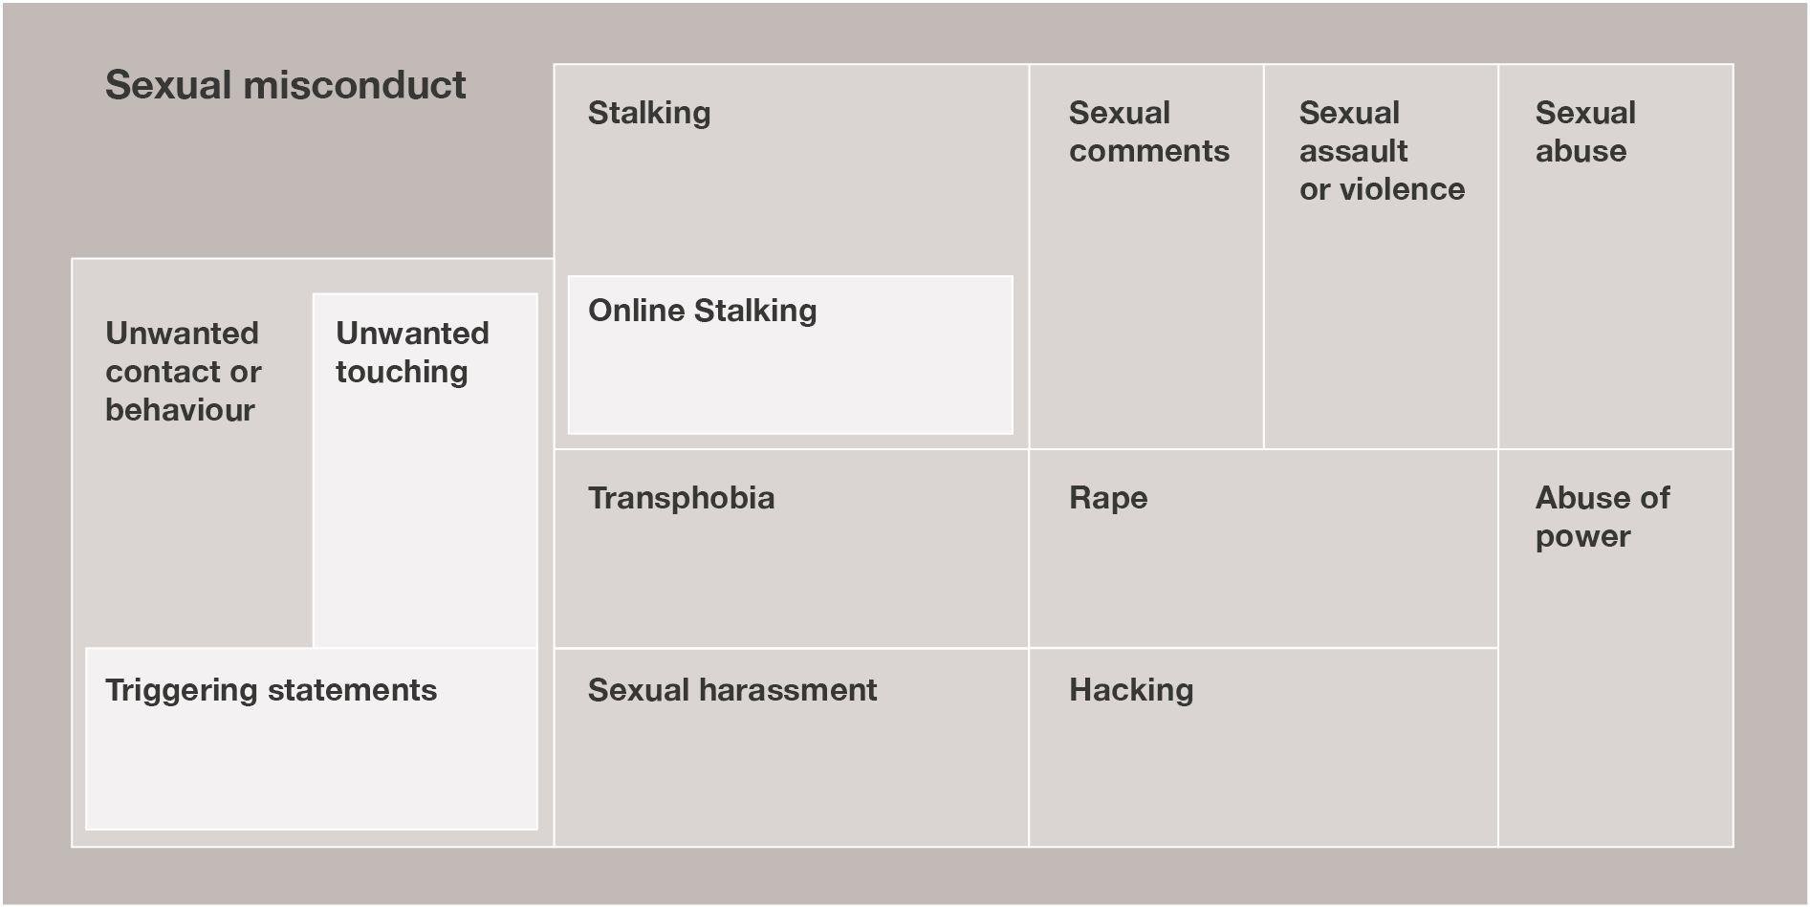
Following behaviours appear from highest to the least mentioned- unwanted behaviour or contact including making triggering statements about survivors (11 entries), sexual assault or violation of consent (7 entries), sexual harassment (4 entries),transphobia (4 entries), stalking including online stalking (3 entries), rape (3 entries), abuse of power (2 entries), sexual abuse (2 entries), hacking or spyware mediated abuse (2 entries), generic mentions of sexual misconduct with no details (2 entries) and sexual comments (2 entries).

Data by Faculty
Each Faculty and academic unit has its own unique culture. Whilst it is important to have a whole institution approach to the prevention of and response to bullying, harassment, and sexual misconduct, Faculties and academic units are working to address problematic cultures.
Faculties were given the first full academic years’ data from Report + Support (October 2019 - September 2020), together with an intervention framework to plan how they will prevent and respond to these issues. Faculties and academic units are continuing to review their data and cultures so they can better plan and implement interventional actions. These actions include: having difficult conversations about the underlying issues and the identified behaviours; changing local practices such as using pronouns in email signatures or agreeing not to text/email outside of working hours, undertaking behaviour change focussed training; raising awareness of expected behaviours and running local campaigns.
Figure 6. Proportion of reported issues in Schools, Faculties, Vice Provosts’ Offices, and central professional services
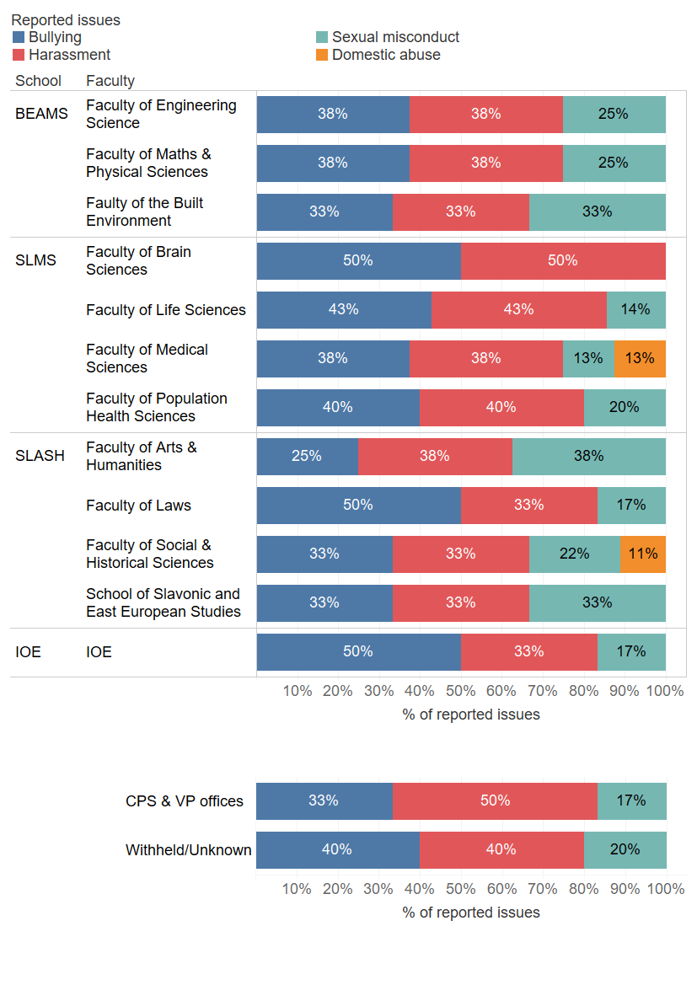

In the school of Built Environment, Engineering and Mathematical Sciences- Faculty of Engineering Science and Faculty of Maths & Physical Sciences both had 38% bullying, 38% harassment and 25 % sexual misconduct reports; and Faculty of built environments had 33% bullying, 33% harassment and 33 sexual misconduct reports.
In the school of life and medical sciences- Faculty of Brain Sciences had 50% reports of bullying and 50% of harassment; Faculty of Life Sciences had 43% reports of bullying, 43% harassment and 14% sexual misconduct; Faculty of Medical Sciences received 38% bullying, 38% harassment, 13% sexual misconduct and 13 % domestic abuse; and Faculty of Population Heath Sciences had 40 % reports of bullying, 40% harassment and 20% sexual misconduct.
In the School of law, art & humanities, and social and historical sciences- Faculty of Arts & Humanities received 25% bullying, 38% harassment and 38% sexual misconduct; Faculty of Laws received 50% bullying, 33% harassment and 17% sexual misconduct; Faculty of Social and Historical sciences received 33% bullying, 33% harassment, 22% sexual misconduct and 11% domestic abuse; and School of Slavonic and East European Studies received 33% bullying, 33% harassment and 33% sexual misconduct.
In the Institute of education, the percentage of reports was 50% bullying, 33% harassment and 17% sexual misconduct.
In central professional services and office of vice-provosts, the percentage or reports was 33% bullying, 50% harassment and 17% sexual misconduct.
In all the reports where area was withheld or unknown, 40 % were of bullying, 40% harassment and 20% sexual misconduct.

Figure 7. Number of reports by School, Faculty, central professional services, and VP offices in 2019/20 and 2020/21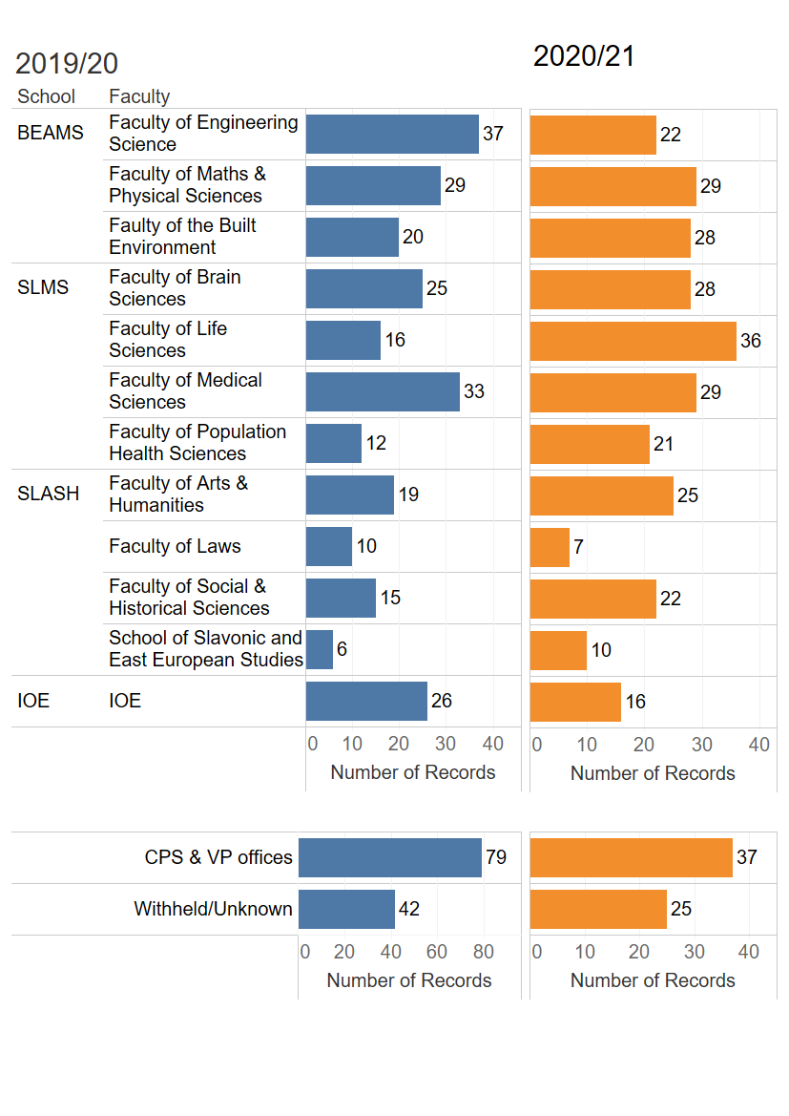

Faculty of engineering sciences saw a decrease in reports from 37 in 2019-20 to 22 in 2020-21. Faculty of maths and physical sciences had a constant number of reports at 29 for both 2019-20 and 2020-21. Faculty of built environment saw an increase from 20 reports in 2019-20 to 28 in 2020-21. Faculty of brain sciences saw an increase from 25 reports in 2019-20 to 28 in 2020-21. Faculty of life sciences saw and increase from 16 reports in 2019-20 to 36 in 2020-21. Faculty of medical sciences saw a decrease from 33 reports in 2019-20 to 29 in 2020-21. Faculty of population health sciences saw an increase from 12 reports in 2019-20 to 21 in 2020-21. Faculty of arts & humanities saw an increase from 19 reports in 2019-20 to 25 in 2020-21. Faculty of laws saw a decrease from 10 reports in 2019-20 to 7 in 2020-21. Faculty of social and historical sciences saw an increase from 15 reports in 2019-20 to 22 in 2020-21. School of Slavonic and east European studies saw an increase from 6 reports in 2019-20 to 10 in 2020-21. Institute of Education saw a decrease from 26 reports in 2019-20 to 16 in 2020-21. Central professional services and office of vice-provosts saw a decrease from 79 in 2019-20 to 37 in 2020-21. 42 reports made in 2019-20 did not disclose the area which decreased to 25 in 2020-21.

Most faculties have seen an increase in reporting year on year. It should not be assumed that an increase in reporting is synonymous with increased frequency of incidence. It is not possible to ascertain from this data if the increase is due to improved knowledge of Report + Support, decreased tolerance of unacceptable behaviour or increased unacceptable behaviours.

Figure 8. The number and proportion of form of reporting in Schools, Faculties, central professional services, and Vice Provosts’ offices

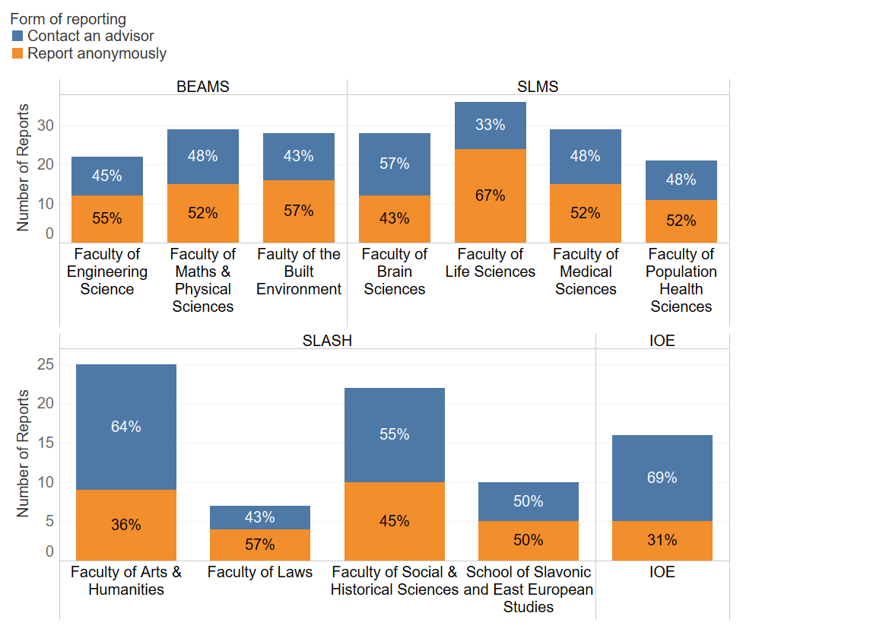

Faculty of engineering sciences had 45% contact advisor reports and 55 % anonymous out of total 22 reports. Faculty of maths and physical sciences had 48% contact advisor reports and 52 % anonymous out of total 29 reports. Faculty of built environment had 43% contact advisor reports and 57 % anonymous out of total 18 reports. Faculty of brain sciences had 57% contact advisor reports and 43% anonymous out of total 23 reports. Faculty of life sciences had 33% contact advisor reports and 67 % anonymous out of total 12 reports. Faculty of medical sciences had 48% contact advisor reports and 52 % anonymous out of total 30 reports. Faculty of population health sciences had 48% contact advisor reports and 52 % anonymous out of total 14 reports. Faculty of arts & humanities had 64% contact advisor reports and 36 % anonymous out of total 25 reports. Faculty of laws had had 43% contact advisor reports and 57 % anonymous out of total 7 reports. Faculty of social and historical sciences had 55% contact advisor reports and 45 % anonymous out of total 14 reports. School of Slavonic and east European studies had 50% contact advisor reports and 50 % anonymous out of total 12 reports. Institute of Education had 69% contact advisor reports and 31% anonymous out of total 30 reports. Central professional services and office of vice-provosts had 35% contact advisor reports and 65 % anonymous out of total 37 reports. Out of 25 reports which did not disclose an area, 64% were anonymous and 36% with details to contact an advisor.

Equality monitoring data of the reporting party
Sharing equality monitoring data when reporting through Report + Support is optional. However, it does help UCL to understand if certain groups of students or staff are experiencing patterns of behaviour.

Data note: individuals may have withheld equality monitoring data in either or both internal systems, and Report + Support.

Ethnicity

Table 6. Proportion of reports by ethnicity in relation to staff and student profile
Ethnicity | Number of reports from staff | Proportion of reports in relation to UCL staff profile | Number of reports from students | Proportion of reports in relation to UCL student profile
Arab | <5 | 0.8% | <5 | 0.3%
Asian or Asian British | 12 | 1.1% | 25 | 0.3%
Black or Black British | 7 | 2.0% | <5 | 0.2%
Chinese | <5 | 0.6% | 16 | 0.1%
Jewish | <5 | n/a | <5 | n/a
Mixed/multiple heritage | 11 | 2.4% | 13 | 0.5%
Other ethnic background | 0 | 0.0% | <5 | 0.1%
White | 81 | 0.9% | 53 | 0.3%
Withheld/Unknown | 53 | n/a | 49 | n/a
Chinese & Other Asian | 8 | 1.0% | 32 | 0.2%
Data note: UCL student and staff databases only collect Jewish as a religious identity whereas Report + Support also collects it as an ethnicity category.

Gender

Table 7. Proportion of reports by gender in relation to staff and student profile
Gender | Number of staff reports | Proportion of reports in relation to UCL staff profile | Number of student reports | Proportion of reports in relation to UCL student profile
Women | 82 | 1.0% | 96 | 0.3%
Men | 38 | 0.5% | 31 | 0.2%
Non-Binary | <5 | n/a | <5 | n/a
In another way | <5 | n/a | <5 | n/a
Withheld/Unknown | 46 | n/a | 35 | n/a
Data note: UCL records legal sex and Report & Support collects gender

Table 8. Proportion of reports by age groups
Age group | %
17 and under | 2%
18 – 21 years | 19%
22 – 25 years | 10%
26 – 35 years | 27%
36 – 45 years | 14%
46 – 55 years | 9%
56 - 65 years | 3%
66 and over | <1%
Withheld/Unknown | 16%

Table 9. Proportion of reports by trans identity
Are you Trans? | %
Yes | 1%
No | 78%
Withheld/Unknown | 21%

Table 10. Proportion of reports by religion or belief
Religion or belief | %
No religion | 40%
Buddhist | 2%
Christian | 11%
Hindu | 3%
Jewish | 1%
Muslim | 5%
Sikh | 0%
Spiritual | 1%
Any other religion or belief | 1%
Withheld/Unknown | 36%

Table 11. Proportion of reports by sexual orientation
Sexual orientation | %
Heterosexual | 54%
Bisexual | 7%
Gay man | 3%
Gay woman/lesbian | 2%
In another way | 2%
Withheld/Unknown | 33%

Table 12. Proportion of reports by disability
Disability | %
Yes | 17%
No | 54%
Withheld/Unknown | 28%

Table 13. Number and proportion of harassment reports by protected characteristic (Equality Act 2010)
Category | Count | %
Age | 7 | 11%
Disability | 9 | 14%
Gender Reassignment | 1 | 2%
Race | 14 | 21%
Religion or Belief | 6 | 9%
Sex | 20 | 30%
Sexual Orientation | 3 | 5%
Other | 6 | 9%
Data note: Protected characteristic was added to the question set in November 2020

Description of outcomes of disciplinary cases
The following data provide insight into the number of formal cases and outcomes for issues of reported bullying, harassment, and sexual misconduct for the period 25 February 2020 – 24 February 2021.
UCL is committed to improving transparency of processes and outcomes within the bounds of the law. Therefore, the data presented adhere to the General Data Protection Regulation.

Formal cases against students
There were 10 formal student cases, and these were all students reporting other students. This is down from 24 last year, likely to be due to fewer in-person interactions due to the Covid-19 pandemic. While there have been fewer formal cases, we have received an increased number of reports from students. Often multiple people will report one individual’s misconduct.
Table 14. Formal sexual misconduct cases against students by outcome
Expulsion | <5
Referred to the police | <5
Warning / reprimand | 0
Informal action (e.g. no contact agreement, moved halls) | <5
Case ongoing | 0
Not upheld | 0

Table 15. Formal harassment cases against students by outcome
Expulsion | 0
Referred to the police | 0
Warning | 0
Informal action (e.g. no contact agreement, moved halls) | <5
Ongoing | 0
Not upheld | 0

Table 16. Formal bullying cases against students by outcome
Expulsion | 0
Referred to the police/alternative authority | <5
Warning | 0
Informal action (no contact agreement, moved halls) | 0
Ongoing | 0
Not upheld | <5

Formal cases against staff
There have been 37 formal cases reporting staff behaviour during the period. This is the same number as last year. The following tables detail outcomes, reporting party roles, [text missing here?]
Table 17. Formal complaints about staff* by outcome
Dismissal | <5
Final Written Warning | <5
Formal Oral Warning | <5
Informal action | 7
Not upheld | 19
Under investigation | <5
Written Warning | <5
Withdrawn | 0
Employee Resigned before formal hearing | <5

Table 18. Number of formal complaints about staff by reporting party
Current Staff | 23
Former Staff | <5
Current Student | 9
Former Student | <5
External Party | <5

Table 19. Number of formal complaints about staff by category of complaint
Type | Numbers | How many upheld
Sexual misconduct | 9 | <5
Bullying &/or Harassment | 29 | 10

Cases that have not been upheld often relate to a lack of sufficient evidence. To offer more information to students and staff on bringing a formal case (such as initiating a student disciplinary, staff disciplinary or grievance) and the evidence needed UCL has produced guidance on how to bring a formal case which can be found on the Report + Support ‘support’ pages.

Summary of key trends and institutional actions taken
Depending on the context, actions taken have included:
- Conversations by managers with individuals named in reports to set out UCL’s expectations of behaviour and the expectation that poor behaviour will not be repeated.
- Targeted communications within departments outlining key behavioural concerns, and next steps.
- ‘Demystifying Report + Support’ presentations to staff and students in academic units.
In the past year a new process has been introduced - an ‘environmental investigation’ - where there has been cluster reporting of poor behaviour and problematic culture, particularly where these reports are anonymous. The possibility of commissioning ‘environmental investigations’ is now included in the Prevention of Bullying, Harassment and Sexual Misconduct Policy. An environmental investigation enables UCL to understand the behaviours and culture in that locale in more detail, and to develop targeted approaches and interventions, even whilst specifics remain unknown.
Recommendations resulting from environmental investigations so far have included: changes to management structures; improvements in communication styles and methods; professional development and upskilling; and individual behaviours to be considered under the relevant formal procedure, for example, the staff disciplinary procedure.

Next steps and action plan for UCL
Over the coming year, UCL will undertake the following new actions to address the concerns raised by this year’s Report + Support data and to continue progress in shaping a safer and more inclusive environment:
- The Reporting Review Task and Finish Group will make recommendations to Academic Board on short, medium, and long-term improvements to our reporting processes.
- We will review and improve the investigation and disciplinary processes for students and staff raising concerns about bullying, harassment, and sexual misconduct.
- Bystander training will be developed for staff.
- An education programme around antisemitism will be developed.
- There will be further behavioural interventions in departments.
- We will undertake exploratory work to develop a new framework for conflict dialogue at UCL.
- Launch a Respect and Inclusion online training for all students.
- We will embed key policy changes and existing support and training in departments.

Ways to stay engaged and get involved

How you can get involved
The Full Stop campaign has been developed to enable all members of the UCL community to participate. Everyone has a role to play in shaping a welcoming and inclusive working and learning environment. Below are some suggestions about how students and staff can get involved as individuals, or within Departments and Faculties.

As an individual
- Practice the four Ds of bystander intervention: direct, distract, delegate and delay
- Speak with a peer or colleague about low level unacceptable behaviour. How do they identify it? What do they do to challenge it?
- Join the social media conversation and share #Whyfullstopmatterstome
- Think about a colleague or peer who demonstrates positive behaviour and helps shape a positive working and learning environment and let them know. It’s important to celebrate the positive ways of working!

As a Department or Faculty
- Share the Full Stop videos and case studies.
- Use the Let’s Talk about Race campaign materials locally.
- Embed active bystander training into your student induction.
- Allow time in team or group meetings to reflect on behaviour, explore support options and consider how you can take action.
- Profile students and staff who have been engaging with the campaign and modelling positive and inclusive behaviours within the department/Faculty.
- Have regular communications about diversity and inclusion initiatives with students and staff, and highlight the key progress made.
- Share the findings of the Report + Support trend analysis report and the next steps for your area.

Further information about how to get involved can be found in the Full Stop thematic toolkits on the Full Stop website.

UCL are keen to ensure we remain transparent and accountable in our prevention of and response to harmful behaviours if you have any feedback on this report, please contact reportandsupport@ucl.ac.uk.

EHRC (2019, Oct) Racial harassment inquiry: survey of universities. Research report 130.
EHRC report (2019, Oct) Tackling racial harassment.
Refuge (2020, Apr) 25% increase in calls to National Domestic Abuse Helpline since lockdown measures began [Press release] accessed June 30, 2021.
UKRI (last updated June 2021). Preventing harm in research. Retrieved from https://www.ukri.org/about-us/policies-standards-and-data/good-research-resource-hub/preventing-harm-in-research/ on 30 June 2021

