
HR DIVISION
Report + Support | Annual Report 2021/22 | 1

UCL logo planters
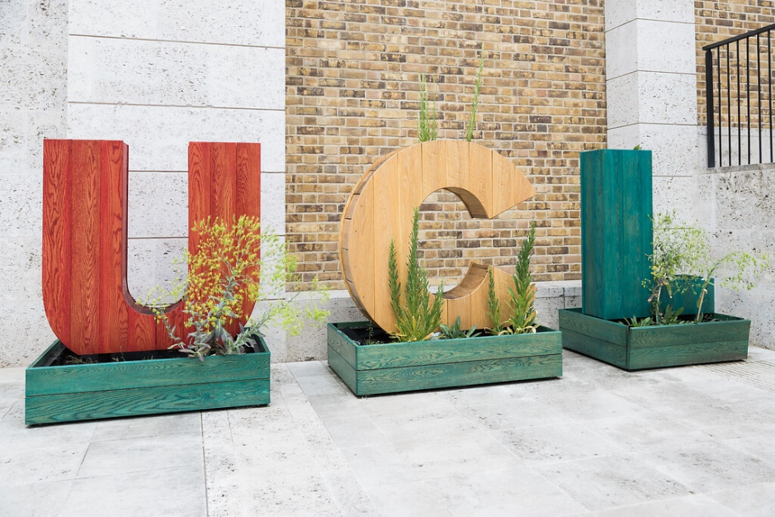

Report + Support
Annual Report 2024/25

Contents
Foreword 3
Improvements to Report + Support over the last year 5
Summary of data highlights 6
Number of reports made in 2024/25 7
Types of issues reported in 2024/25 8
Number of reports since 2019 10
Who is reporting and who are they reporting against 11
Who reported 11
Reported Parties Relationship with UCL. 12
Connection between the reporting party role and reported party 13
What they are reporting 14
Sexual Misconduct 15
Anonymous reporting 17
Outcome(s) of reports 19
Diversity monitoring data by people making reports 20
Ethnicity 20
Gender 21
Disability 21
Sexual Orientation/Identity 21
Action Plan 22
Initiatives to reduce harassment on the grounds of a protected characteristic 22
Staff Awareness and Training 23
Student Awareness and Training 24
Improved data collection 25
Appendix A: Diversity Data 26

Foreword
Dear all
Launched at UCL in 2019, Report + Support (R+S) is one way for staff and students to contact an advisor or make a report anonymously regarding issues of bullying, harassment, sexual misconduct, and domestic abuse. UCL recognises that reporting is essential to ensure students and staff receive the best support and so that we can investigate matters and ensure we have a positive work, study, and community culture.
In addition to R+S, students may report an issue via the student Casework Team and staff may report an issue via the grievance procedure. This report only focuses on submissions via Report + Support and is therefore only one source of data. Going forward we are proposing to include information on reports received outside of Report + Support.

Since 2019, the number of students and staff making reports had steadily increased until 2023/24. Over the last two years we have seen a slight decline in the number of reports. However, R+S is only one channel for reporting incidents. The percentage of anonymous reports has steadily decreased over the years, demonstrating an increase in trust and confidence in the service.

Since last year’s report we have made extensive changes to how Report+Support operates resulting in an improvement in our response rates and the user experience.

On 1 August 2025, we welcomed the introduction of the Office for Students E6 condition for higher education providers, relating to preventing and tackling harassment and sexual misconduct. This has resulted in a single comprehensive source of information for students on all aspects of bullying, harassment and sexual misconduct; as well as a full review of our Prevention of Bullying, Harassment and Sexual Misconduct policy and our Personal Relationships Policy.

Alongside this, we continue to invest in a range of preventative education and training. We are launching mandatory staff training on the Prevention of Bullying, Harassment and Sexual Misconduct and Personal Relationships and we have reviewed our student Active Bystanders training programme in partnership with the Student Union. This training will become mandatory for all students from September 2025.

During the 2025/26 academic year and beyond we will respond to the insights provided in this year’s report and other sources, implementing campaigns to prevent and address harmful behaviour; and launching a new Equality, Diversity and Inclusion (EDI) strategic plan that encompasses behaviour and culture change.

We welcome further feedback from students and staff on any of the contents of this report, how we can engage you more in our work moving forward or on any of our plans to improve the support, reporting and prevention services available for you here at UCL.

Best wishes,
Donna Dalrymple
UCL Chief People Officer
(Autumn Term, 2025)

Improvements to Report + Support over the last year
      - In January 2025, the Student Support and Wellbeing team assumed responsibility for the triaging of student reports, and they now have a Service Level Agreement of responding within 48 hours. Where students have provided contact details, the team will follow up to help identify what support/next steps and if the student has opted into two-way messaging the team will send the student a message with an offer of support. The changes to the operating in model are now overseen and managed by the Specialist Advice and Casework Services Team.
- In June 2025, the Employee Relations team took over a new triage system for all staff reports and they now respond to staff within two working days. We have strengthened our HR teams who deal with staff cases and they have been trained in trauma-informed approaches. The team will work with Workplace health and the People Partnering team if there is a health or wellbeing issue and where needed, the Employee Relations team will help connect individuals with the right UCL services e.g. Crime Prevention, Workplace Wellbeing etc. If the concern involves a student, the case will be jointly reviewed with the Student Casework team to ensure a co-ordinated approach. If there is a named report seeking informal resolution, this will be sent to the Human Resources People Partnering (HRPP) team to support.
- Anonymous staff reports are triaged by the HRPP team and while we cannot investigate individual cases from anonymous reports, if they opt in to the new anonymous messaging service, we can seek more information and provide information on available support.
4. The Associate Directors of HR People Partnering provide monthly data on
Report + Support to Faculties to help identify trends or hotspots of reported behaviours which will help determine how best to tackle issues.
These changes mean that those who report a concern now only have to communicate once to one team.
- We have reviewed our R+S web pages to ensure that they are up to date and more user-friendly.

Summary of data highlights
- Some key trends and data points during 2024/25 were:
- The number of R+S Reports (n909) submitted, decreased from the previous year (n946) (Graph 1)
- The top two reported issues continue to be 1. Bullying, 2. Harassment. (Table 2)
- Online harassment increased by 228% to 154 incidents making this the third highest category (Table 2). However, this has resulted in skewing the data and a potential decrease in the other incident types e.g. religion or belief-based hate and antisemitism.
- Islamophobia increased by 19% to 56 incidents while reporting of other religion or belief-based hate decreased by 28% from the previous year (Table 2)
- Antisemitism decreased by 67% from the previous year (Table 2)
- The majority of reports were made against UCL staff (48%) with (36%) made against students (Figure 2)
- 81% of reports against UCL staff were made by other UCL staff
- The proportion of anonymous reports this year decreased to 46.5% from 51.6% in 2023/24.
- The top three reasons given for reporting anonymously excluding ‘no answer’ were “I’m worried about retaliation (13%), “Nothing would be done if I made a complaint” (9%), and “I have concerns it might affect my current/future career” (9%), which remain the same reasons as last year (Table 5.)
- Sexual misconduct is the 6th highest reported issue (n125) in 2024/25 (Table 2.)
- 47.5% of all reports were from women, 16.8% were from men, 3.3% were from Other and 29.8% are unknown.
- White staff were least likely to report issues via R+S (1.4%) whereas staff of ‘Arab’ ethnicity reported at a level nearly 4 times as high (4.8%). (Table A1)
- There was no large statistical differences in reporting between different ethnic groups from students, but again students of ‘Arab’ ethnicity recorded the highest proportion of reports at 1.6%,
- 12% of disabled staff submitted reports which was a small increase on last year (9.8%) (Table A3).
- the majority of reports submitted by staff and students were from staff who stated their sexual orientation/identity was heterosexual (46%). The next highest number being received from staff and students who had stated their sexual orientation/identity was ‘Bisexual’ (8%)

Number of reports made in 2024/25
- This annual report covers the period from 1 October 2024 to 30 September 2025 to align with the academic year. Where this annual report refers to students and UCL staff, these categories also include reports from ex-staff and ex-students. In 2024/25 former staff and students accounted for about 4% of the reports submitted.

Table 1. Number of reports made in 2024/25
UCL profile | Number in UCL | Count of reports (inc. ex-staff and students) | % of UCL population
Staff | 18,357 | 342 | 1.9%
Students | 51,707 | 544 | 1.1%
Third party staff | N/A | 20 | N/A
Not Known | N/A | 3 | N/A
Total | N/A | 909 | N/A

Types of issues reported in 2024/25
- Reporting parties can select multiple incident types related to their report. In 2024/25 there were 1,828 different incident types reported across the 909 reports. Table 2. provides a breakdown and shows the percentage change between 2023/24 and 2024/25.

Table 2. Incident types reported and percentage change between 2024/25 and 2023/24
Type | Number of Incidents reported 2024/25 | Number of Incidents reported 2023/24 | % increase/decrease
Bullying | 451 | 438 | 3%
Harassment | 355 | 338 | 5%
Online Harassment | 154 | 47 | 228%
Racism | 148 | 215 | -31%
Other | 146 | 109 | 34%
Sexual Misconduct | 125 | 117 | 7%
Sexism | 95 | 69 | 38%
I'm not sure | 79 | 79 | 0%
Antisemitism | 67 | 204 | -67%
Islamophobia | 56 | 47 | 19%
Other religion or belief-based hate | 42 | 58 | -28%
Transphobia | 35 | 18 | 94%
Ableism | 26 | 24 | 8%
Homophobia | 21 | 17 | 24%
Domestic Abuse | 21 | 16 | 31%
Biphobia | 4 | 5 | -20%
Did not answer | 3 | 0 | 0%
Total | 1828 | 1801

- Bullying (n451) and harassment (n355) remain the top two reported issues and recorded relatively modest increases of 3% and 5%, respectively. Bullying accounted for 25% of the total incidents reported, up slightly from 24% the previous year. Combined, these make up 44% of the incidents reported in 2024/25. Racism has been overtaken by online harassment as the third highest reported issue and increased significantly by 228% to 154 incidents (8% of total incidents) which is an increase on the 3% of total incidents recorded the previous year. The category of online harassment is not particularly helpful here as it is a sub-category of harassment and doesn’t highlight at a high level what the nature (or protected characteristic) of the harassment involved.

- Reports of racism have decreased by 31% (n148) in 2024/25 (8% of total incidents) from the higher 215 reported in 2023/24 (12% of total incidents). The proportion of reports related to antisemitism have also significantly decreased by 67% (n67) and accounted for 4% of total incidents reported, from 204 incidents reported in 2023/24 (11% of total incidents reported). However, we do know some of the online harassment was related to racism and antisemitism but it is difficult to easily report on this. The proportion of reports of Islamophobia increased in 2024/25 by 19% to 56 (3% of total incidents) from 47 (3% of total incidents) but other religion or belief-based hate dropped by 28% (n42) (2% of total incidents) . Another significant increase was seen in incidents of transphobia which increased by 94% from 18 (1% of total incidents) to 35 incidents (2% of total incidents). Whilst the numbers are small, it is a concerning increase and we will continue to monitor reports throughout the year to inform whether any additional in-year actions are required.

- There is no one reason why there has been an increase in online harassment, which is a sub-set of harassment. The online nature is attributed to the type of online channel, rather than the protected characteristic of the harassment and therefore doesn’t necessarily elicit useful information. The channels of online harassment cited are: departmental Teams channels, Staff network teams channels, email, WhatsApp, social media including Instagram, Discord and X. When reading some of the reports some of them are allegations of bullying, not harassment, some are not relevant to online incidents; and some reporters are selecting every type of incident. Some are related to the Supreme Court judgement; some are related to the Israel/Palestine conflict; some are allegations of transphobia; some are sex discrimination; some are sexual misconduct.

Number of reports since 2019
- The number of reports had grown year on year from 330 in 2019/20 to 946 in 2023/24, In 2024/25 this continuous upward trend did end with a slight reduction in the number of reports to 909.
Graph 1: Total count of reports from 2020/21 to 2024/25

Who is reporting and who are they reporting against

Who reported
- Of the total 909 reports submitted in 2024/25:
- 38% (n342) were from current or former UCL staff.
- 31% (n277) were from current or former undergraduate students (with reporting by undergraduates higher than postgraduates for the second consecutive year).
- 29% (n267) were from current or former postgraduate students.
- 2% (n20) were from third party staff (does not include other external reporters such as former staff or students, members of public etc)
Three people did not answer this question.

Figure 1. Who reported in 2024/25

Reported Parties Relationship with UCL.
- Reports were made against individuals in the following groups:
- 48% (n436) were made against UCL staff.
- 21% (n193) were made against undergraduate students.
- 15% (n136) were made against postgraduate students.
- 7% (n59) were against third party staff or people with no connection to UCL.
- 9% (85) chose ‘I don’t know’

Figure 2. The Reported Parties Relationship with UCL

Connection between the reporting party role and reported party
- The reporting party’s relationship to the reported party (Table 3) shows that reports are more likely to be made against someone in the same group, except for third party staff, however the proportions do differ as follows.
- Undergraduate students were more likely to make reports against other undergraduate students - 58% (n160) of total reports from undergraduate students.
- Postgraduate students were more likely to make reports against other Postgraduate students - 39% (n104) of total reports from postgraduate students.
- UCL Staff were more likely to make reports against other UCL staff - 81% (n278) of total reports from UCL staff.
- Third party staff were more likely to make reports against UCL staff, 20% (n4), undergraduate students, 20% (n4) or didn’t know the connection to UCL, 20% (n4) of the total reports from third party staff. However, the numerical differences between all the categories for third party staff was minimal.
Table 3. Connection between reporting party role and reported party 2024/25
Reporting Party | I don't know | Post-graduate Student | They are not connected | Third-party Staff | UCL Staff | Undergraduate Student | Total
Not answered | 0 | 1 | 0 | 0 | 2 | 0 | 3
Postgraduate Students | 20 | 104 | 26 | 7 | 96 | 14 | 267
Third Party Staff | 4 | 2 | 3 | 3 | 4 | 4 | 20
UCL Staff | 25 | 16 | 6 | 2 | 278 | 15 | 342
Undergraduate Students | 36 | 13 | 9 | 3 | 56 | 160 | 277

What they are reporting
- Of the top 4 issues (Incident types) reported in 2024/25:
  - 47.6% (n215) of all reports about bullying were made by UCL staff. (Table 4c)
  - 34.1% (n121) of all reports of harassment were made by UCL Staff (Table 4c) and the remainder were evenly split between 32.4% (n115) by Postgraduate students (Table 4b) and 31.3% (n111) by Undergraduates (Table 4a).
  - 39.6% (n61) of all reports about online harassment were made by UCL staff (Table 4c), and 28.6% (n44) by Postgraduate students (Table 4b) and 28.6% Undergraduate students. (Table 4a)
36.5% (n54) of all reports about racism were made by Undergraduate students. (Table 4a)

Tables 4a – 4d. Reporting party and top 4 reported issues 2024/25

Table 4a - Undergraduate Students
Bullying | % | Harassment | % | Online Harassment | % | Racism | %
93 | 20.8% | 111 | 31.3% | 44 | 28.6% | 54 | 36.5%

Table 4b - Postgraduate Students
Bullying | % | Harassment | % | Online Harassment | % | Racism | %
133 | 29.4% | 115 | 32.4% | 44 | 28.6% | 47 | 31.8%

Table 4c – UCL Staff
Bullying | % | Harassment | % | Online Harassment | % | Racism | %
215 | 47.6% | 121 | 34.1% | 61 | 39.6% | 45 | 30.4%

Table 4d – Third Party Staff
Bullying | % | Harassment | % | Online Harassment | % | Racism | %
10 | 2.2% | 8 | 2.2% | 5 | 3.2% | 2 | 1.3%

Multiple options can be selected in a single report.

Sexual Misconduct
- Sexual misconduct remains one of the most frequently reported issues (n125) and is the 6th highest reported issue in 2024/25 (Table 2.), after an increase of 7% on the previous year.
- 39.2% (n49) were by Undergraduate students.
- 38.4% (n48) were by Postgraduate students
- 18.4% (n23) were by UCL Staff
- 4% (n5) were by Third Party Staff
Figure 3. Party Reporting Sexual Misconduct 2024/25

- The relationship to UCL of individuals reported for sexual misconduct issues was as follows:
- 34% (n42) were against UCL staff.
- 29% (n36) were against Undergraduate students.
- 23% (n29) were against Postgraduate students.
- 10% (n13) were against people with no connection to UCL.
- 4% (n5) were unknown

Figure 4. Reported Parties Relationship with UCL (Sexual Misconduct)

Anonymous reporting
- Anonymous reporting in 2024/25 has continued to decline in line with the general overall trend seen in previous years. In 2024/25 the proportion of anonymous reports decreased to 46.5% from 51.6%. This now sits just above the lowest proportion recorded in 2021/22 (44.5%)

Graph 2. Trends in proportion of anonymous reporting from 2019/20 to 2024/25

- The top three reasons given for reporting anonymously (Table 5.) remain the same as last year, excluding 28% (n491) where no answer was provided:

  - “I’m worried about retaliation” 13%, (n226).
  - “Nothing would be done if I made a complaint” 9%, (n164).
  - “I’ve concerns it might affect my current/future career” 9%, (n165).

Table 5. Reason(s) for reporting anonymously
Reason(s) for reporting anonymously | Count | %
Not answered | 491 | 28%
I'm worried about retaliation | 226 | 13%
Nothing would be done if I made a complaint | 164 | 9%
I have concerns it might affect my current/future career | 160 | 9%
I am worried about being called a troublemaker | 124 | 7%
I'm worried that there would be repercussions in my social circle | 101 | 6%
I'm worried that I won't be believed | 99 | 6%
I reported it to someone at the University but they didn't take it seriously | 73 | 4%
I cannot prove the behaviour took place | 63 | 4%
Other | 55 | 3%
I don't want to get anyone into trouble | 40 | 2%
I feel too embarrassed or ashamed | 39 | 2%
I don't know how to make a complaint | 36 | 2%
It's not serious enough to warrant a complaint | 30 | 2%
I don't want anyone to know it took place | 28 | 2%
I don't have time to make a complaint | 27 | 2%
I feel partly to blame for what happened | 11 | 1%
I reported it to the Students' Union but they didn't take it seriously | 9 | 1%
Totals | 1776 | 100%
Multiple options can be selected in a single report.

Outcome(s) of reports
- There were 551 outcomes recorded for named reports (excluding anonymous reporting) (see Figure 5.) and the top 3 outcomes were:
  - Informal resolution 23% (n126).
  - Transferred into casework investigation 18% (n101).
  - No further action17% (n93).
We have focused on named reports principally due to anonymous reporting limiting UCL’s ability to act.
Figure 5. Outcomes for named reports (excluding anonymous reporting) in 2024/25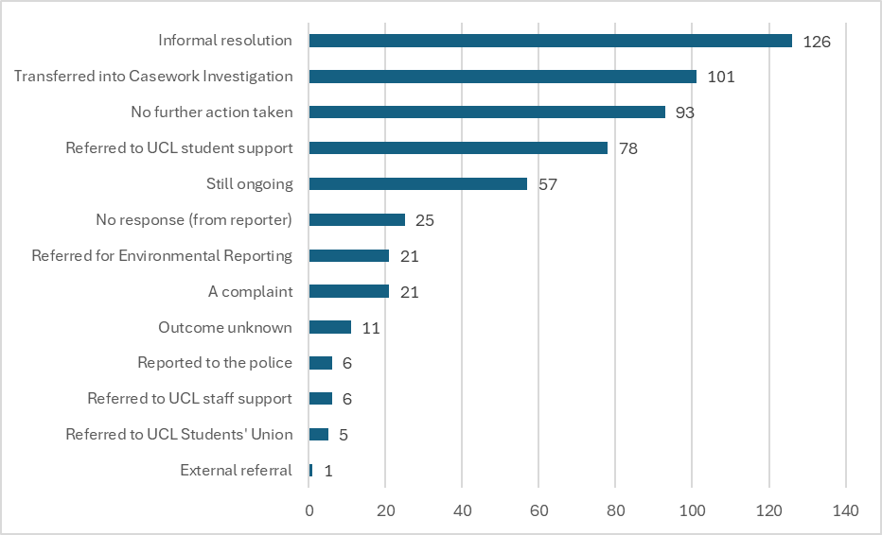
Multiple options can be selected in a single report.

Diversity monitoring data by people making reports

Ethnicity
- Sharing diversity monitoring data when reporting through R+S is optional. Where data is available some staff groups are disproportionately represented among those reporting incidents. See Appendix A: Diversity Data for more details.
- 41% (n140) of UCL staff who reported issues (n342) did not specify their ethnicity. For students this was lower at 32% (n173) of the total reports submitted by students (n544). See Table A1.
- There were some variations in reporting rates for different ethnic groups amongst UCL Staff (Table A1). The comparison considered the overall representation of each ethnic group at UCL relative to the number of reports submitted. This shows that white staff were least likely to report issues via R+S (1.4%) whereas staff of ‘Arab’ ethnicity reported at a level nearly 4 times as high (4.8%).

- Other ethnic groups with a high proportion of reports relative to their staff population were ‘Asian or Asian British – Pakistani’ with 4.1%, ‘Black or Black British other’ with 4% and ‘Mixed/Multiple heritage’ with 3.8% This higher reporting rate is again noteworthy, especially given the smaller population size of these groups at UCL, ranging from 25 to 502, compared to over 8,000 white staff.

- Looking at student rates, there was no large statistical differences in reporting between different ethnic groups but again students of ‘Arab’ ethnicity recorded the highest proportion of reports at 1.6%, whilst white students recorded the lowest at 0.6%, together with ‘Chinese’ and ‘Asian or Asian British – Bangladeshi.’

Gender
- 47.5% of all reports were from women, 16.8% were from men, 3.3% were from Other and 29.8% are unknown. Compared to the UCL population, 1.2% of female staff and 1% of female students submitted a report. In comparison, 0.8% of male staff and 0.4% of male students submitted a report (Table A2).

Disability
- Disabled staff and students submitted a smaller proportion of the total reports (n909) with 12% reporting compared to staff who did not declare a disability (55%) (Table A3). This is a small increase on last year, where the proportion of reports where the individual had declared a disability was 9.8% However, a relatively high proportion of reporting parties again chose not to share their disability status (33%).

Sexual Orientation/Identity
- Again, a high proportion of reporting parties chose not to share information relating to sexual orientation/identity (38%) (Table A4) which is a reduction compared to last year (44.7%). Of those who did, the majority of reports submitted by staff and students were from staff who stated their sexual orientation/identity was heterosexual (46%). The next highest number being received from staff and students who had stated their sexual orientation/identity was ‘Bisexual’ (8%) with ‘Gay men’ and ‘Gay women/lesbian’ both reporting 2% each. 4% were recorded as ‘other’. This again seems broadly in line with previous years.

Action Plan
- For the 2025/26 academic year and beyond, UCL will respond to the insights afforded by this report and other evidence of need, including:

Initiatives to reduce harassment on the grounds of a protected characteristic
- On 31 October 2025, an institutional EDI strategic plan was approved and implementation has now commenced. The institutional priorities include developing and embedding a values framework across UCL processes and policies to enable people to live our values and, as a result, recognise and reward positive behaviours while addressing harmful behaviours.
- Another priority is to equip our leaders and managers with the tools and confidence to foster inclusive environments and manage sensitive scenarios, that could lead to harmful behaviours, and to foster an open and inclusive environment , where people feel safer to report and seek support.
- In the 2025/6 academic year we will also develop a Religion and Belief action plan to foster a respectful environment for all students and staff, where religion, belief, and non-belief are understood, valued, and protected. One of the immediate actions that we will focus this plan on is awareness and training on Islamophobia.
- Building on our 3 year antisemitism programme, in 2025/6 we are delivering antisemitism training to cohorts of our UCL senior leadership team,
- Developing - and starting delivery of an institutional Disability Action Plan which, among other things, aims to improve disabled staff confidence in reporting bullying and harassment and increase staff awareness of disability.

Towards the latter end of 2025/6 we will commence work on a new LGBTQ+ action plan that will continue on from the current 3-year plan.

Staff Awareness and Training
In addition to the above initiatives which will raise staff awareness and deliver training on certain characteristics, we will continue to provide development programmes and interventions to prevent and address harmful behaviour including:
- Implementing new mandatory staff training on Prevention of Bullying, Harassment, and Sexual Misconduct, in response to UCL’s revised policies and new Office for Students requirements. The training module will include information on freedom of speech.
- ‘Where Do You Draw The Line?’ training on preventing and responding to bullying, harassment, and sexual misconduct. The training offers departments the opportunity to undertake a collective analysis of the individual and contextual factors that might create and sustain a work environment in which harmful behaviour occurs and empowers participants to work together to address these factors. A further 18 sessions were delivered in the year to 360 participants.
- ‘Taking The Lead’ workshops bring senior managers within departments together to encourage a strategic and proactive approach to preventing and tackling bullying and harassment. Over 1500 staff have participated since October 2018 and an additional 5 sessions were delivered in the year to 75 leaders.
- Other workshops have addressed: Sexual Misconduct, Challenging Conversations, Microaggressions, Allyship, Practical Approaches to Race Allyship (see below), Implicit Bias. Approximately 1,500 participants were engaged through this training offering.
- ‘Practical Approaches to Race Allyship’ is training for UCL departments with impact for cultural change in the wider higher education sector through its inclusion in the B-MEntor programme. B-MEntor brings together seven London higher education institutions to facilitate mentoring for staff from underrepresented Black, Asian and Minority Ethnic backgrounds.
- Providing packages of bespoke workshops on working cultures for departments.
- ‘Supporting staff with reasonable adjustments – training for line managers’ to increase confidence in, and awareness of, supporting disabled and neurodivergent staff through reasonable adjustments as part of a core development programme.
- Report + Support presentations to a range of UCL staff routinely and on request.
- In addition, anonymised R+S data is shared with local leadership teams to inform a targeted approach to intervention and prevention. The EDI team and the HR People Partnering Team, both within the HR Division, collaborate with local partners to develop measures in response to the data and to support improved outcomes. This extends to locating and sharing impactful practice in interventions made centrally and locally.
- We have developed an LGBTQ+ Equity training module for staff, which was launched in November 2025.

Student Awareness and Training
- Rolling out the updated and now mandatory, Students’ Union UCL ‘Active Bystander Programme’. Workshops teach students how to recognise and safely intervene in situations of bullying, harassment and sexual misconduct. It aims to empower students to act and support their peers. Over 6,000 students have engaged with the programme with 95% feeding back that the programme has helped them develop an understanding of what constitutes bullying, harassment, and sexual misconduct both on campus and online.
- The Student’s Union is also rolling out new ‘Consent & Tackling Sexual Violence’ workshops due to demand and interest from students, which go beyond typical consent training. This workshop enables students to engage critically with real world communication, sexual experiences, and identities, interacting with the practice of consent, and interpersonal and systemic notions of power and privilege.
- ‘Report + Support presentations to a range of UCL students routinely and on request.

Improved data collection
- We are currently reviewing the way we collect data in the Report + Support platform to better inform future reports. We wish to review: whether the public should be using Report + Support or the Public Complaints procedure; better classification of reports; improved EDI data; more understanding around the themes of complaints. Next year we aim to include more qualitative information around themes and trends.
- UCL is keen to ensure that we remain transparent and accountable in responding to harmful behaviour. If you have any feedback on this report or on R+S in general, please contact employmentpolicy@ucl.ac.uk.

Appendix A: Diversity Data

Table A1. Ethnicity (disaggregated) 2024/25
Ethnicity (group) | Reports from staff | Staff profile | Proportion of staff reports vs staff profile | Reports from students | Student profile | Proportion of student reports vs student profile
Any other ethnic background | 0 | 398 | N/A | 0 | 826 | N/A
Arab | <5 | 84 | 4.8% | 20 | 1,282 | 1.6%
Asian - Other background | 9 | 384 | 2.3% | 40 | 3,728 | 1.1%
Asian or Asian British - Bangladeshi | <5 | 182 | 1.6% | 6 | 994 | 0.6%
Asian or Asian British - Indian | 10 | 663 | 1.5% | 27 | 3,757 | 0.7%
Asian or Asian British - Pakistani | 6 | 148 | 4.1% | 11 | 1,280 | 0.9%
Black or Black British - African | 7 | 290 | 2.4% | 17 | 1,730 | 1.0%
Black or Black British - Caribbean | <5 | 190 | 2.6% | <5 | 253 | 0.8%
Black or Black British – Other background | <5 | 25 | 4% | 0 | 61 | 0%
Chinese | 15 | 652 | 2.3% | 101 | 17,553 | 0.6%
Jewish (see note) | 6 | N/A | N/A | 23 | N/A | N/A
Mixed/Multiple heritage | 19 | 502 | 3.8% | 30 | 2,839 | 1.1%
White | 117 | 8,444 | 1.4% | 94 | 15,376 | 0.6%
Withheld/Unknown | 140 | 6,395 | 2.2% | 173 | 2,028 | 8.5%
Total | 342 | 18,357 | 1.9% | 544 | 51,707 | 1.1%
UCL student and staff databases collect data about being Jewish as a religious category whereas R+S also collects such data as an ethnic category. Therefore, it is not possible to include the proportion of reports in relation to UCL for Jewish ethnicity.

Table A2. Gender 2024/25
Gender | Reports from staff | Staff profile | Proportion of staff reports vs staff profile | Reports from students | Student profile | Proportion of student reports vs student profile
Women | 123 | 9,995 | 1.2% | 309 | 31,651 | 1.0%
Men | 67 | 8,362 | 0.8% | 86 | 19,931 | 0.4%
Other | 18 | N/A | N/A | 12 | 125 | 9.6%
Withheld/Unknown | 134 | N/A | N/A | 137 | N/A | N/A
Total | 342 | 18,357 | 1.9% | 544 | 51,707 | 1.1%
UCL records sex and R+S records gender.

Table A3. Disability 2024/25
Disability | 24/25 Count | 24/25  %
Yes | 105 | 12%
No | 501 | 55%
Withheld/Unknown | 303 | 33%
Total | 909 | 100.0%

Table A4. Sexual Orientation/Identity 2024/25
Sexual Orientation/Identity | 24/25 Count | 24/25  %
Heterosexual | 416 | 46%
Bisexual | 76 | 8%
Gay man | 20 | 2%
Gay woman/Lesbian | 18 | 2%
Asexual/Queer/Other | 39 | 4%
Withheld/Unknown | 340 | 38%
Total | 909 | 100.0%

